**In GIS test:**

Permissions added for Geometer Supervisor:



But in the District reports of Geometer Supervisor dashboard the rejected reports are not showing.

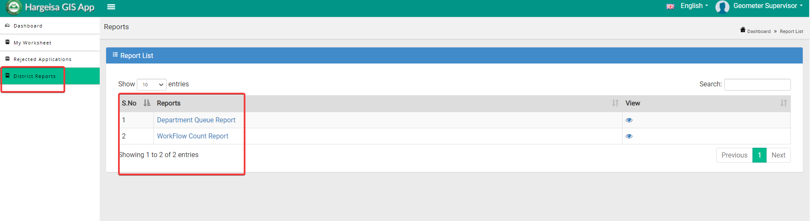

**In GIS production:**

Permissions added for Geometer Supervisor:



But in the District reports of Geometer Supervisor dashboard the rejected reports are not showing.

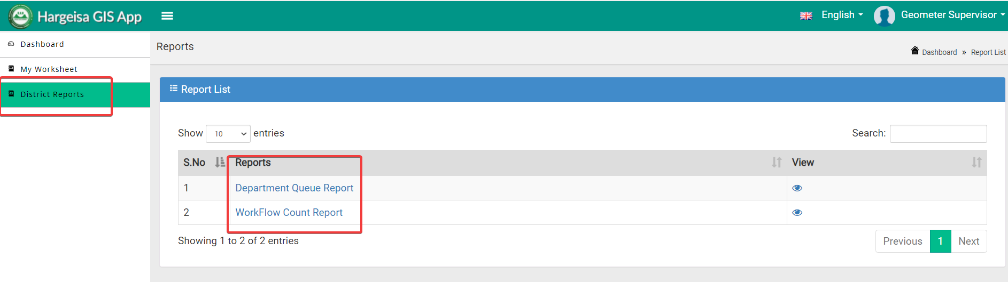

**In GIS test**: CustomerService Dashboard

Permissions added for CustomerService:



But not showing in the district reports

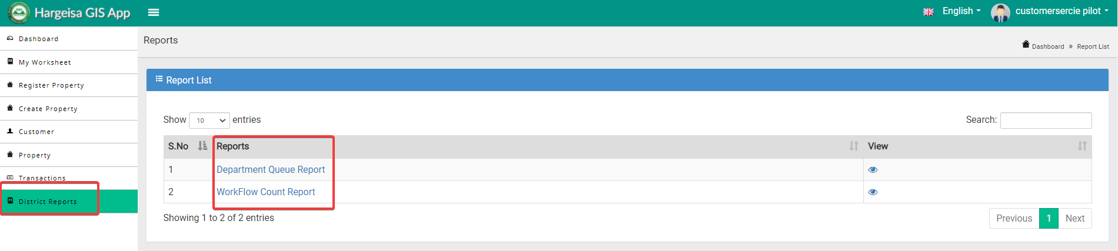

**In production**:

Permissions added for CustomerService:



But not showing in the district reports

