**Analysis of Ticket (https://teams.haroob.com/issues/412)  
  
Below Troubleshoot steps tried both in Test and Production which fails:-**

1. Tried with invoice value above 1000 and below 1000 but error pattern not identified.  
   2>Tried by creating invoice no ends with 14 or 15 but no pattern identified.  
     
   **ANALYSIS:--**As per the analysis we found out that for the invoice having Grand total as 1014,4015 are having printing issue both in Test portal and production portal.

**Screen shot From test portal invoices with Grand total value as 1014, 4015.**

1. <https://test-portal-smartmeter.c2btech.com/admin/purchaseInvoice/PINV-02021>
2. <https://test-portal-smartmeter.c2btech.com/admin/purchaseInvoice/PINV-02023>
3. <https://test-portal-smartmeter.c2btech.com/admin/purchaseInvoice/PINV-02024>

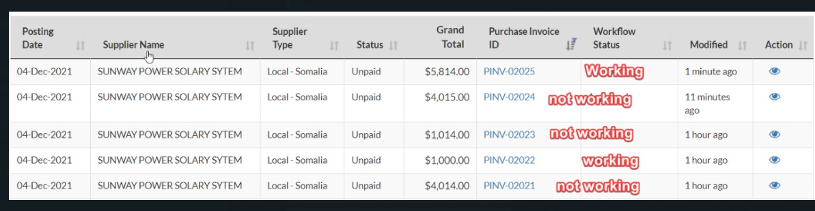

**Screen shot From Production portal invoices with Grand total value as 1014, 4015.**

1. <https://nuwacoapp.haroob.com/admin/purchaseInvoice/PINV-02850>
2. <https://nuwacoapp.haroob.com/admin/purchaseInvoice/PINV-02849>
3. <https://nuwacoapp.haroob.com/admin/purchaseInvoice/PINV-02872>

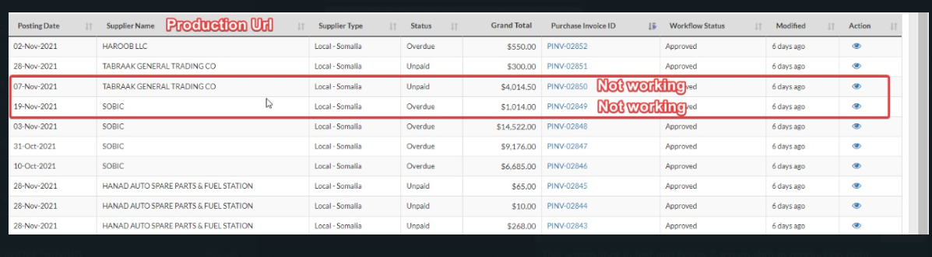  
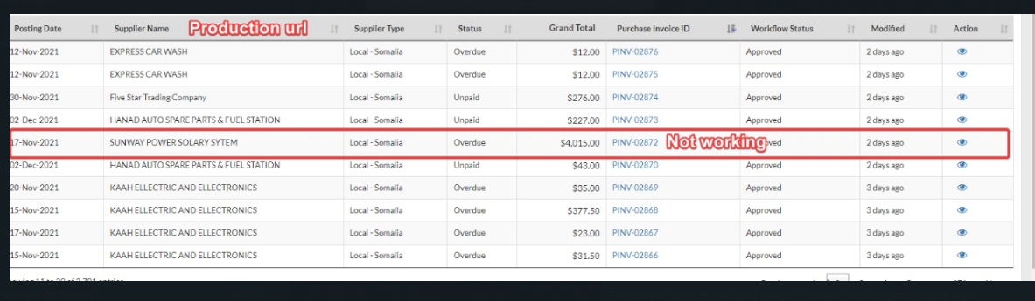

**Screen shot for LOG error in Production:--**

<https://nuwacoapp.haroob.com/admin/log_viewers/logs/2021-12-04/error>

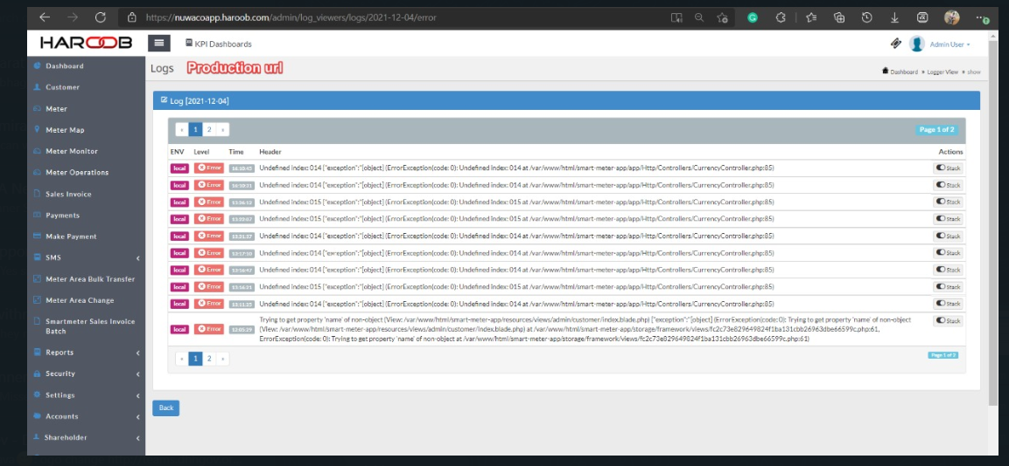

**Screen shot for LOG error in Test Portal:--**

<https://test-portal-smartmeter.c2btech.com/admin/log_viewers/logs/2021-12-04/error>

