TR-14215

Step:1

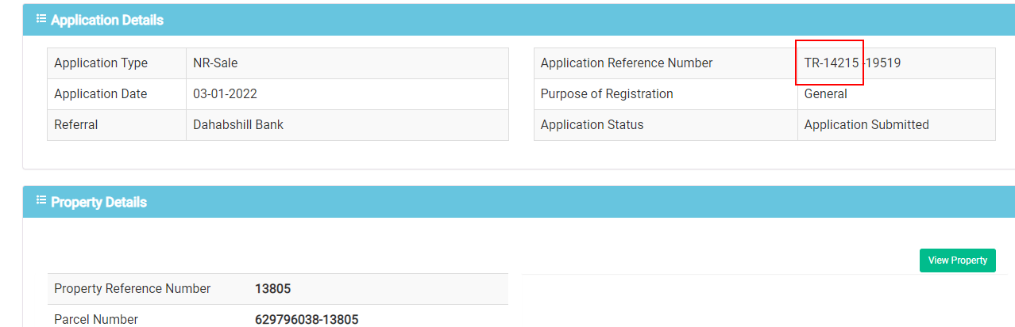

Step2:

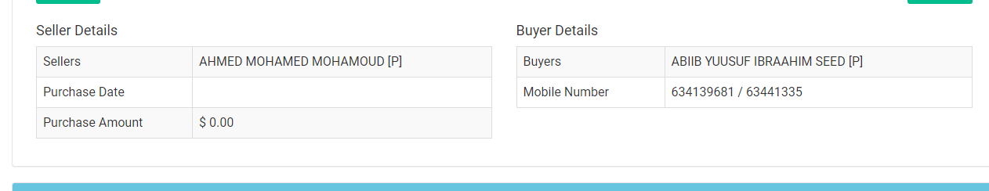

Seller Screen

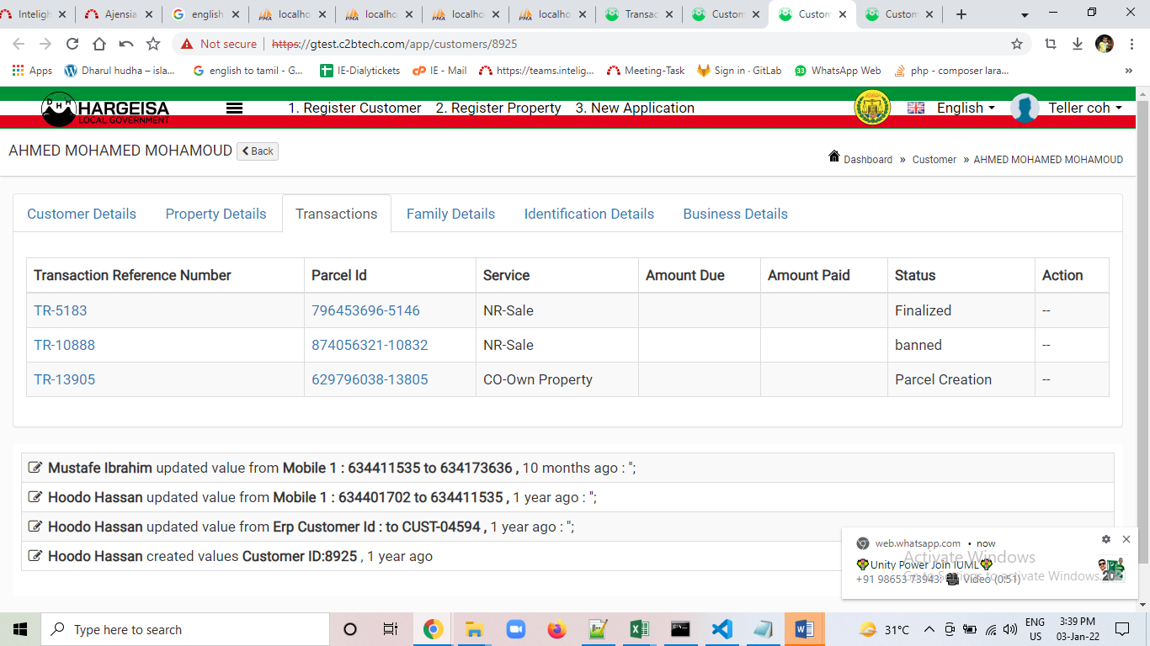

Buyer Screen

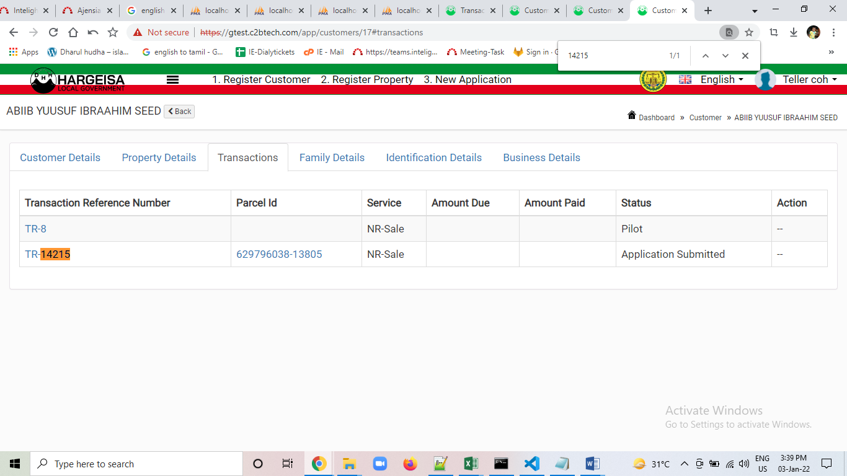

**TR-14216**

Step1:

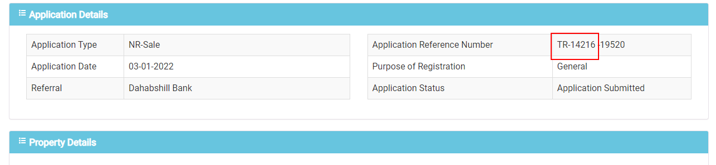

Step2:

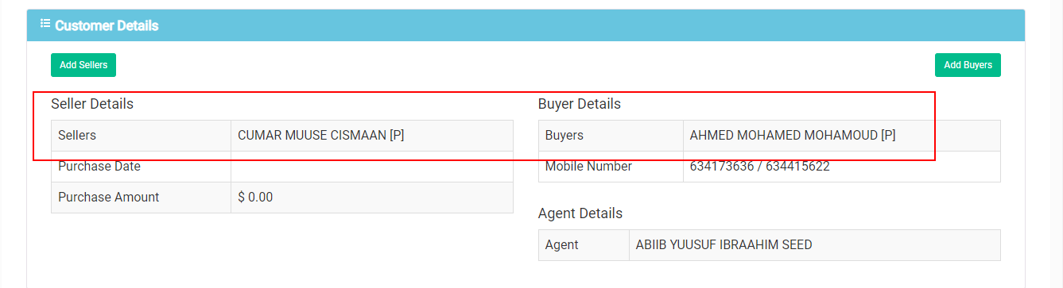

Seller screen

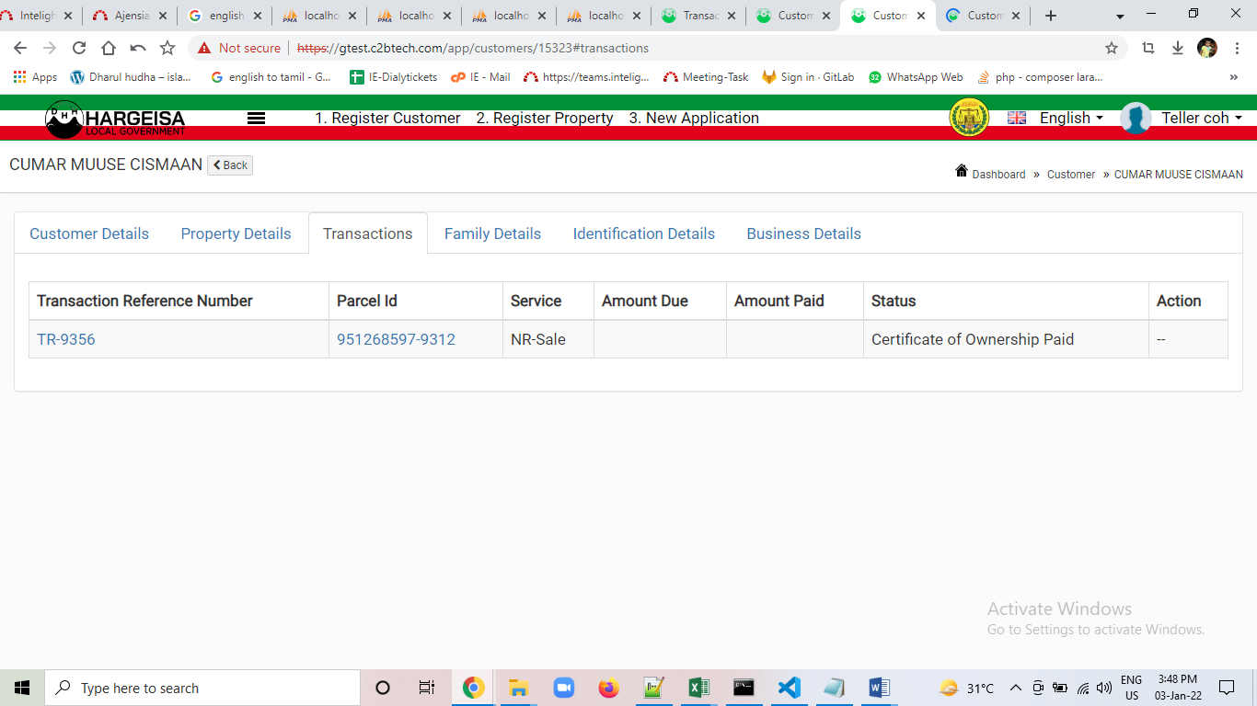

Buyer screen

