URL: <https://gtest.c2btech.com>

System: Test

**Step: 1**

Login the system with Teller user(teller@coh.com) and selected the litigation registration

Page 1: Parties

* Added exciting Plaintiff and Defendant.

Page 2: Property

* Added the Defendant user property in Property page.

Page 3: Litigation

* Selected the Litigation type as “Inheritance”
* Given the Settlement Amount as “0”

Page 4: Summary

The summary page is empty, not showing any above details

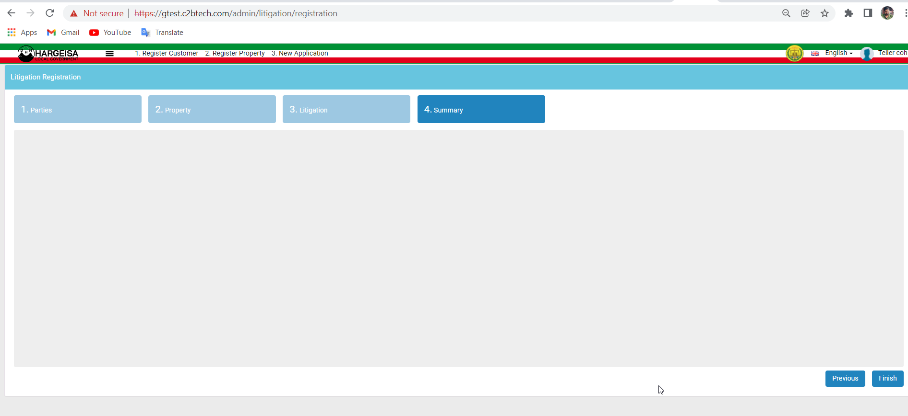

* Submitted the application successfully with Reference Number: TR-14247
* In Documents, added the application form and tried to approve the application

Getting this error: Cannot use object of type stdClass as array

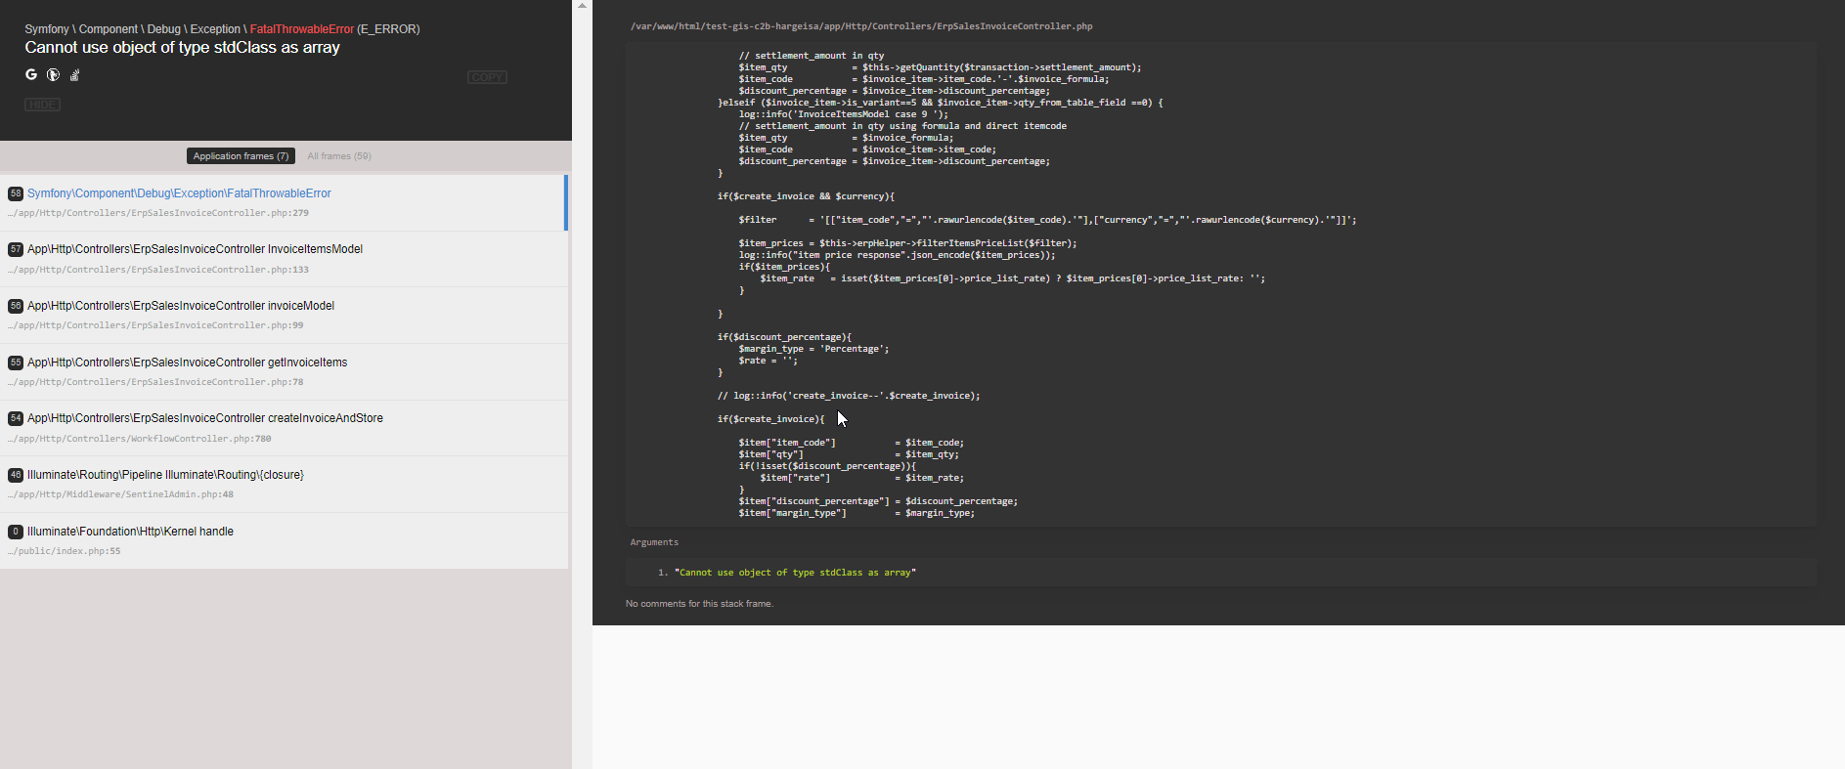

* Invoice is also not created

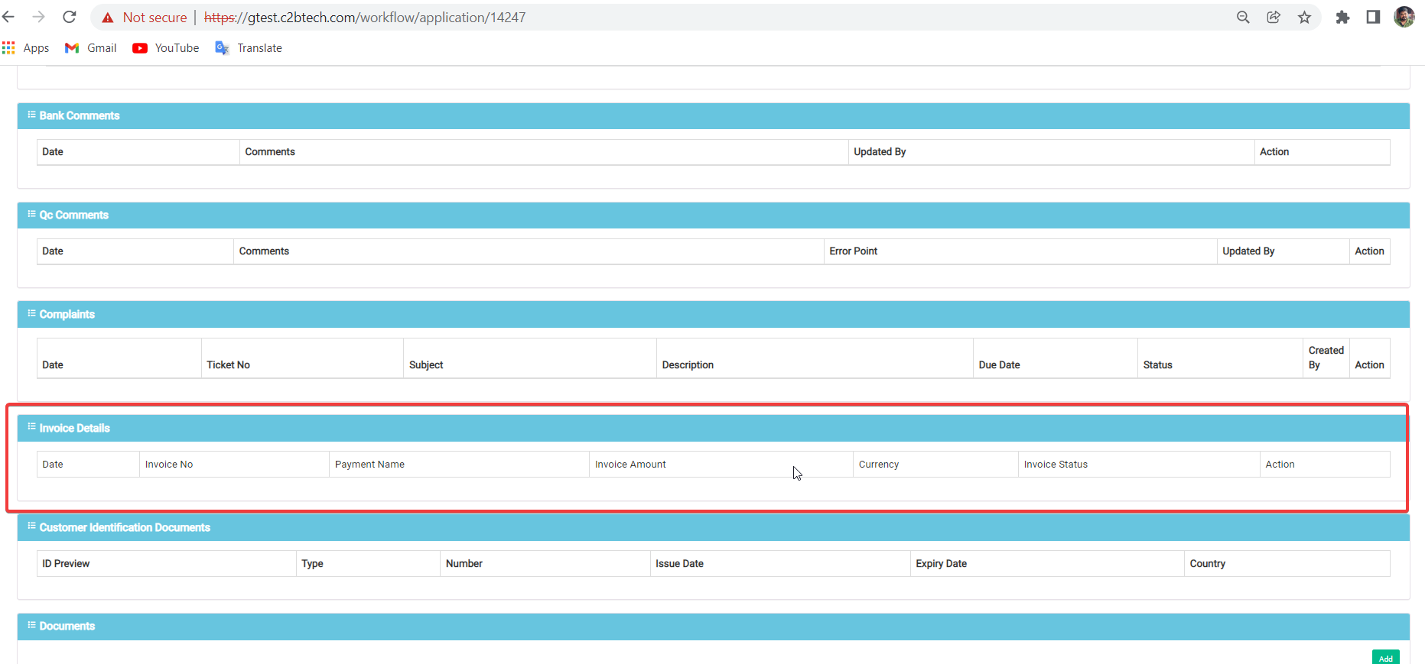

**Step: 2**

Login the system with Admin user(admin@admin.com) and selected the litigation registration

Page 1: Parties

* Added exciting Plaintiff and Defendant.

Page 2: Property

* Added the Defendant user property in Property page.

Page 3: Litigation

* Selected the Litigation type as “Inheritance”
* Given the Settlement Amount as “0”

Page 4: Summary

The summary page is empty, not showing any above details

* Submitted the application successfully with Reference Number: TR-14248
* Without adding the application form in Documents tab, approved the application and moved to payment step.
* In admin login also invoice not generated.

Log in as payment user([paymentcollector@coh.com](mailto:paymentcollector@coh.com))

* In My Worksheet, selected the TR- 14248 and tried to do the payment.
* When we click on Pay getting USD Invoice Not Found error

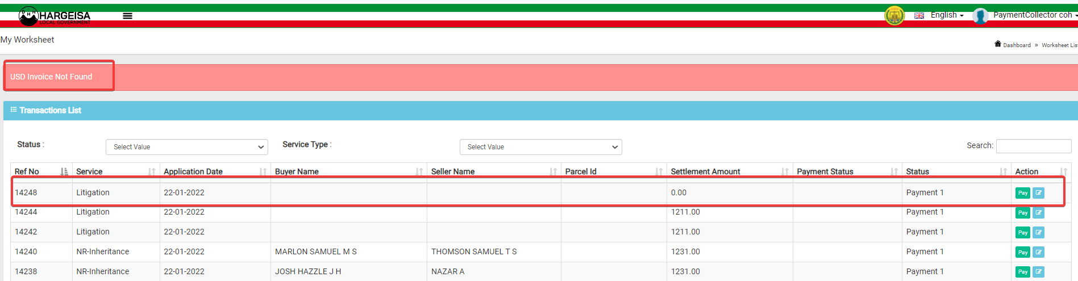

**Step: 3**

Skipped the Payment 1 step and moved to next steps and moved to Court officer

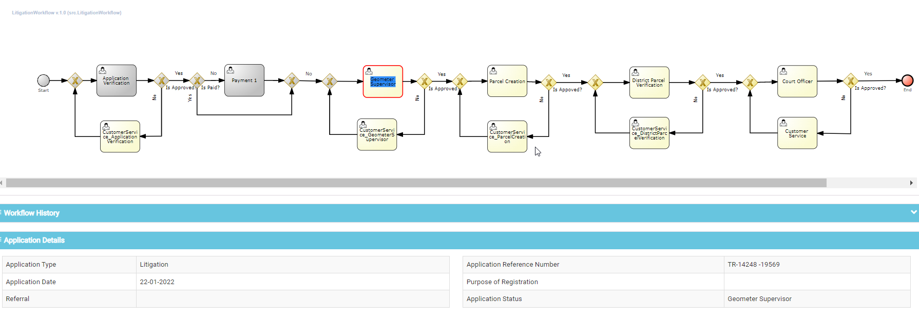

Now for the remaining steps we can able to approve the application with respective users.

**Step: 4**

Login the system with Court Teller user(courtteller@coh.com) and selected the litigation registration

Page 1: Parties

* Added exciting Plaintiff and Defendant.

Page 2: Property

* Added the Defendant user property in Property page.

Page 3: Litigation

* Selected the Litigation type as “Inheritance”
* Given the Settlement Amount as “0”

Page 4: Summary

The summary page is empty, not showing any above details

* Submitted the application successfully with Reference Number: TR-14249
* After submitting the application unable to claim and move to next step.

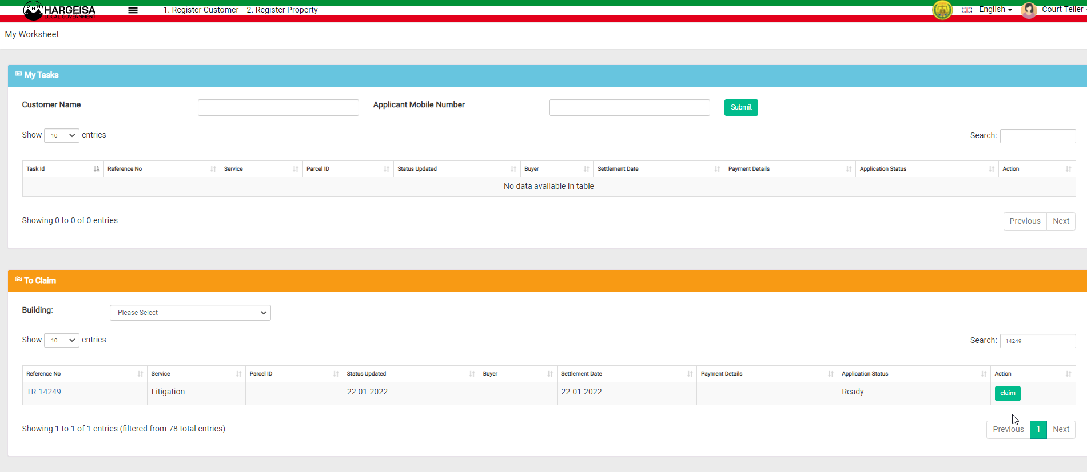

**Step: 5**

Login the system with Litigation teller user(litigationteller.com) and selected the litigation registration

Page 1: Parties

* Added exciting Plaintiff and Defendant.

Page 2: Property

* Added the Defendant user property in Property page.

Page 3: Litigation

* Selected the Litigation type as “Inheritance”
* Given the Settlement Amount as “0”

Page 4: Summary

The summary page is empty, not showing any above details

* Submitted the application successfully with Reference Number: TR-14250
* Without adding the application form in Documents tab, approved the application and moved to payment step.
* The invoice not generated.

Log in as payment user([paymentcollector@coh.com](mailto:paymentcollector@coh.com))

* In My Worksheet, selected the TR- 14250 and tried to do the payment.
* When we click on Pay getting USD Invoice Not Found error