1. Create new reason type called – Address

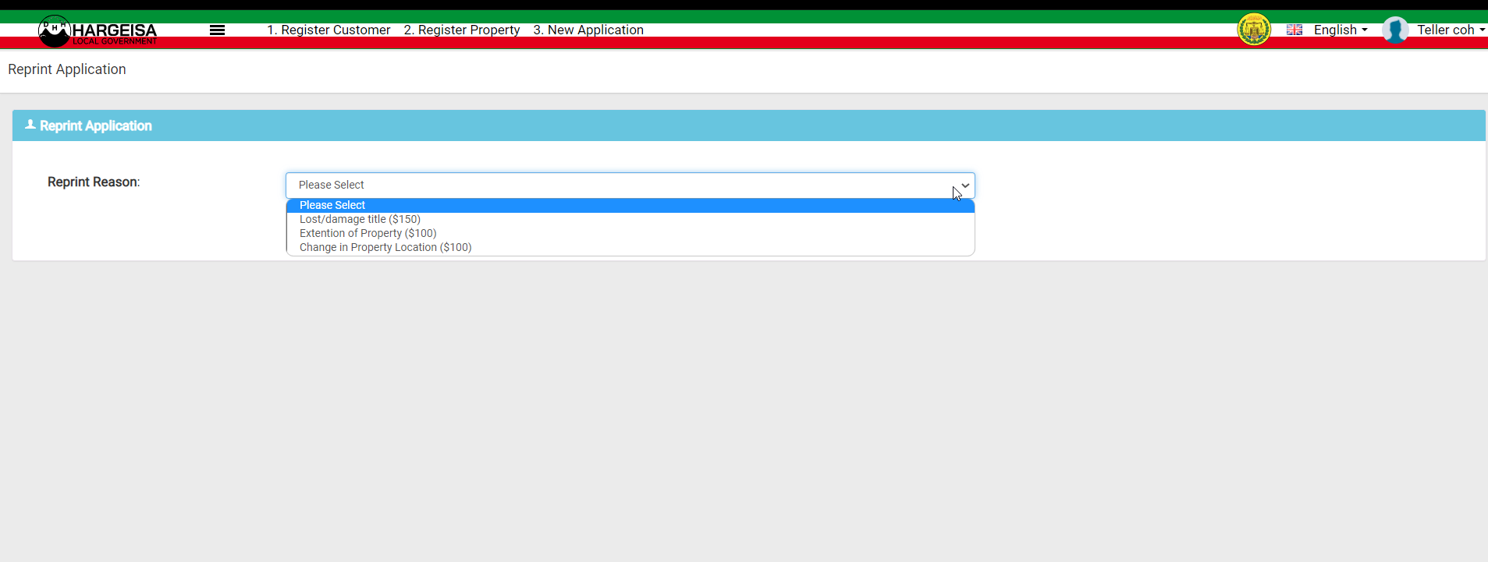

Comments: What to the Address in this dropdown?

1. Create an new field in transaction table called related_transaction_id

Comments: Okay.

1. When a user selects reason type as Address .. then the screen should show a text field and ask the user to enter the transaction Id

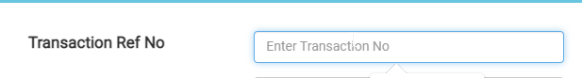

Comments: Okay

1. The entered transaction ID should validated - only transaction Id of service type called AddressIssuance is allowed to enter. This new service type called AddressIssuance is not in the system, it need to be added.

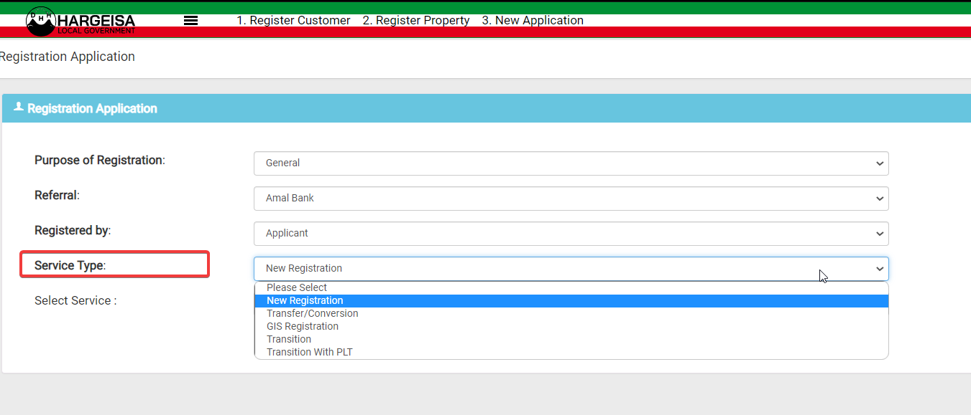

Comments: Need to add here? Also need more clarification on it.