**SHAHAADADA LAHAANSHAHA DHULKA BANNAAN**

**LAND CERTIFICATE**

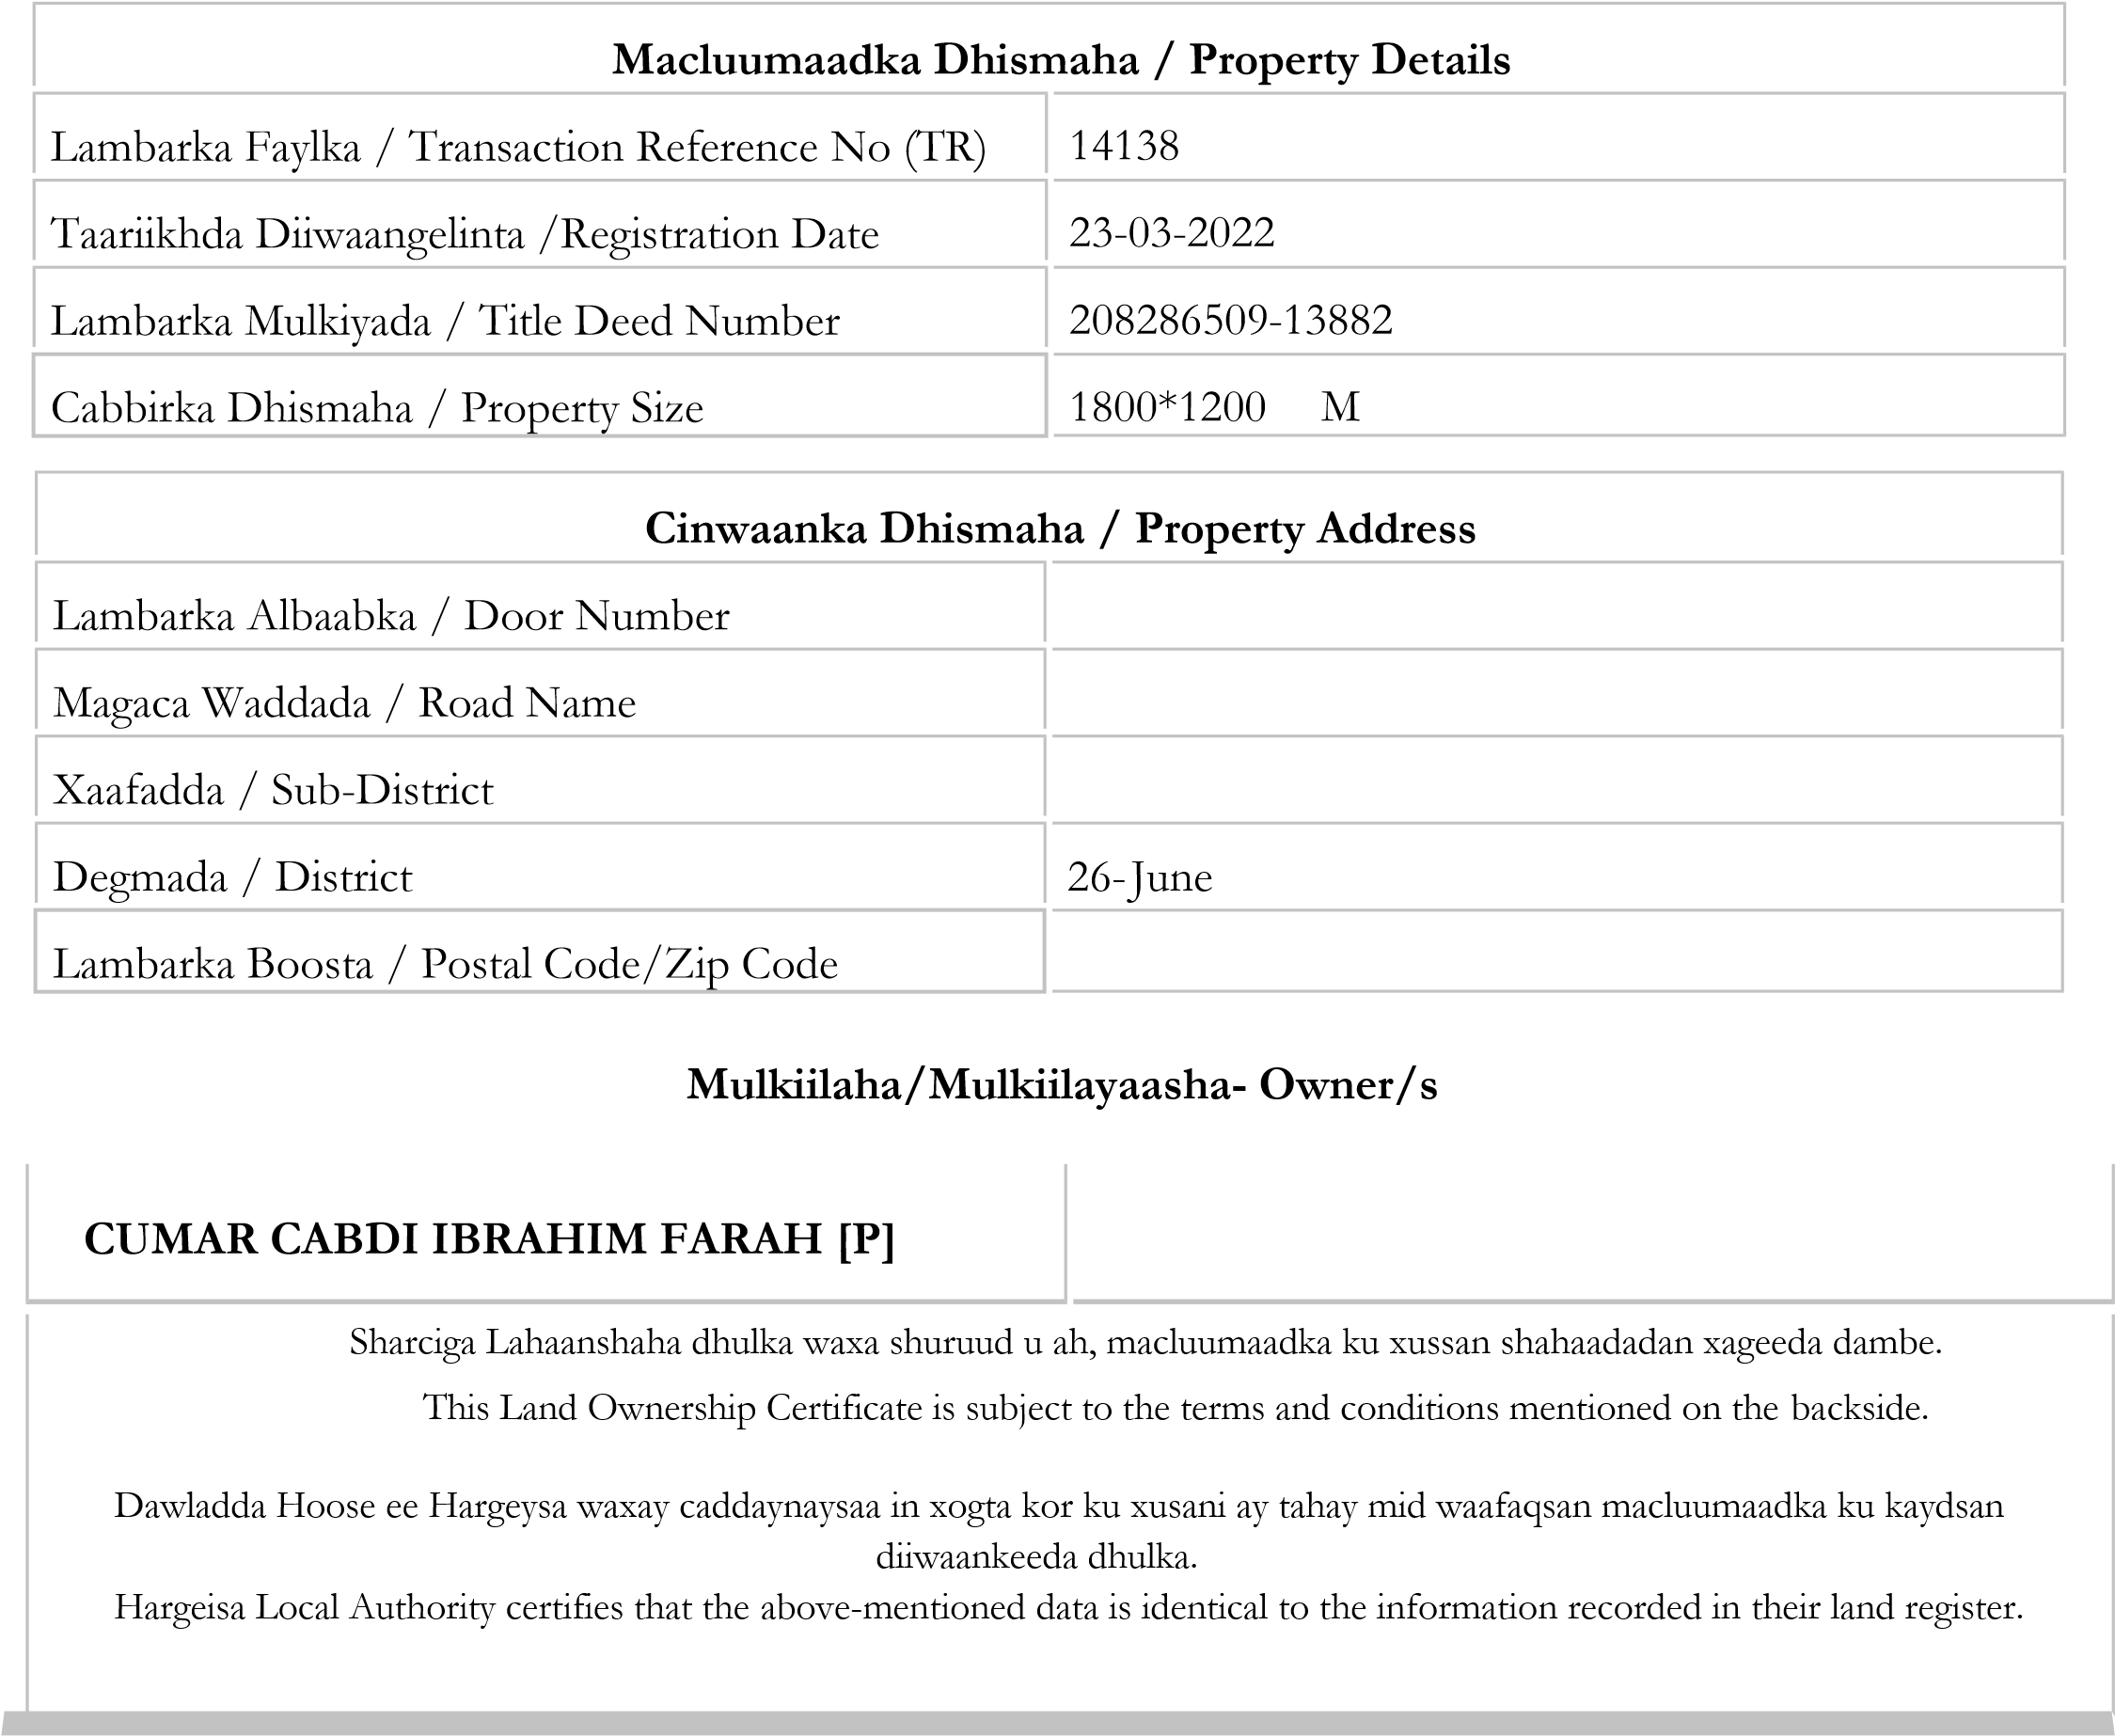

Shahaadda dhulka waxa shuruud u ah, macluumaadka ku xussan shahaadadan xageeda dambe.

This Land Certificate is subject to the terms and conditions mentioned on the back side.

Dawladda Hoose ee Hargeysa waxay caddaynaysaa in xogta kor ku xusani ay tahay mid waafaqsan macluumaadka ku kaydsan diiwaankeeda dhulka.

Hargeisa Local Authority certifies that the above mentioned data is identical with the information recorded in their land register.

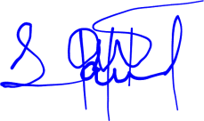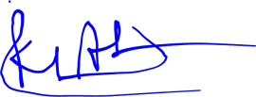

**Siciid Nuur JaamacKhadar Axmed Cumar**



**Xoghayaha Fulinta/Executive Secretary-Xigeenka Duqa Caasimadda/Deputy Mayor**

**Cabdikarim Axmed Mooge**

**Duqa Caasimadda/Mayor of Hargeisa**

**Shuruudaha:**

Eebe ka sakow, guud ahaan dhulka Jamhuuriyadda Somaliland waxa leh Dawladda Somaliland (sida uu tilmaamayo qodobka 12aad, farqadiisa 1aad ee Dastuurku). Hadaba waxa shuruud u ah hantidan dhammaan, xaaladaha, xuquuqda iyo waajibaadka ku xusan dastuurka iyo xeerka maamulka dhulka magaalooyinka. Xeer Lr.17/2001. Sidaa darteed:

* Waa in aad bixisaa dhamaan cashuuraha jira iyo kuwa jiri doona mudada iyo habka loo dajiyo.

* Waa in aad goobta u isticmaasho ujeedada lagu diiwaangeliyey oo kaliya, waxna aan laga doorin dhismaha laga taagay iyada oo aan ogglaansho qoraal ah laga haysan Dawladda Hoose ee Hargeysa.

Shahaaddani waa mid aan ansax ahayn hadii ay soo gaadho waxyeello, xoqitaan ama aad tirtirto wixii macluumaad ah ee xogteeda ah amaba aad ku darto xog kale.

* Dhulka aan ku jirin diiwaanka dhulka ee Dawalada Hoose Hargeysa waxa loo aqoonsanayaa mid sharci darro ah.

**Terms and Conditions:**

Apart from Allah, the entire land of the Republic of Somaliland is owned by the Government of Somaliland (as stipulated in Article 12, Clause 1 of the constitution). Then what is required for this property all, the conditions, rights and obligations set out in the constitution and the urban land administration law. Law No. 17/2001. Therefore:

* You must pay all existing and future taxes following designated procedures.

* You must only use the land for the purpose for which it was registered, without the written permission of the Hargeisa Local Government.

* This Land Certificate shall be invalid in case of damage, erasing or scrapping any statement of its data or adding other data to it.

* The Land Certificate not registered in the land Registry of Hargeisa Local Government considers void.

**Goobta Dhulka:**

Shahaadaddani waxa ku lifaaqan nuqulka nashqadda ee dhulka iyo qorshah. Shahaadaddani waxay koobsanaysaa dhamaan xaqiiqooyinka dhulka, lamana ogola in la daabaco ama nuqul kale laga sameeyo. Ciddii lagu helo falkaas waxa lala tiigsan doonaa sharciga.

**Land Location:**

Enclosed to this land certificate is a copy of the block blueprint and land map. This land certificate contains all facts of the land and may not be reproduced or duplicated. Anyone found guilty of forging and defrauding will be prosecuted.