**Feature Update in the DHH Portal**

1. **Change Primary Seller/Buyer**

We have bug in this process. We want to change primary for any one below we will click change button.

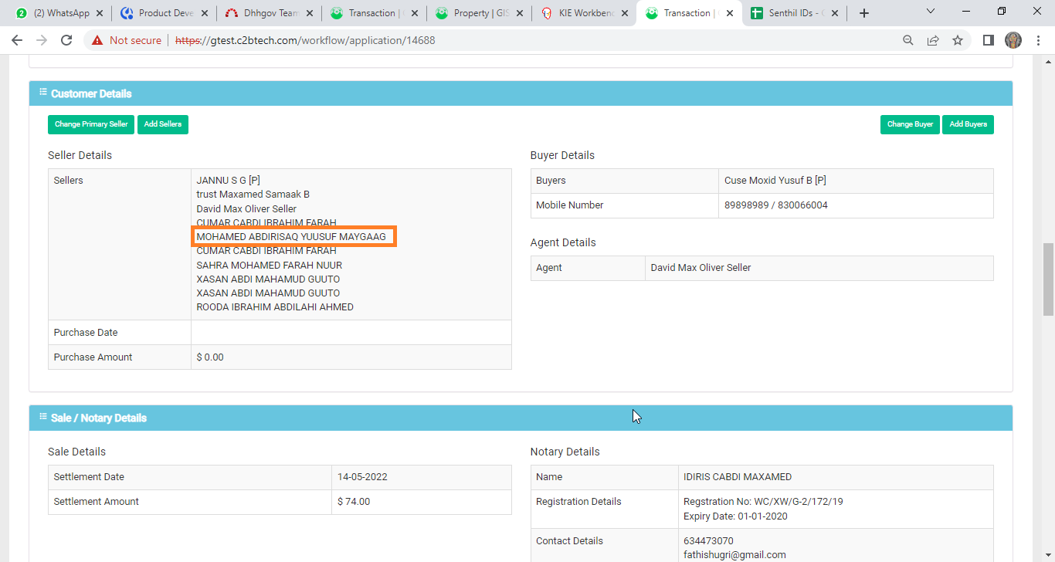

The screen will show below. Here click select Customer button.

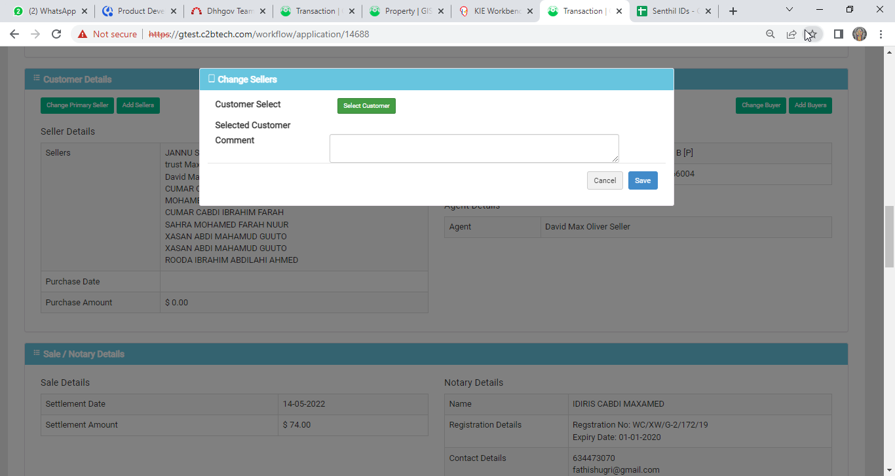

This screen is a bug because it will show only the list of seller/buyer in the TR but it shown list of all customers.

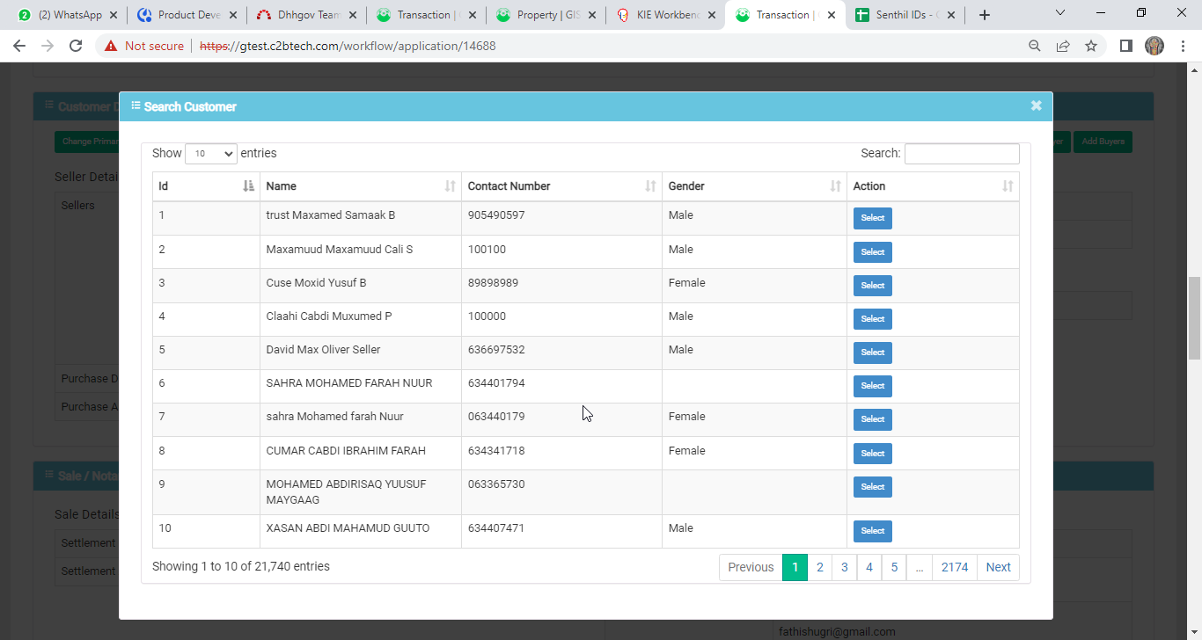

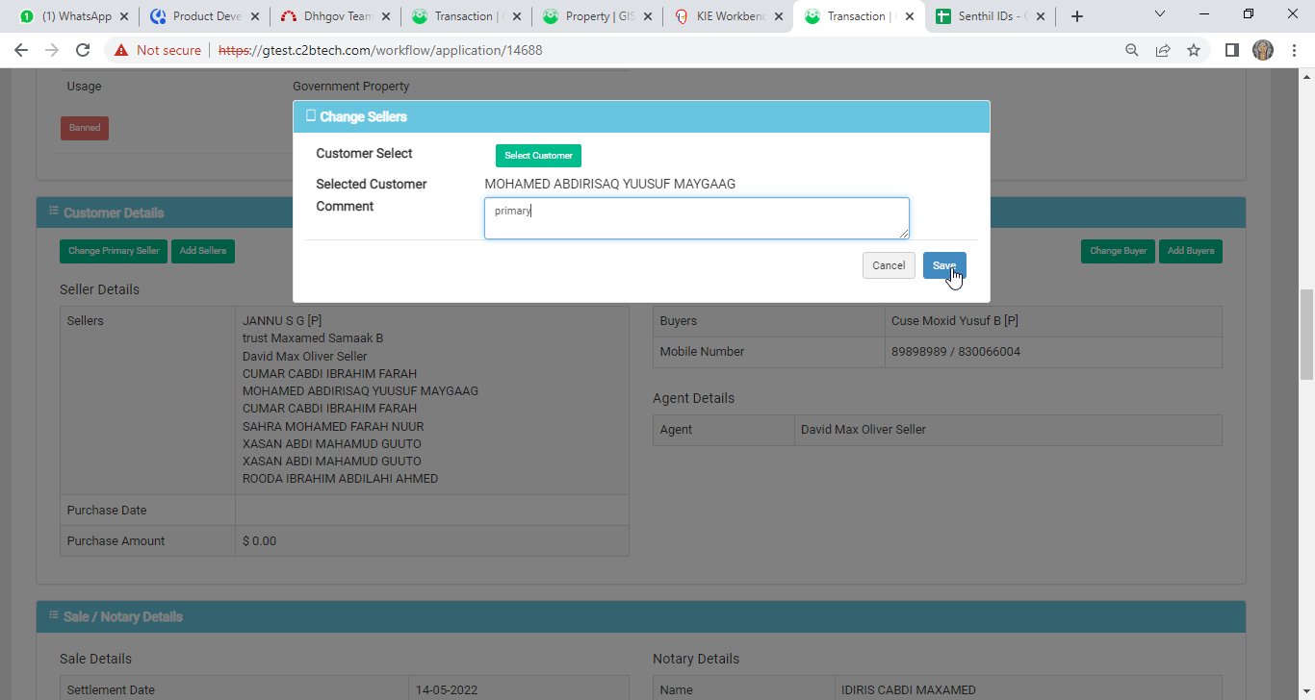

It’s wrong here. If I select primary customer here its make duplicate customer with primary (P) and existing primary customer was deleted in the list.

**Before Change Primary**



**After change primary**

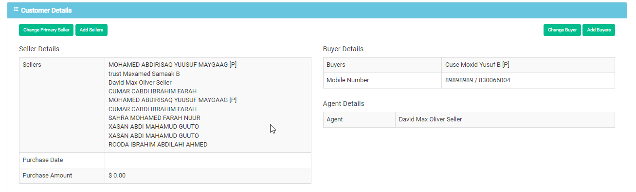

**Solution**

We will update existing customers only. so the list will display the TR customers list only. The popup will show with option button they select and change primary.

Example:

