Locations to be masked

1. Location-1: 9.5645077, 44.0463101

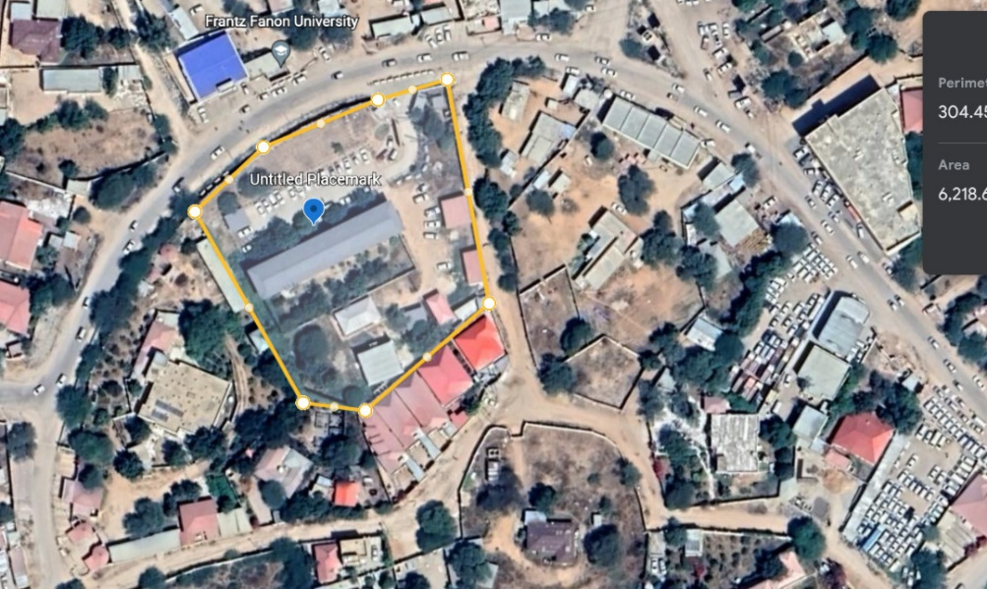

1. Loaction-2: 9.559529, 44.0524492

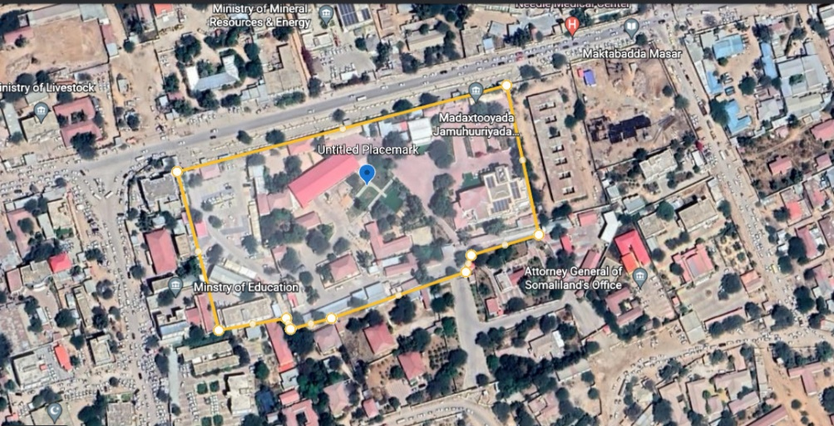

1. Location-3: 9.5452791, 44.0402772

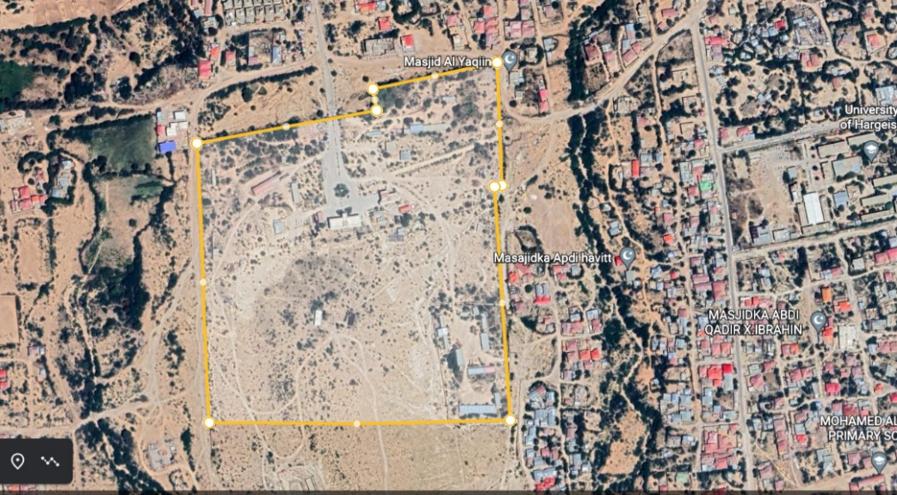

1. Location-4: 9.5538314, 44.051907

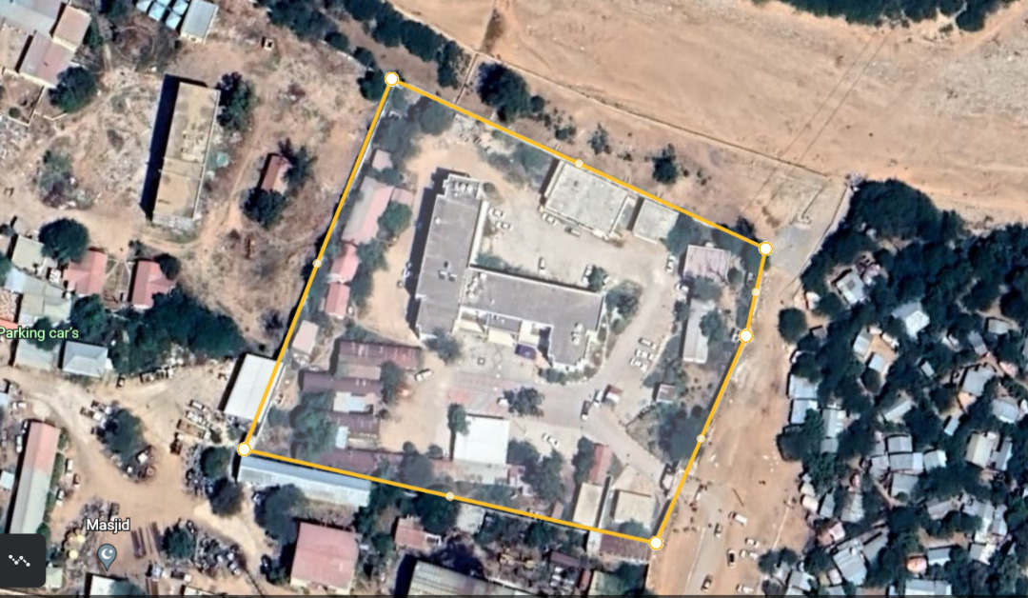

1. Location-5: 9.5535972 44.0477841

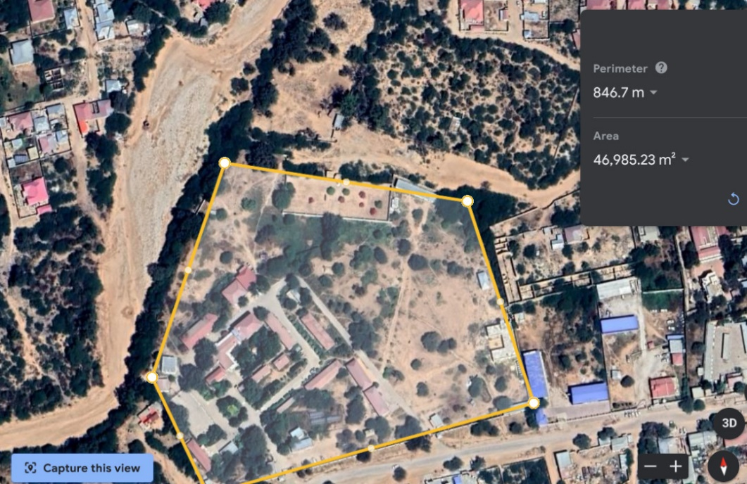

1. Location-6: 9.5512103 44.0580335

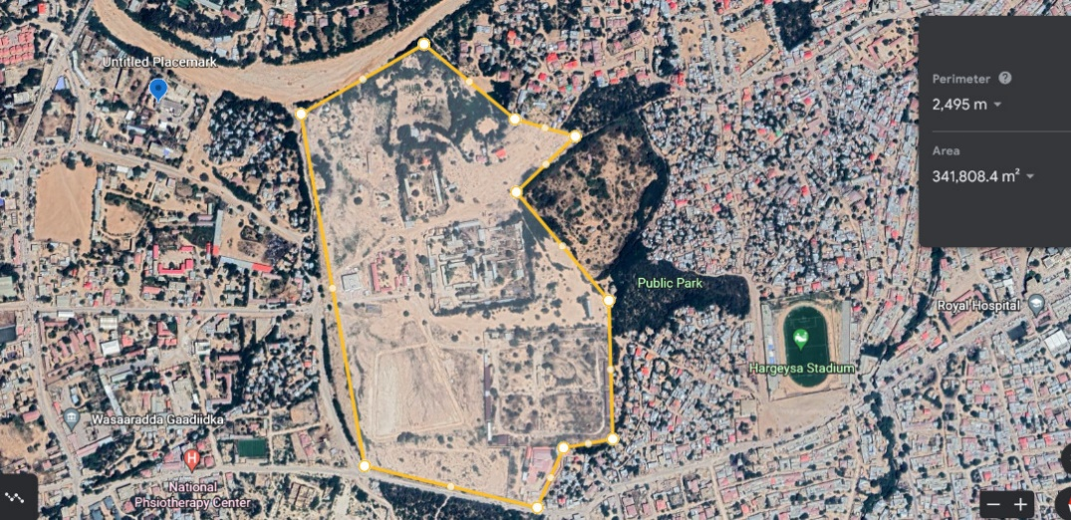

1. Location-7: 9.5648597 44.0641157

