**REQUIREMENTS FOR LOGO AND FONT CHANGE**

1. Logo change should affect all areas which include all document and all title certificates.
2. The above logo should reflect in all document, title certificates, login page and left side of Dashboard.

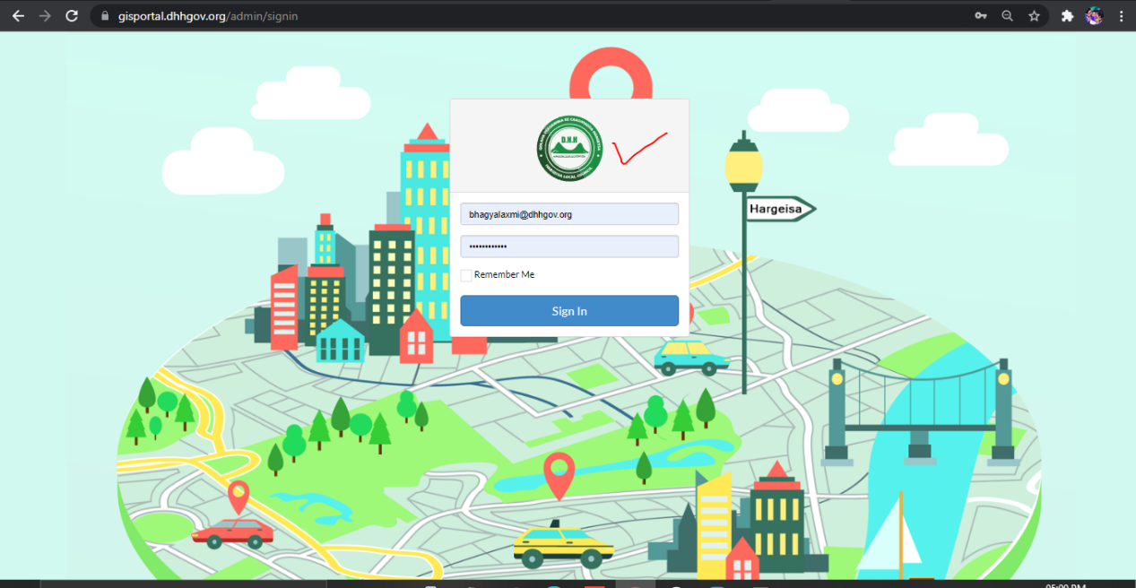  
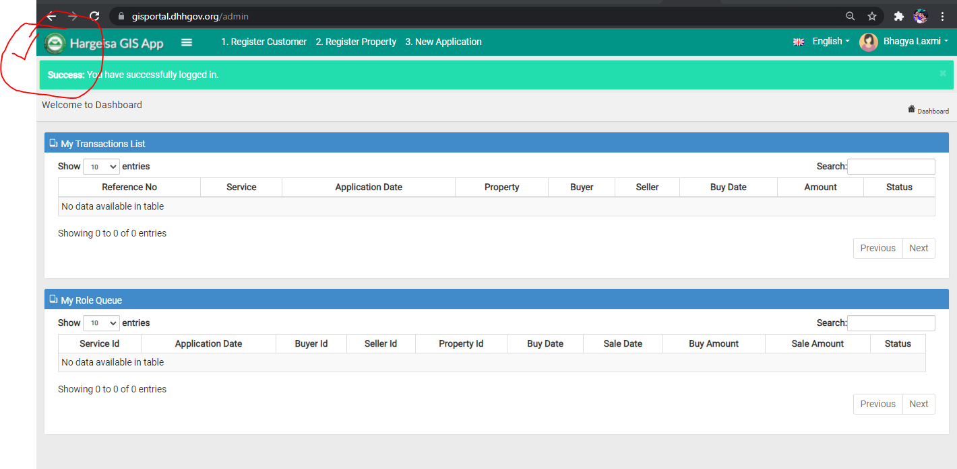  
3>Adding Emblem of somaliland logo newly before to english language menu

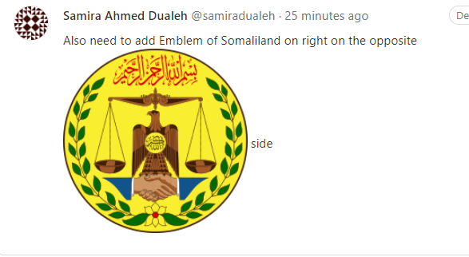

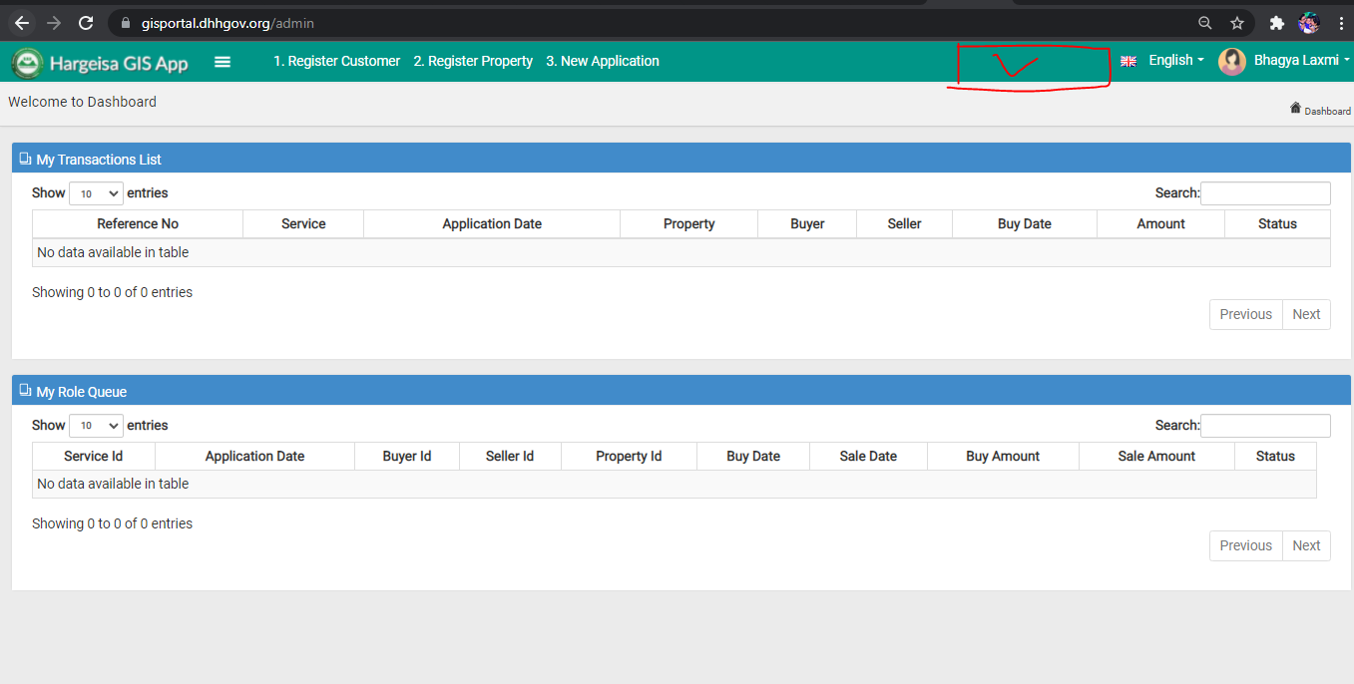

4>pattern of header color should be like green/white/red

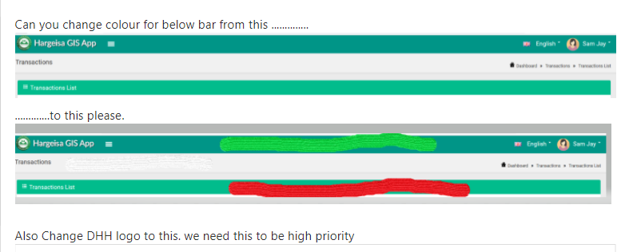

This pattern of header color should be every where inside portal.. this should be maintained.