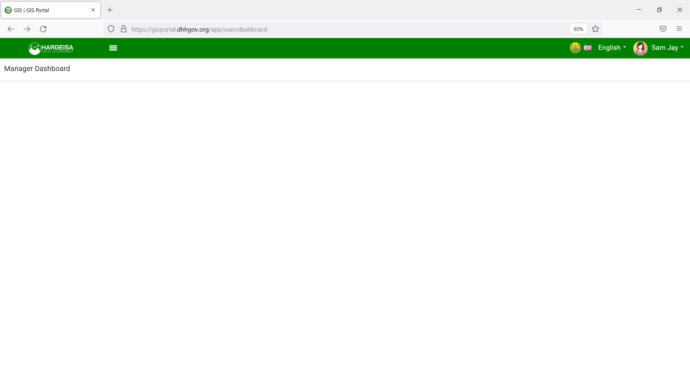

1. We need only this strip/tab to have the colours – Green/Whit/Red
2. Remove all other colours from subheading in the portal
3. Make this logo bit bigger.