Lien Report:

1) Department Queue Report

- Only one District is mentioned out of seven district

- Need more filter to test report

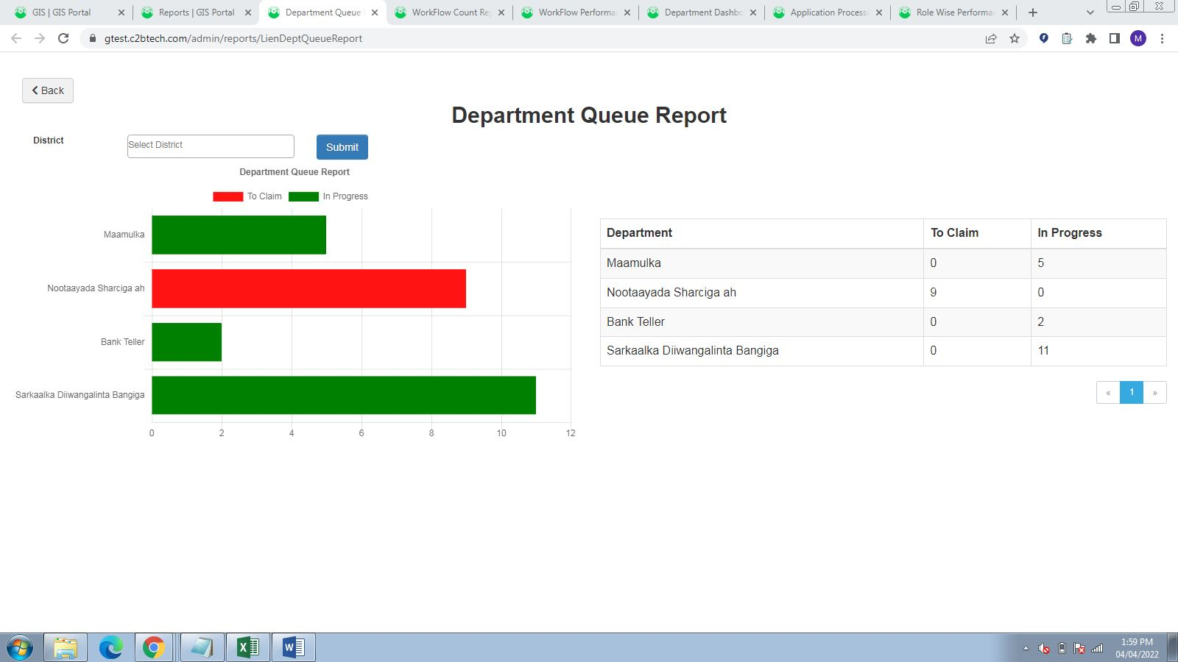

2. Workflow Count Report

Report Working fine

3. Wokflow Performance Report

Data Shown is wrong , Need more Data to Test

Need more Filters to test the Report

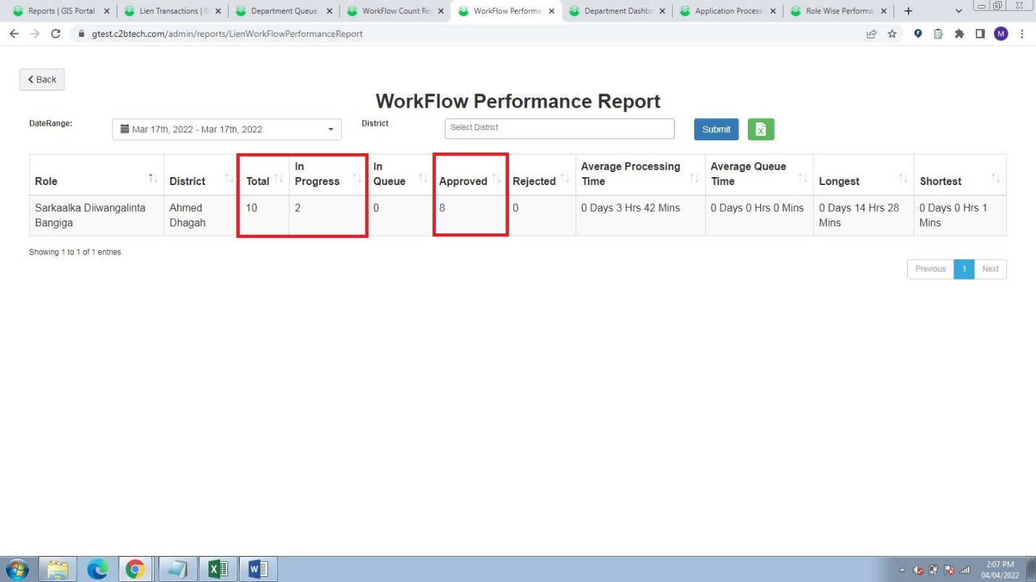 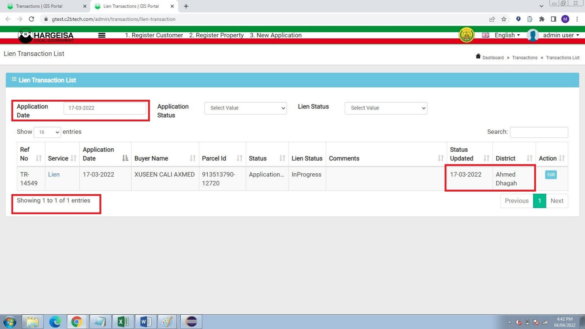

4. Department Dashboard

Working fine

5. Application Processing Time Comparison

Data is shown wrong , one Application is already processed for that date

It is showing no data

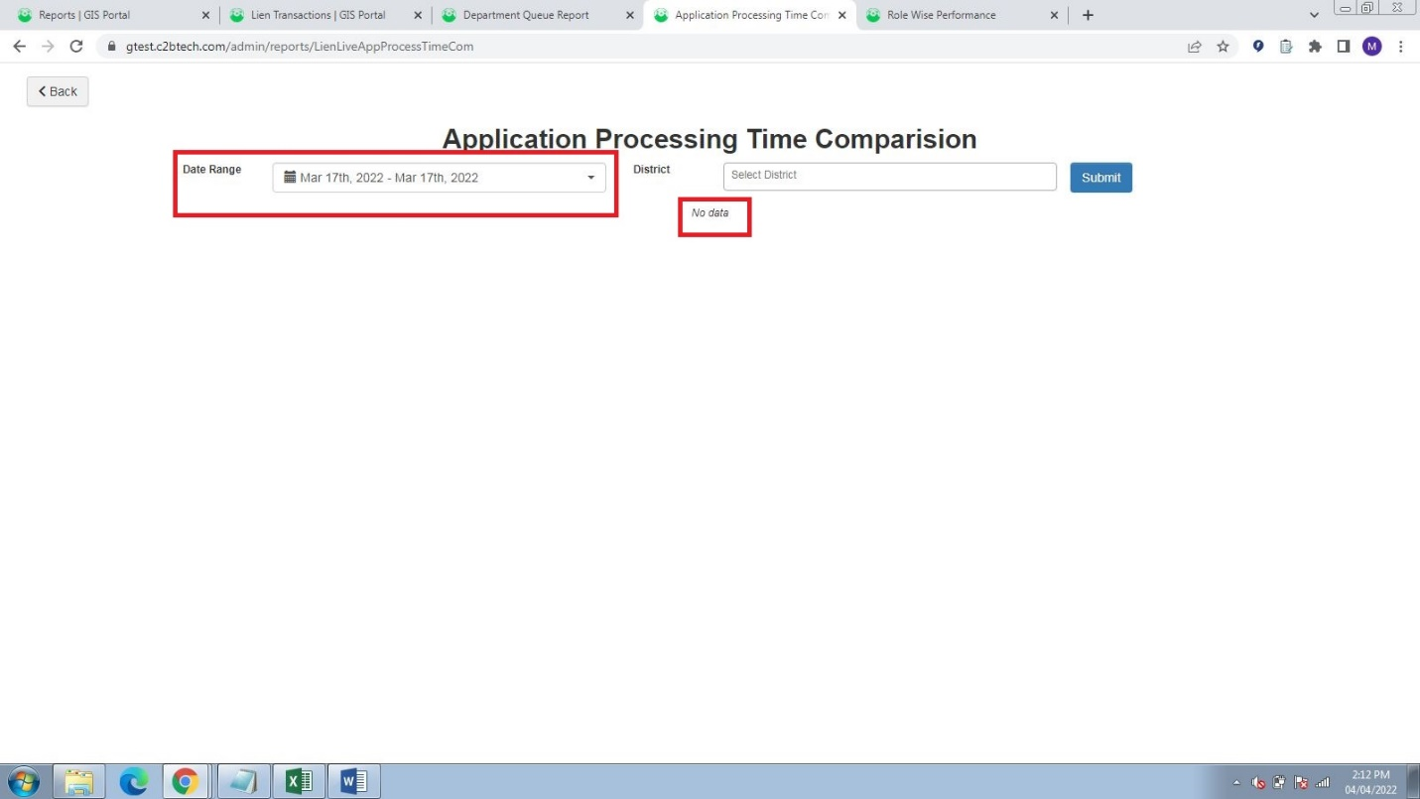 

6. Role Wise Performance

Working Fine

Litigation Report:

1. Dashboard

The Total Applications(District Wise) Data is showing wrong

Need more Filters to test data

Only 1 Application is processed but 4 Applications are showing.

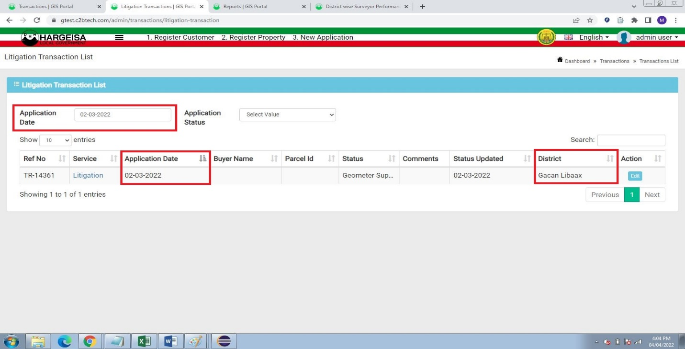

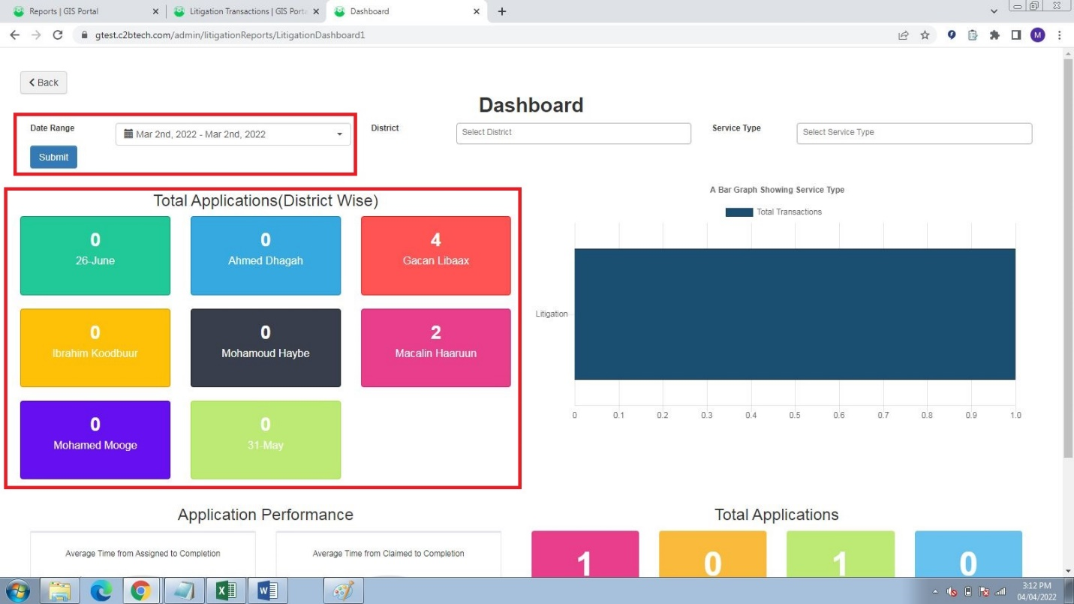

2. Role Wise Performance – Working Fine

3. District Wise Surveyor Performance

Few Roles in Role Section are invalid

Default District is selected

Data Shown is wrong , Application is processed for 2nd Date but showing as 0 in District column

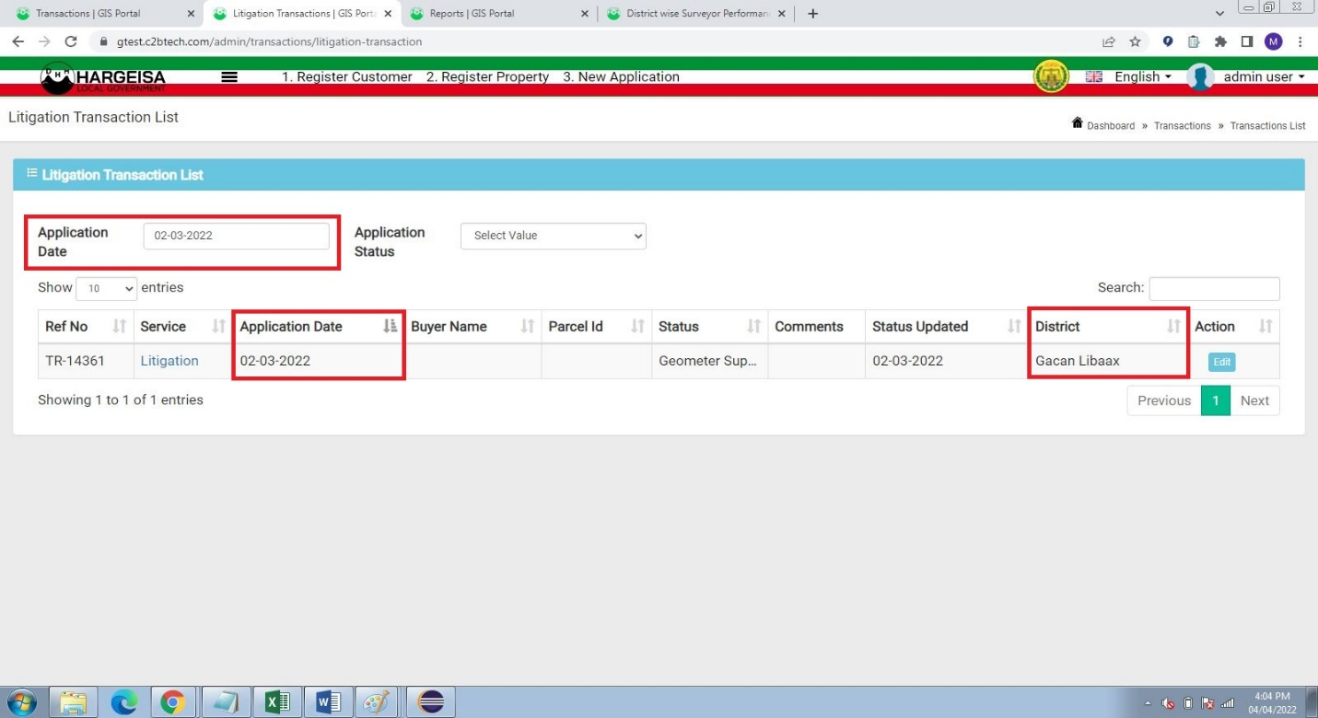

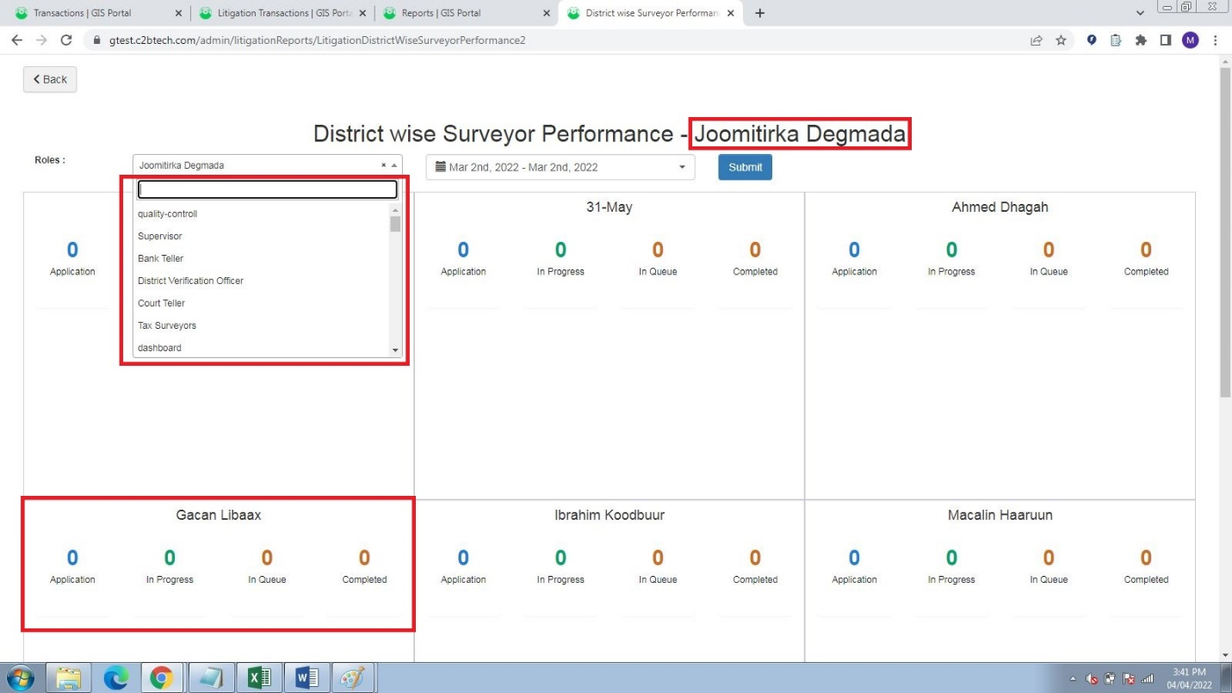

4. Dist Wise Dept Performance

Few Roles in Role Section are invalid

Default District is selected

Data Shown is wrong , Application is processed for 2nd Date but showing as 0 in District column 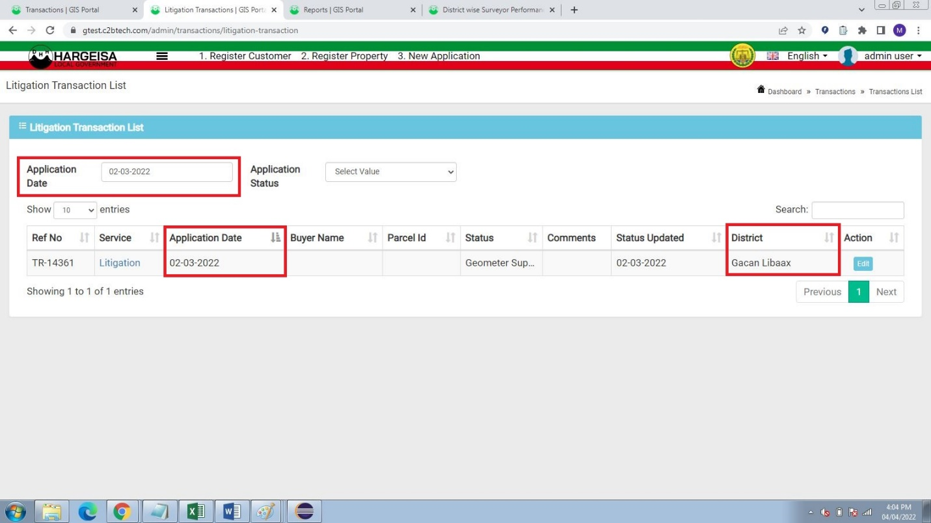 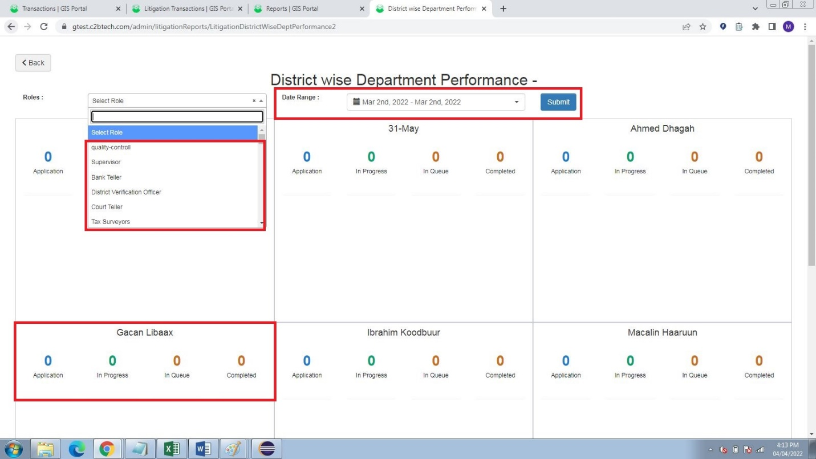

5. Financial Performance

Not having idea from where data is shown

6. Application Processing Time Comparison

Data is shown wrong , one Application is already processed for that date

It is showing no data

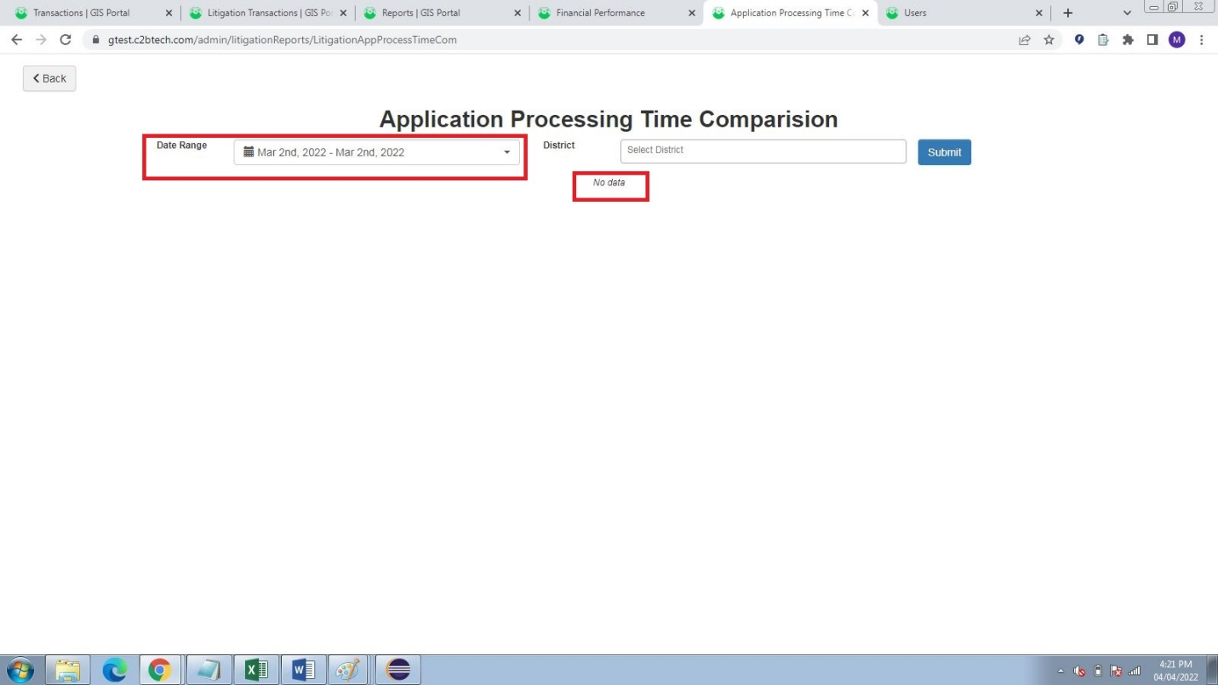

7. Application Received & Completed Comparison

Need more Filters to test data

Suggestion:

Please Add Custom Range Filter in Lien Transactions List Page

Please Add more Filter to test data