Details
Portal Name: Hargeisa (https://gisportal.dhhgov.org)
Change Request #: 2175 | Date of Request: 18-06-22
Requested By: Kannan thanikasalam
Change Request Description:
Need to change parcel size in the portal as 24x14.5 for TR-26955
Reasons for this Change Request:
Existing parcel size in the portal is 14x23.5 .But survey drawing mentioned size is 24x14.5 .So need to change parcel size in the portal as 24x14.5
Approval Signature(s) and Date(s):
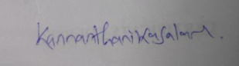Kannan thanikasalam/ 18-06-22

