**PrepaidMeter Activity**

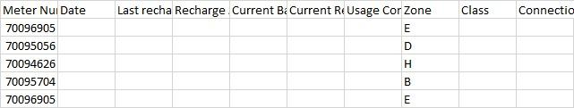

In the prepaid meter we provide the unit of water based on the recharged amount.

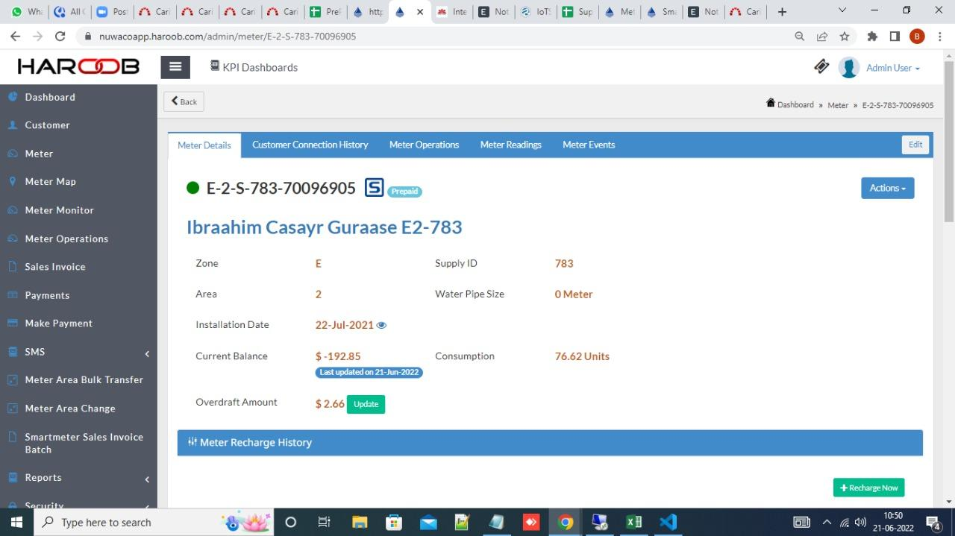

In this above image we can see the **OVERDRAFT AMOUNT AND CURRENT BALANCE** of the meter**.**

And this below image we can and check the

reading date , previous date , current reading and how much units they have consumed till the date , total unitis.

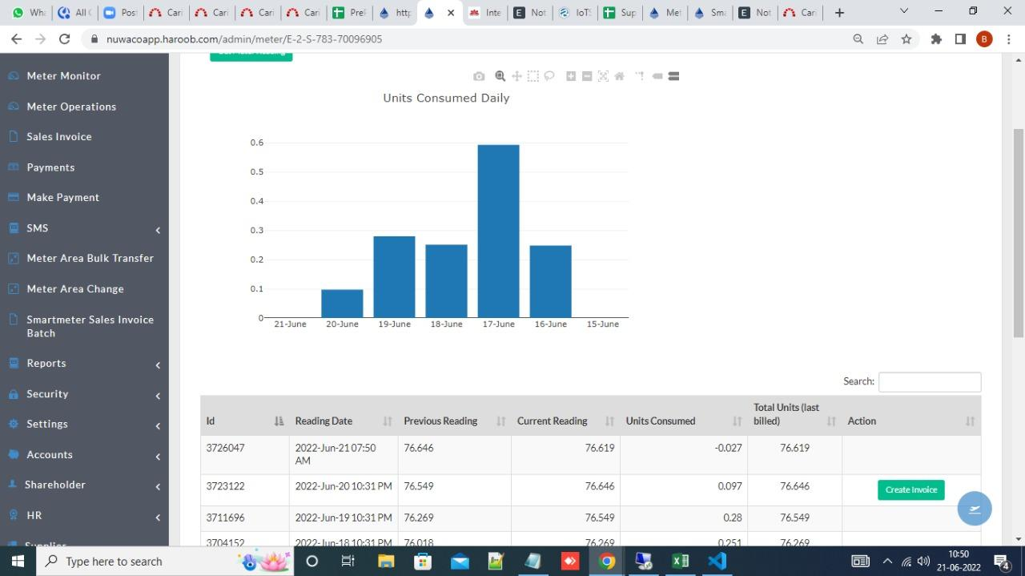

STEP : 1

Select the given meter addres and copy the meter addres and search by query

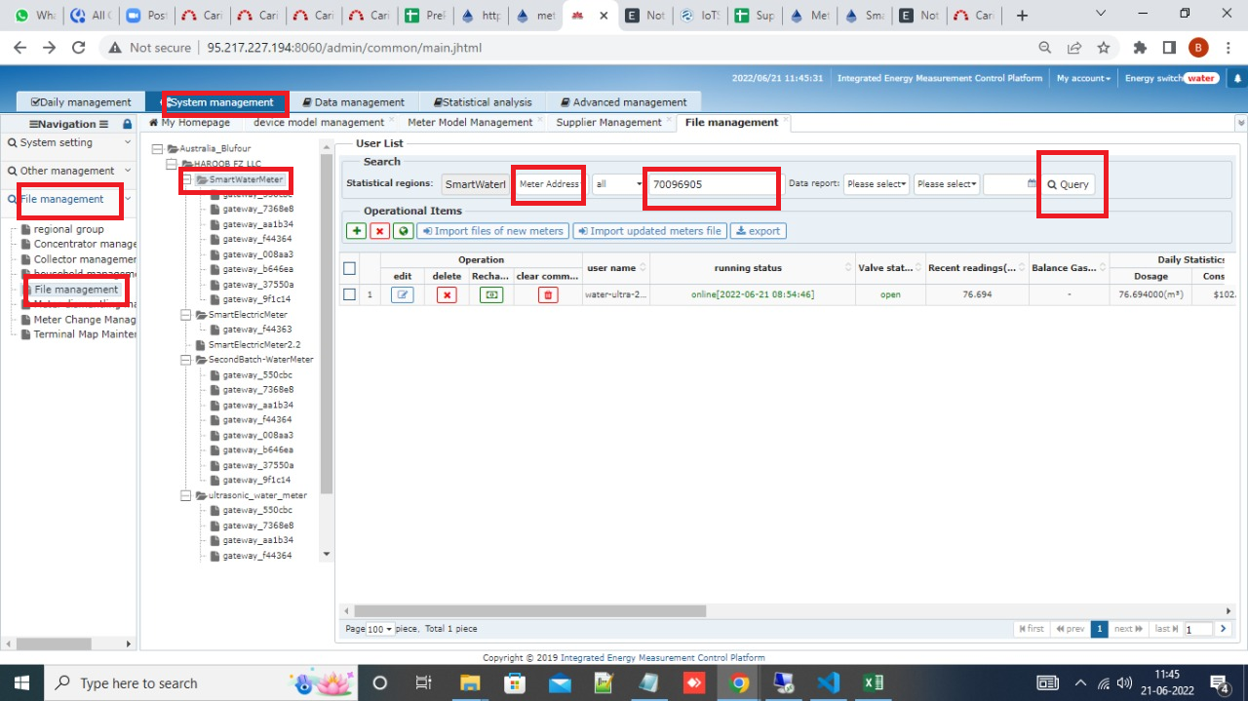

**DAILY METER ACTIVITY**



System management >file management >file management >smart water meter.

STEP : 1

Select the given meter addres and copy the meter addres and search by query

