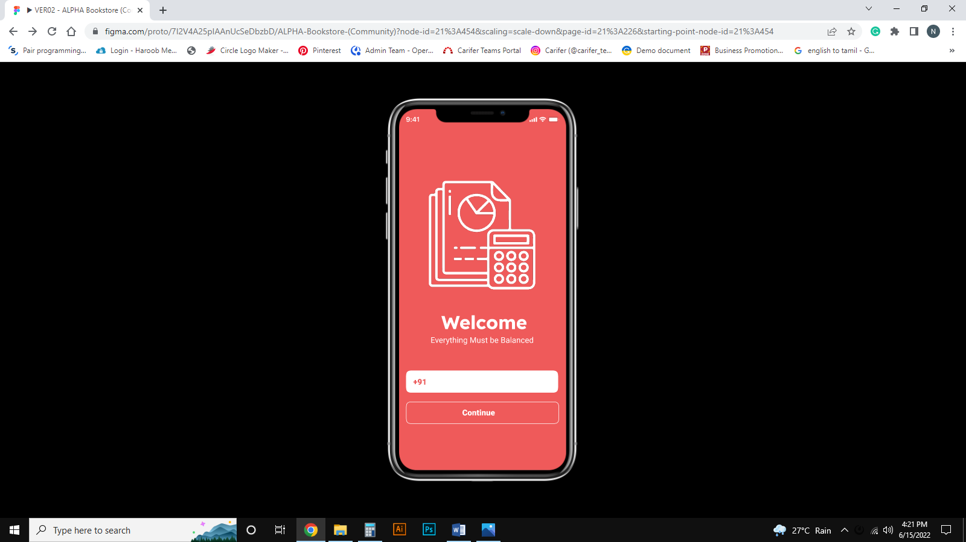
Page 1: Welcome Page – Enter Your Mobile Number and Click Continue Button

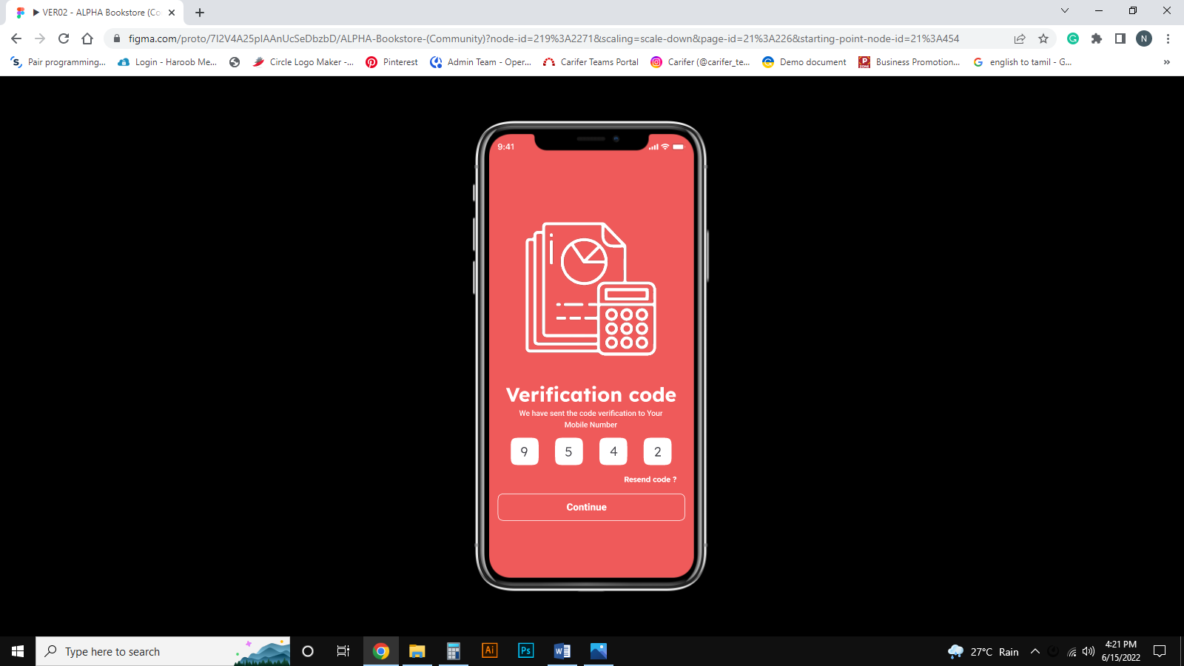
Page 2: Verification Page – Enter Your OTP Number and Click Continue Button

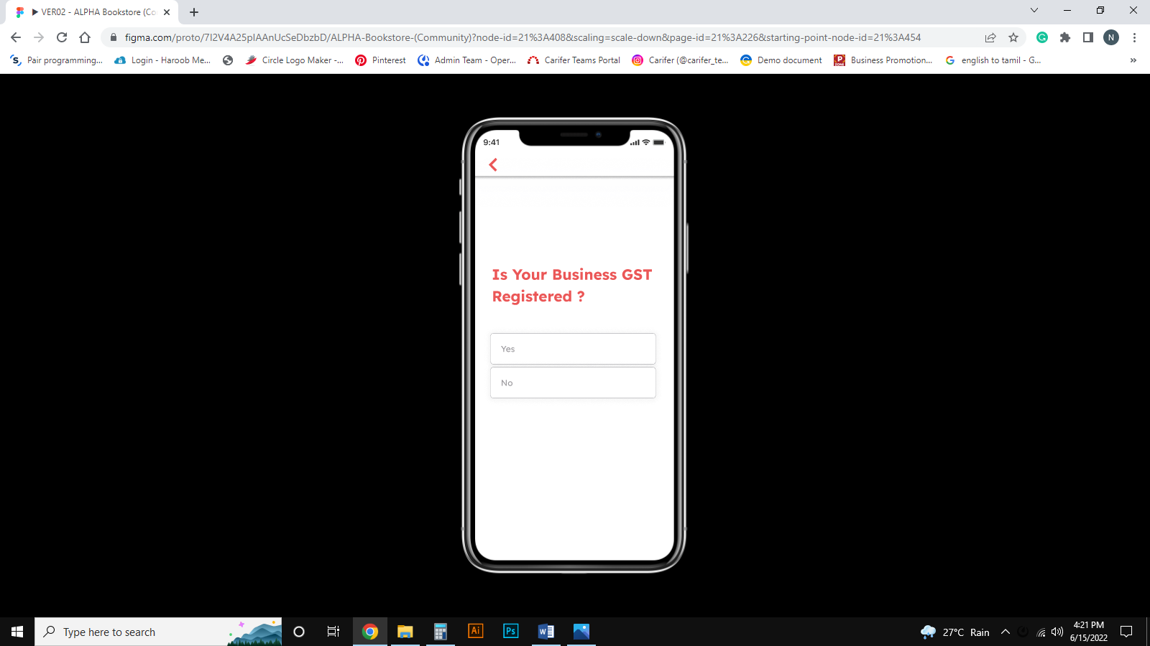
Page 3: Click Yes, If GST Registered. Otherwise Click No

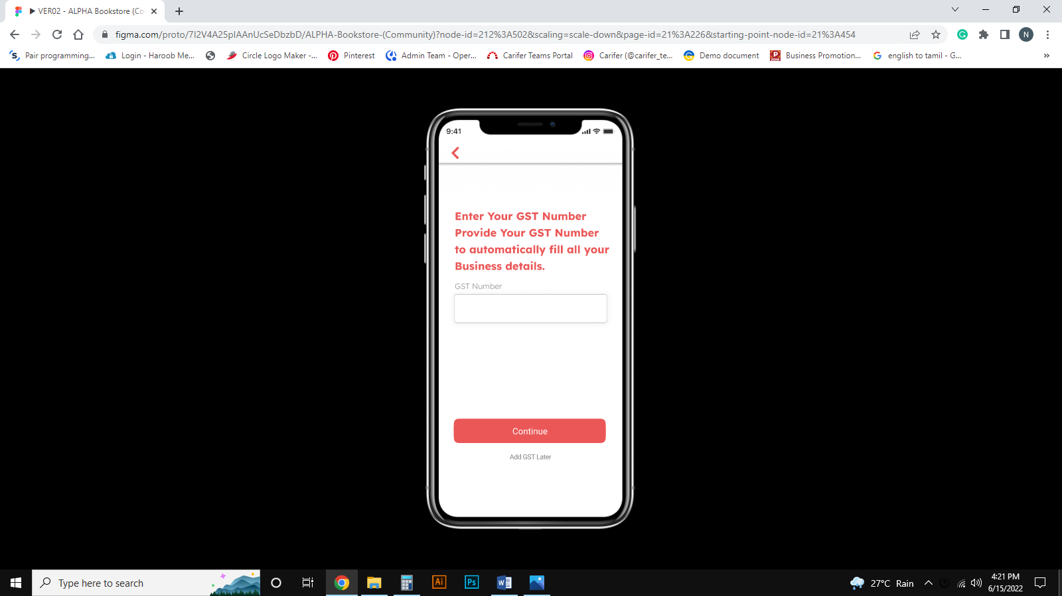
Page 4: IF Yes Means, Enter your GST Number and Click Continue

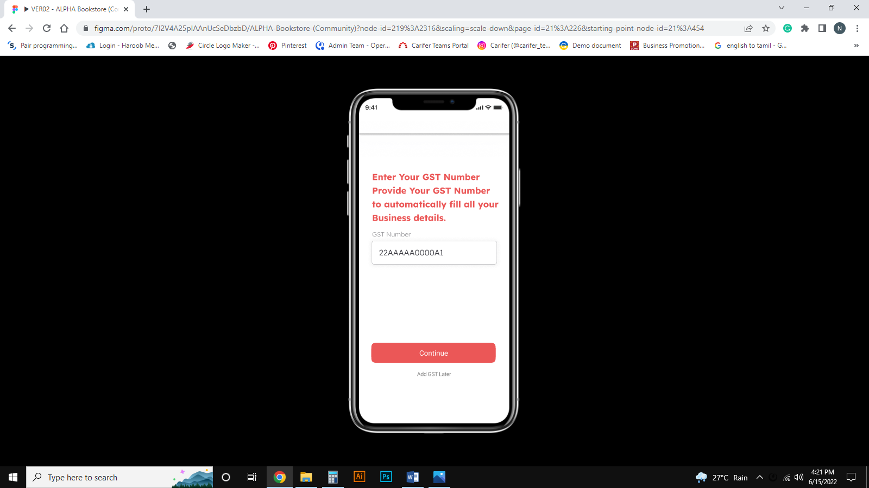
Page 5: Sample GST Number & Click Continue

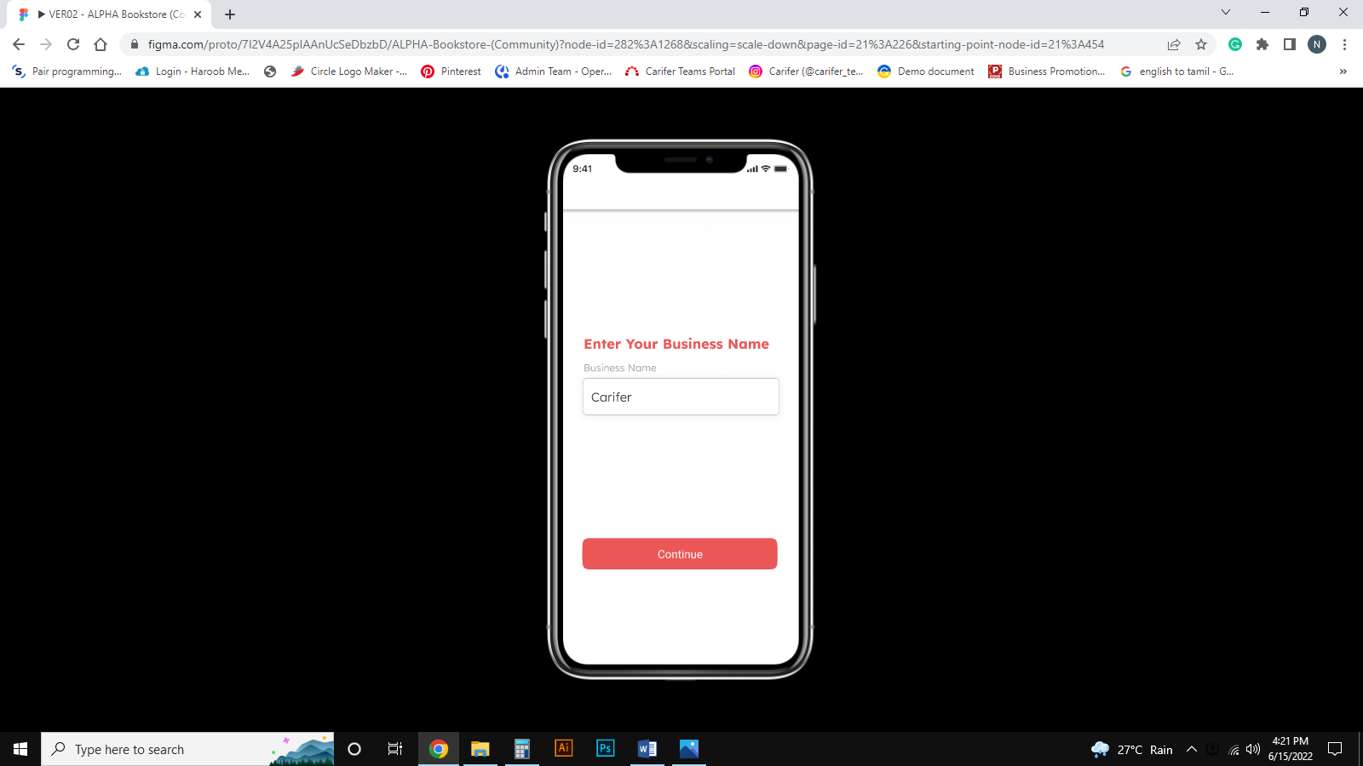
Page 6: Enter Your Business Name & Click continue

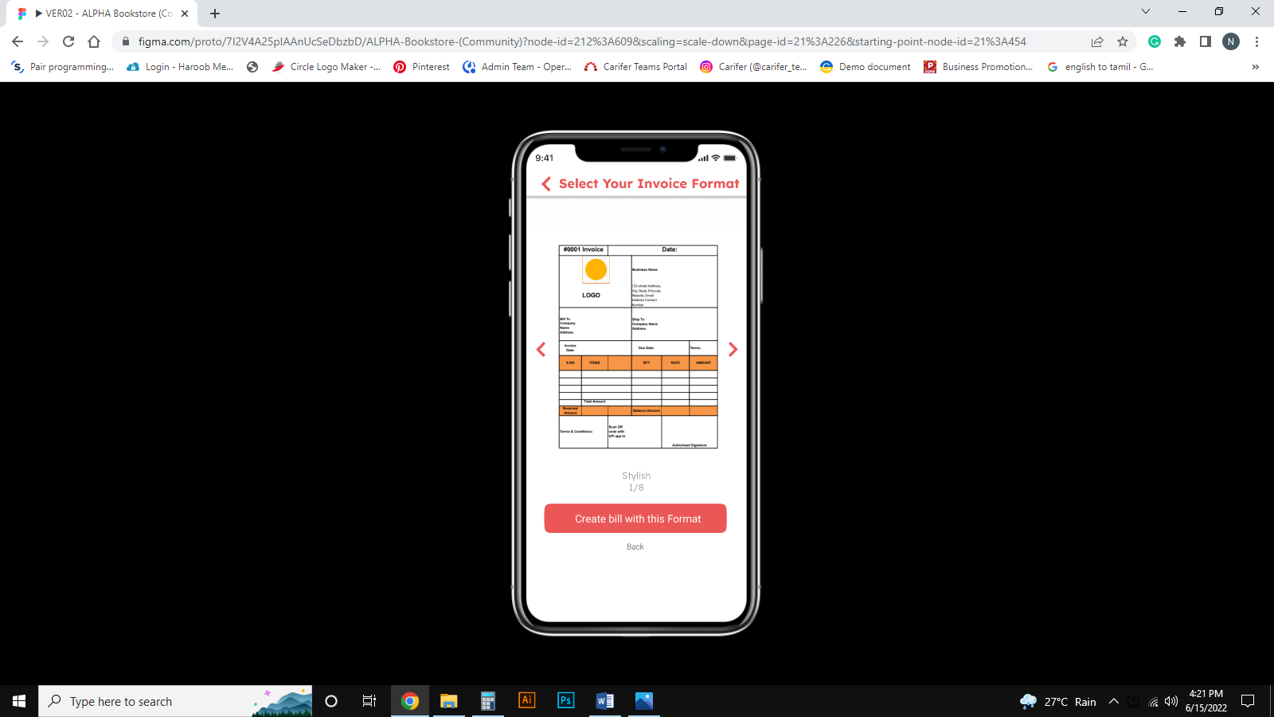
Page 7: Select ANY one From Bill Format Sample Image

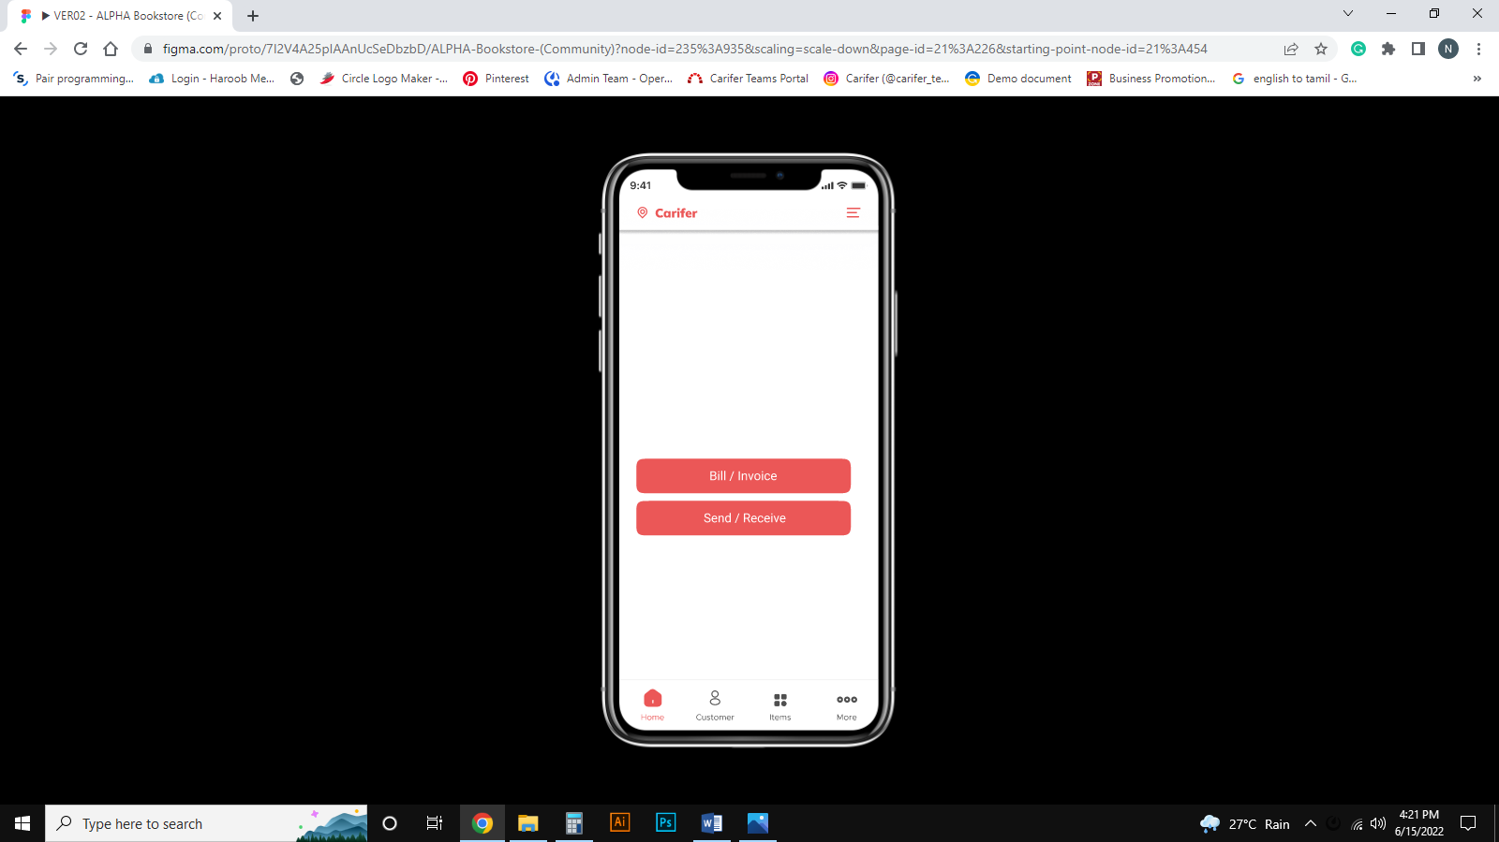
Page 8: Home Page and Click Customer button to View the Registered Customer Details

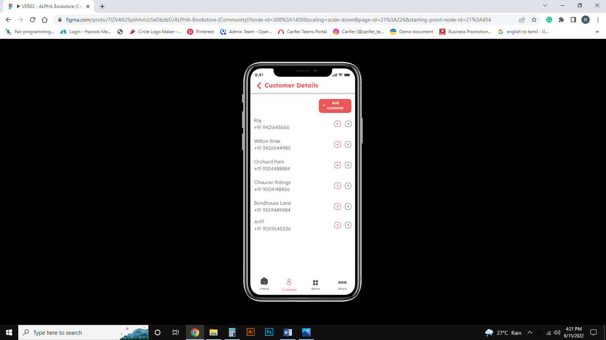
Page 9: Customer Details Page

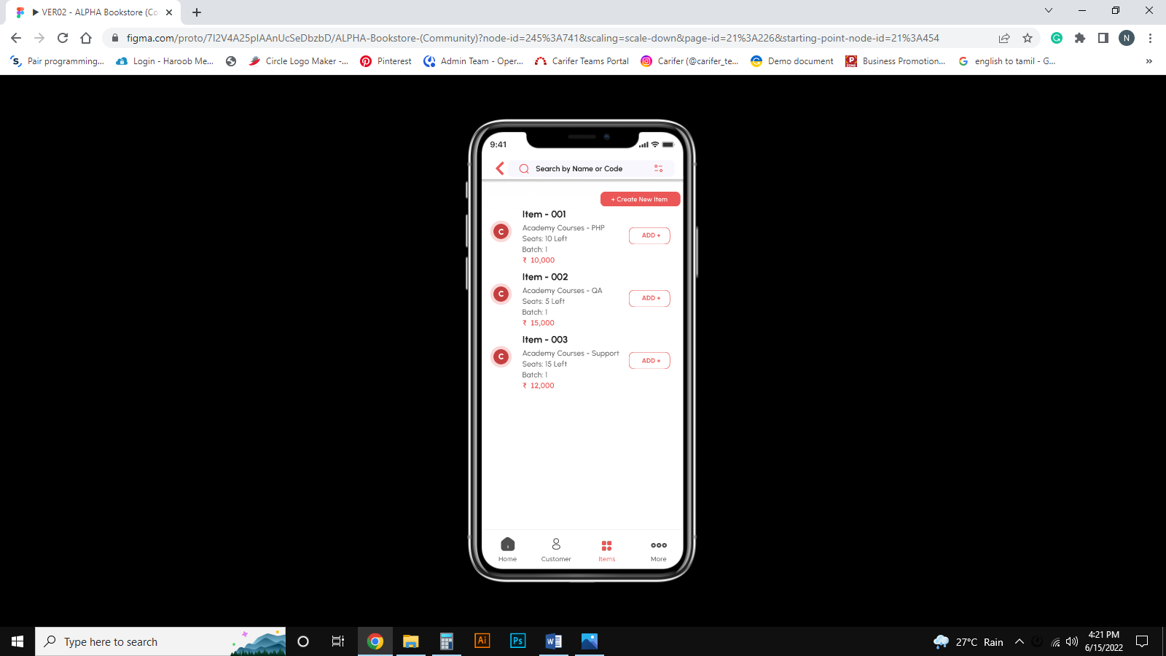
Page 10: Items Details Page

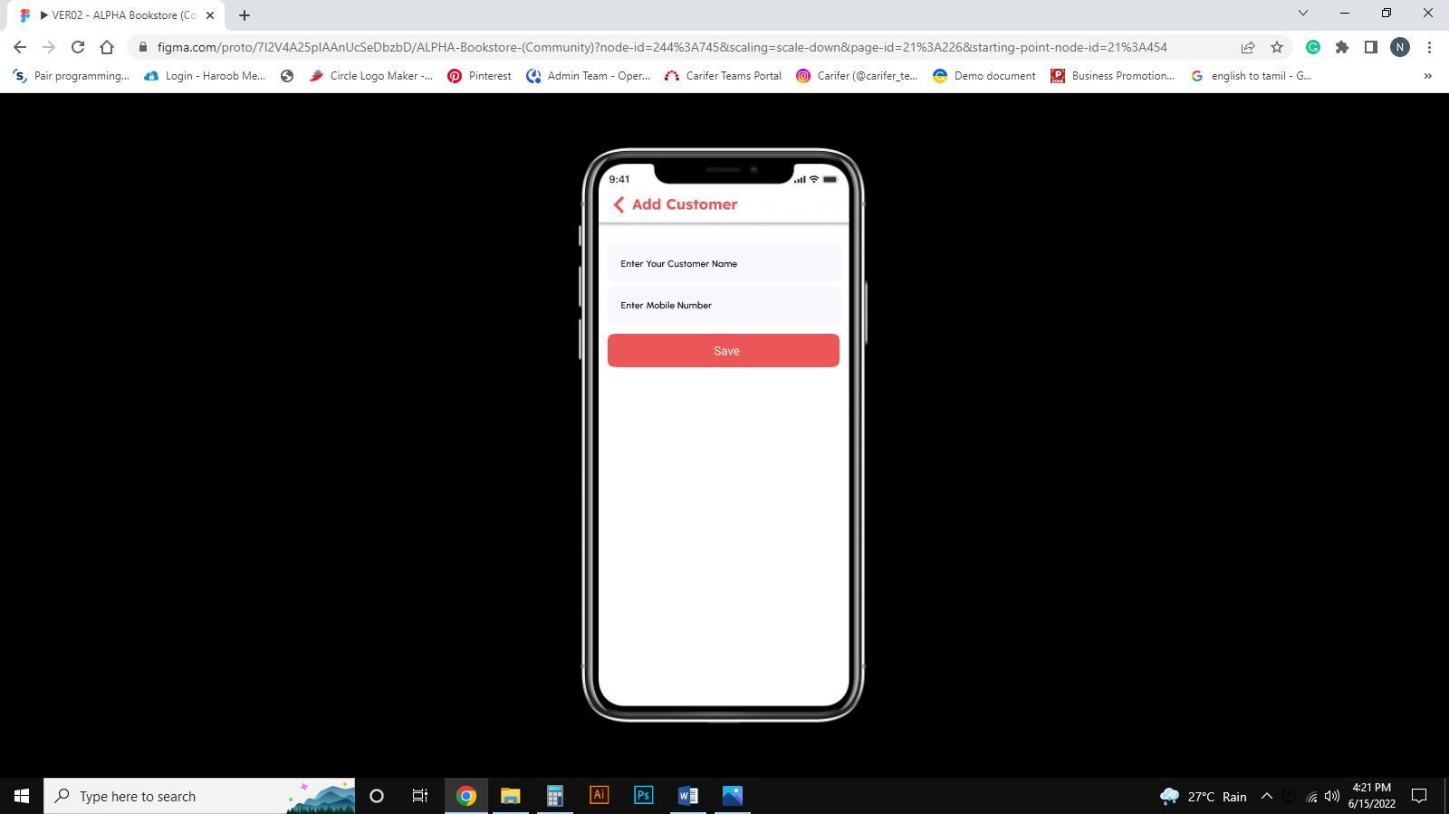
Page 11: Add New Customer Details Page

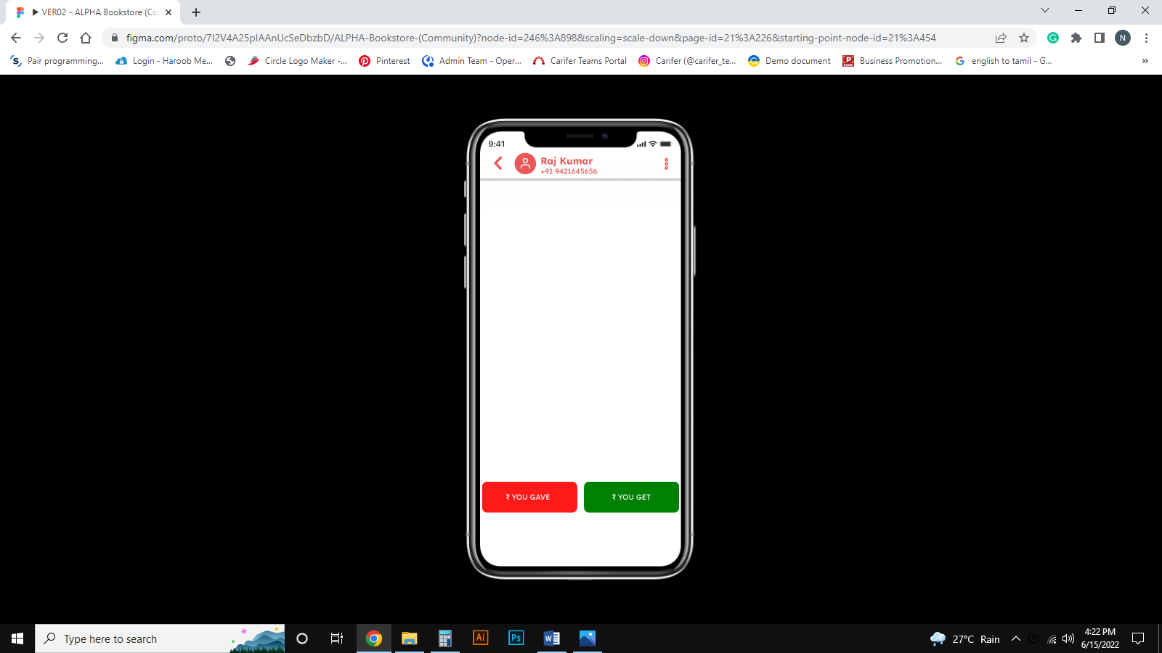
Page 12: If you want to Send or Receive Money From Your Customer. Select Customer and Click (+) Icon and you will get this above Screen. If you want to Send Money. Click YOU GAVE option

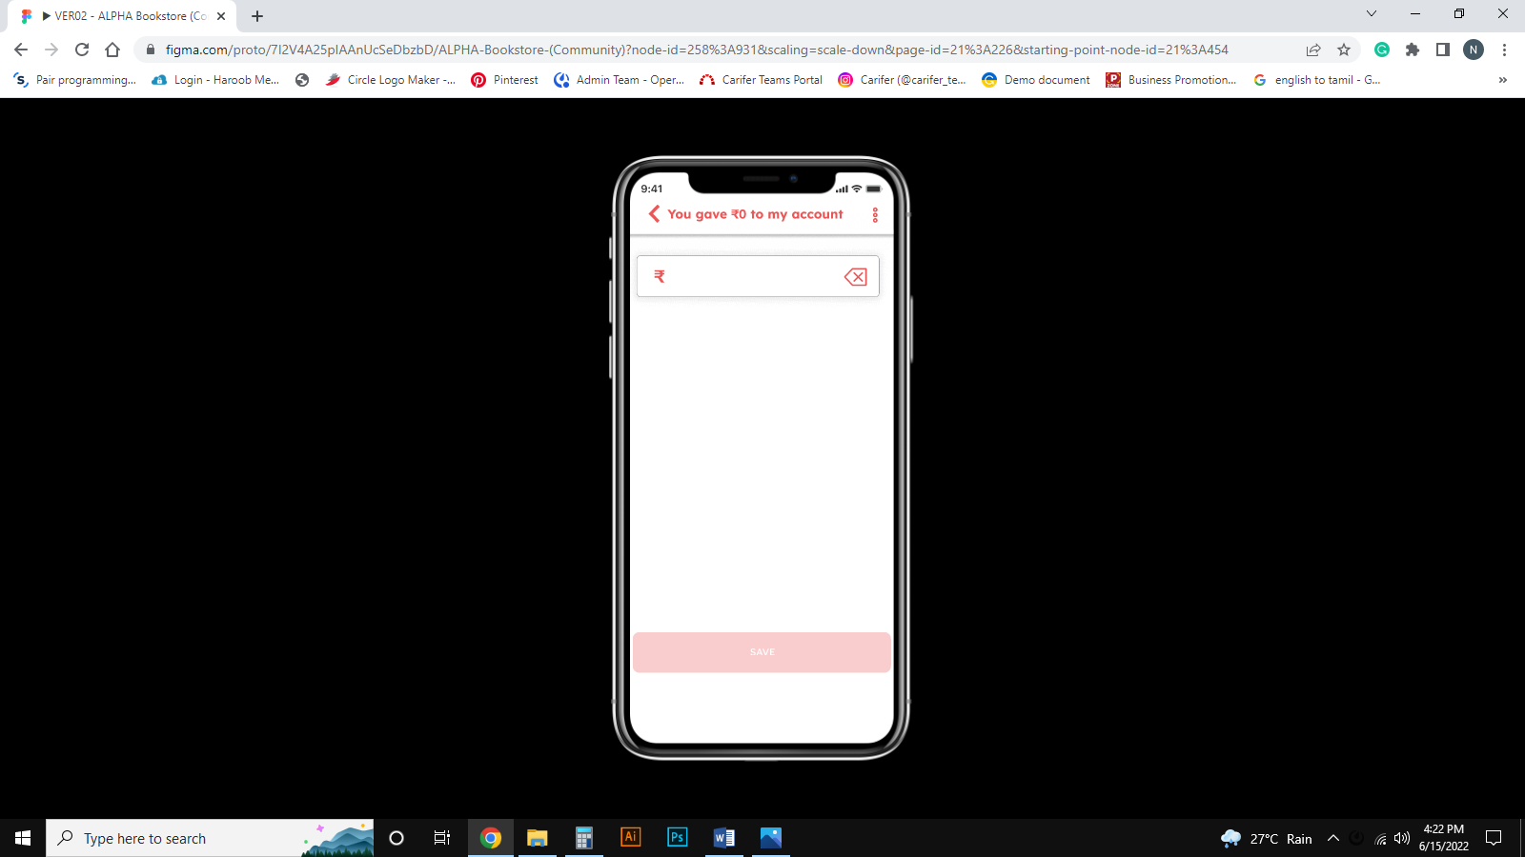
Page 13: Enter the Amount

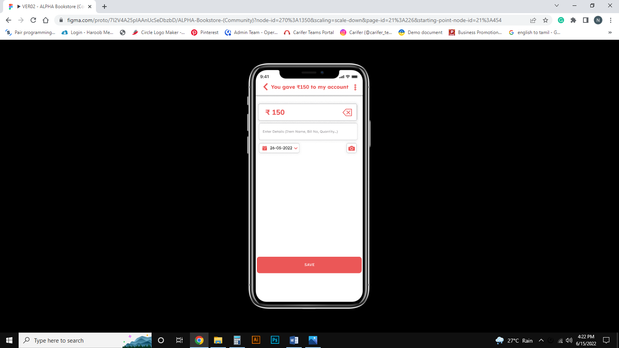
Page 14: Click Save Button and Notification will Send to the Customer

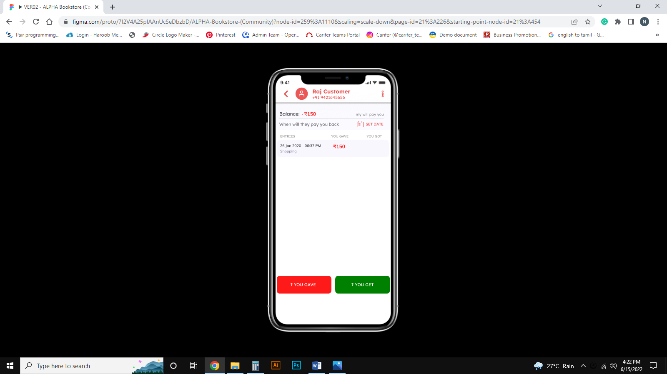
Page 15: Click YOU GET Button For Sending Money to the Customer

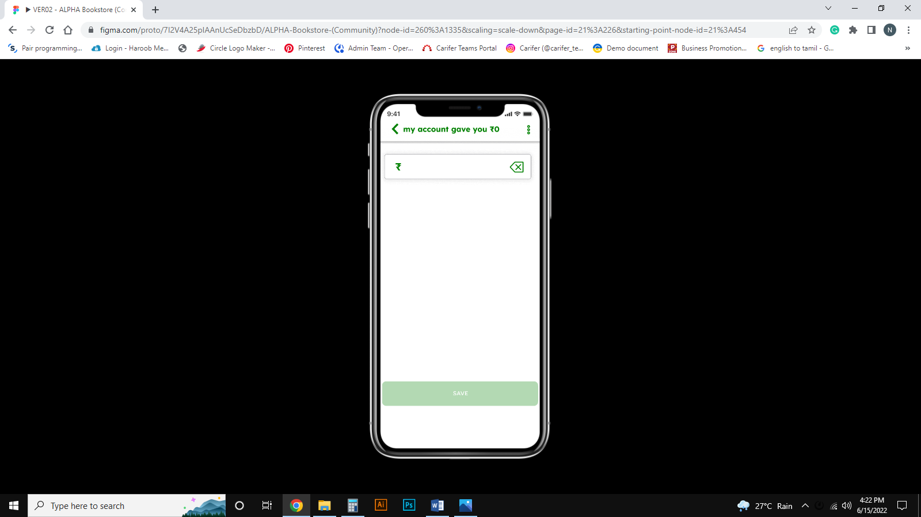
Page 16: Enter the Amount

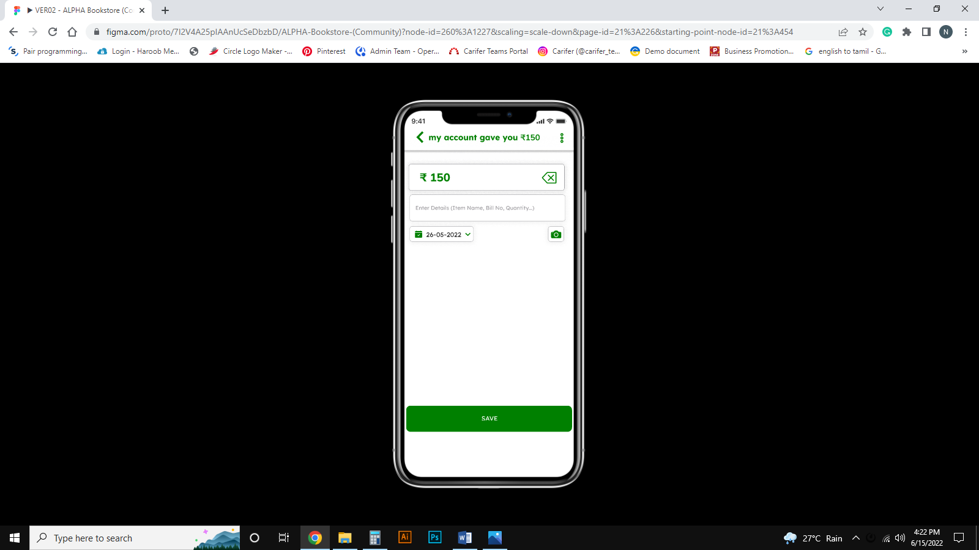
Page 17: Click Save Button and Notification will Send to the Customer

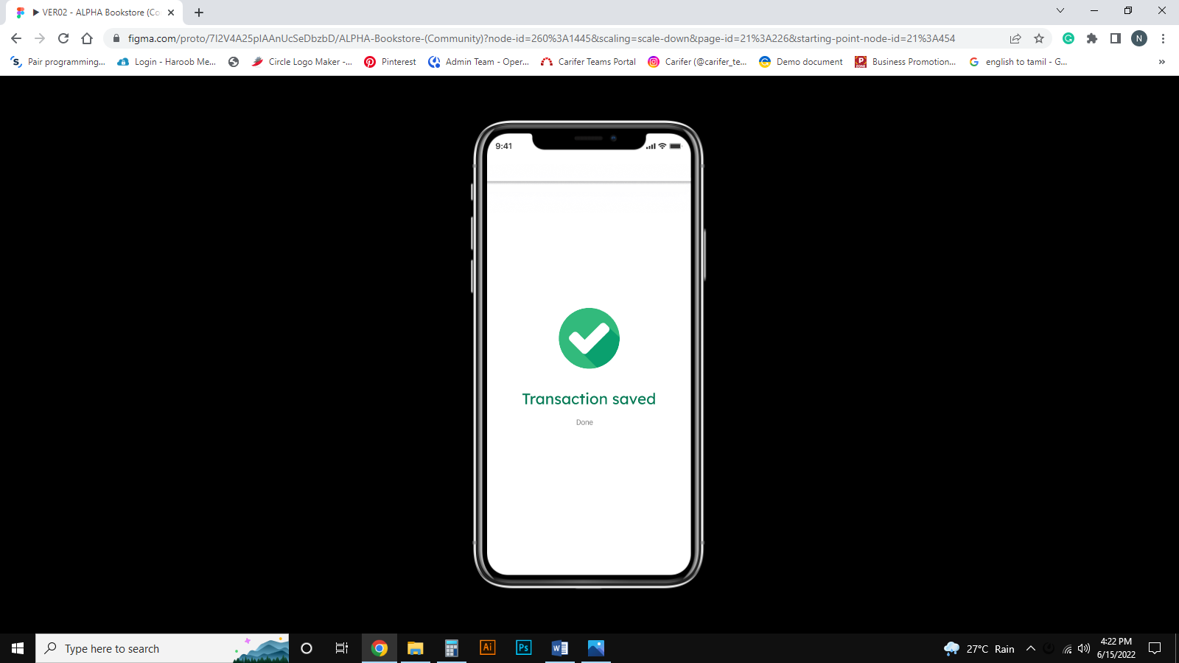
Page 18: Click Done Button

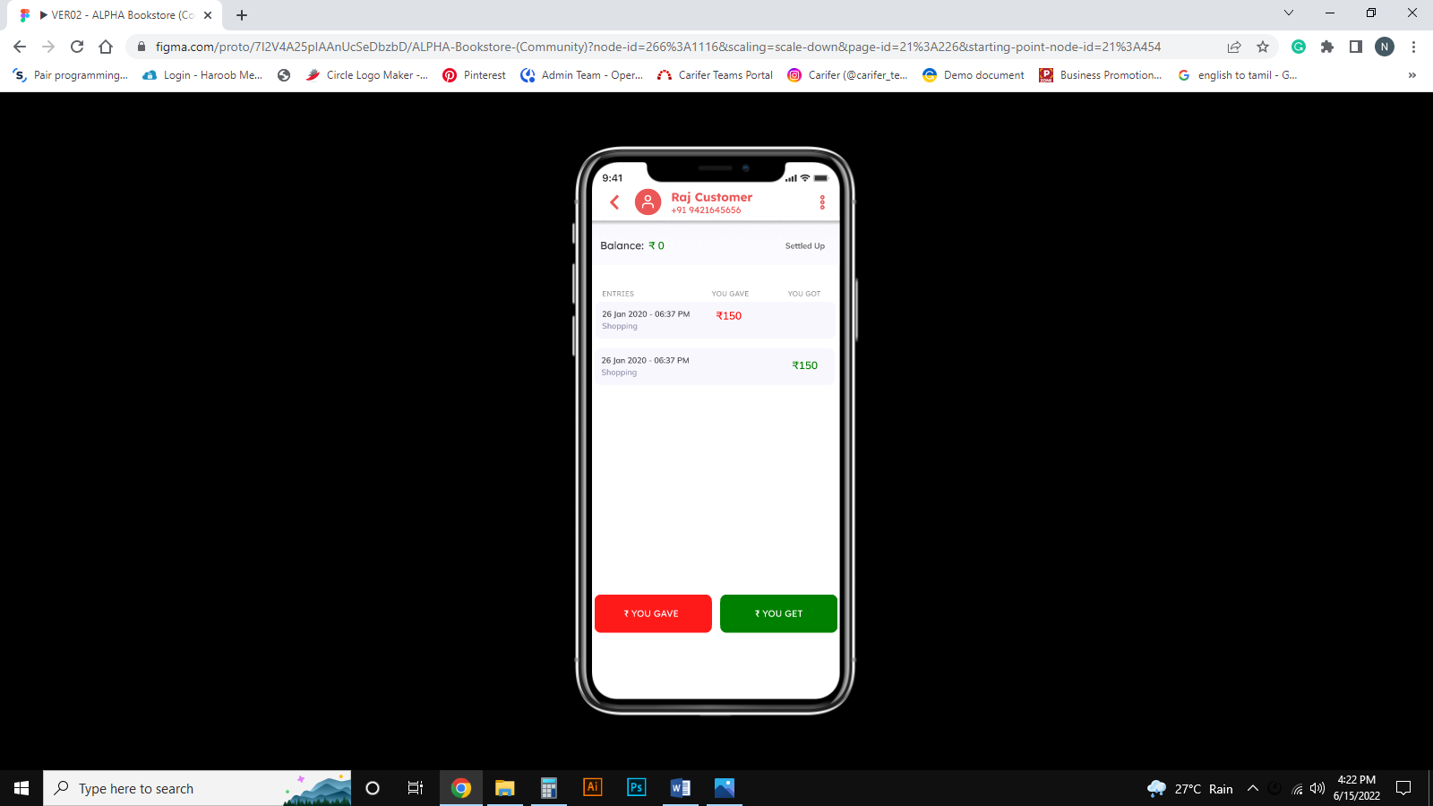
Page 19: Customer Transaction Page

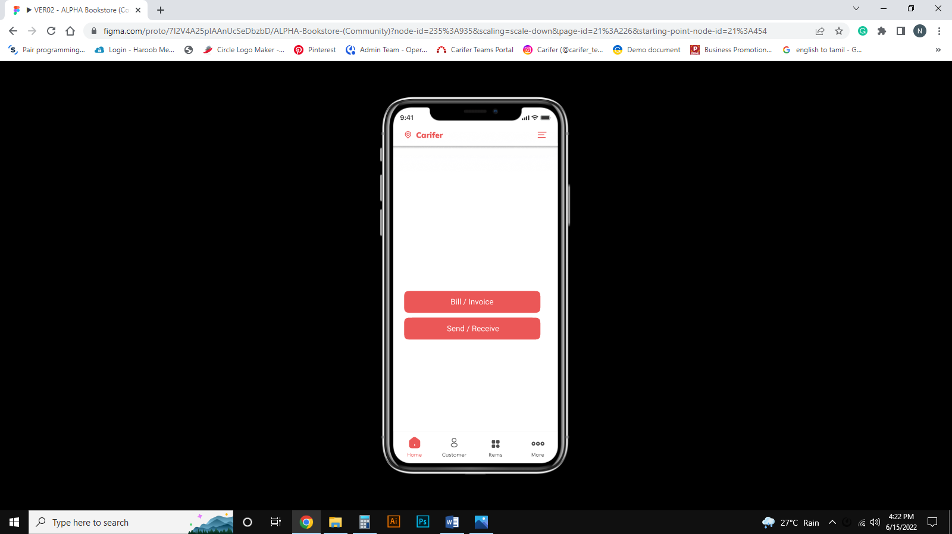
Page 20: Home Page

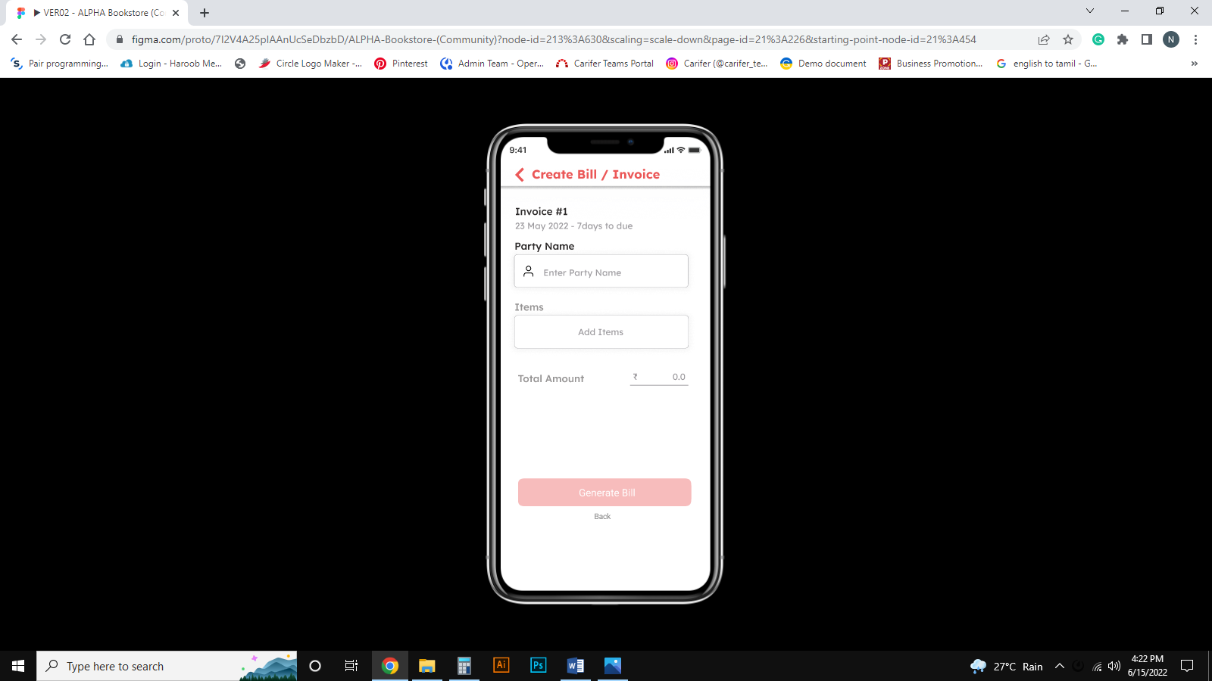
Page 21: Create Bill/Invoice page

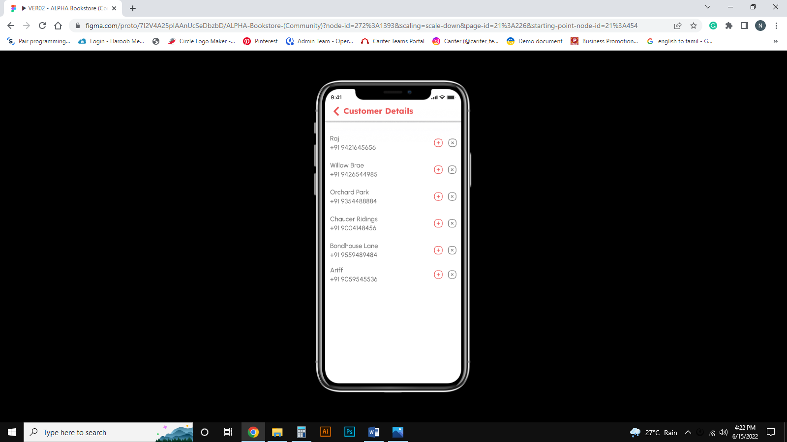
Page 22: ADD Customer Details page

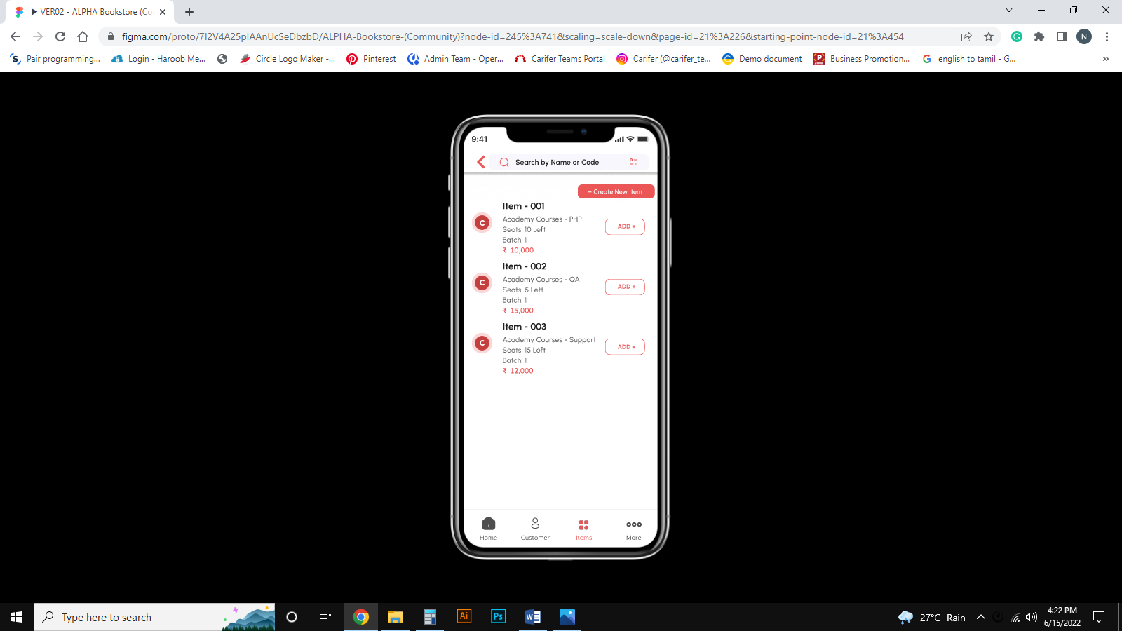
Page 23: ADD Item Details page

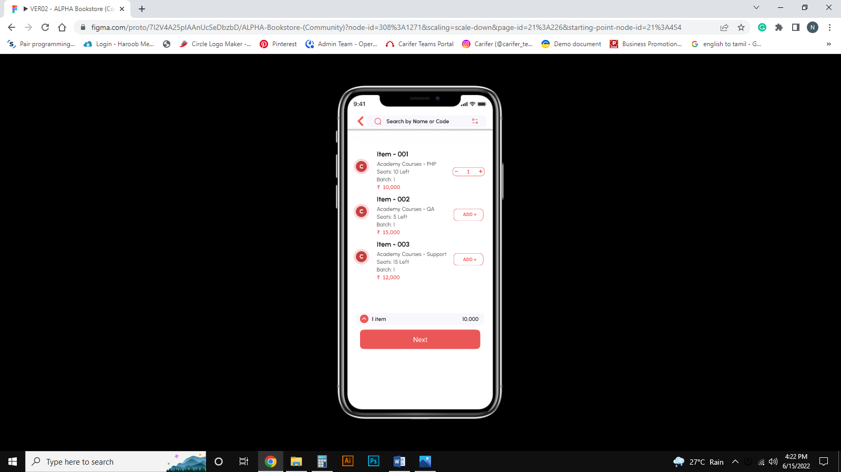
Page 24: ADD Item with amount Details page

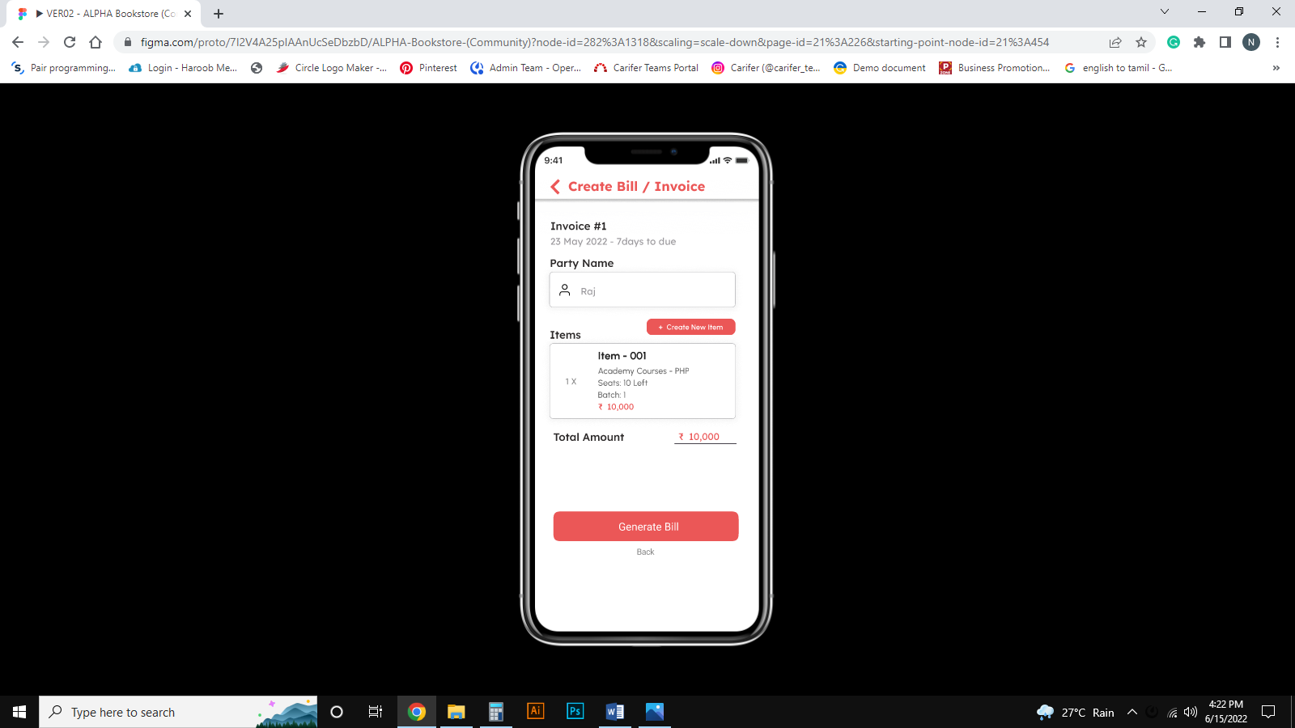
Page 25: Check the Customer name and Item details after click generate bill

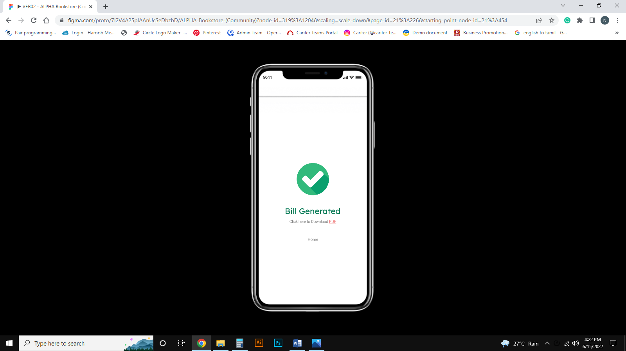
Page 26: Bill Generated and click pdf to download

Page 27: Home page

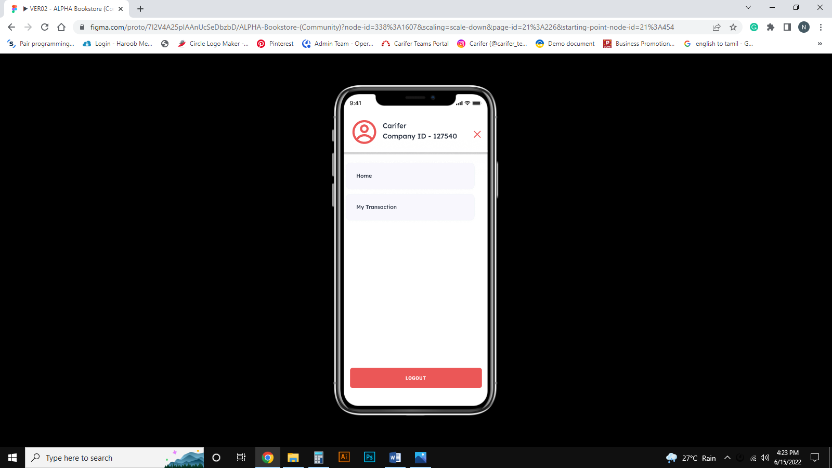
Page 28: Profile Page and if you want Logout. Click logout

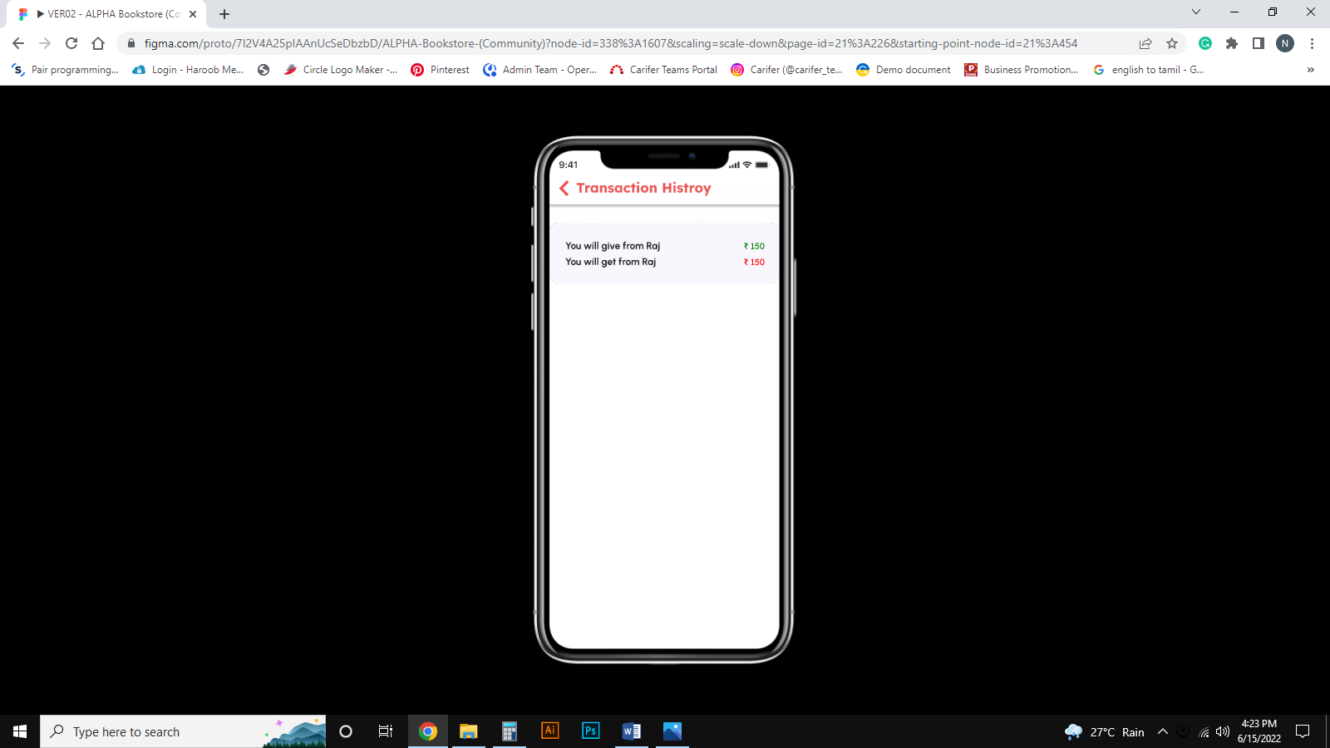
Page 29: Send & Receive Transaction Page

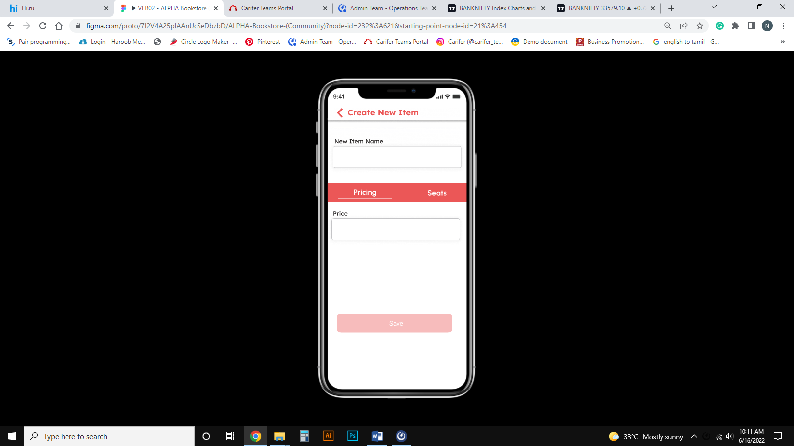
Page 30: Create a New item page – Enter New Item Name and Price

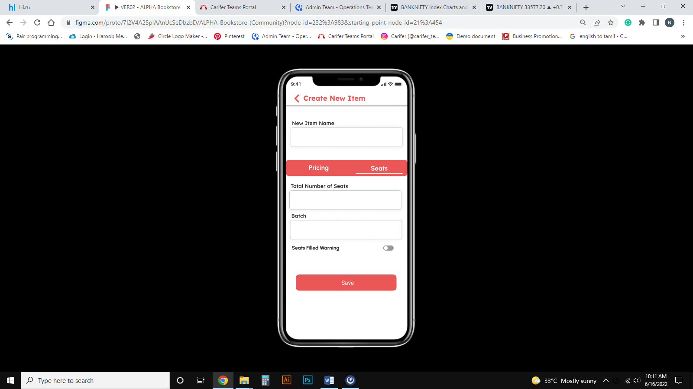
Page 31: Create a New item page – Enter Total Number of Seats, Batch and Filling warning

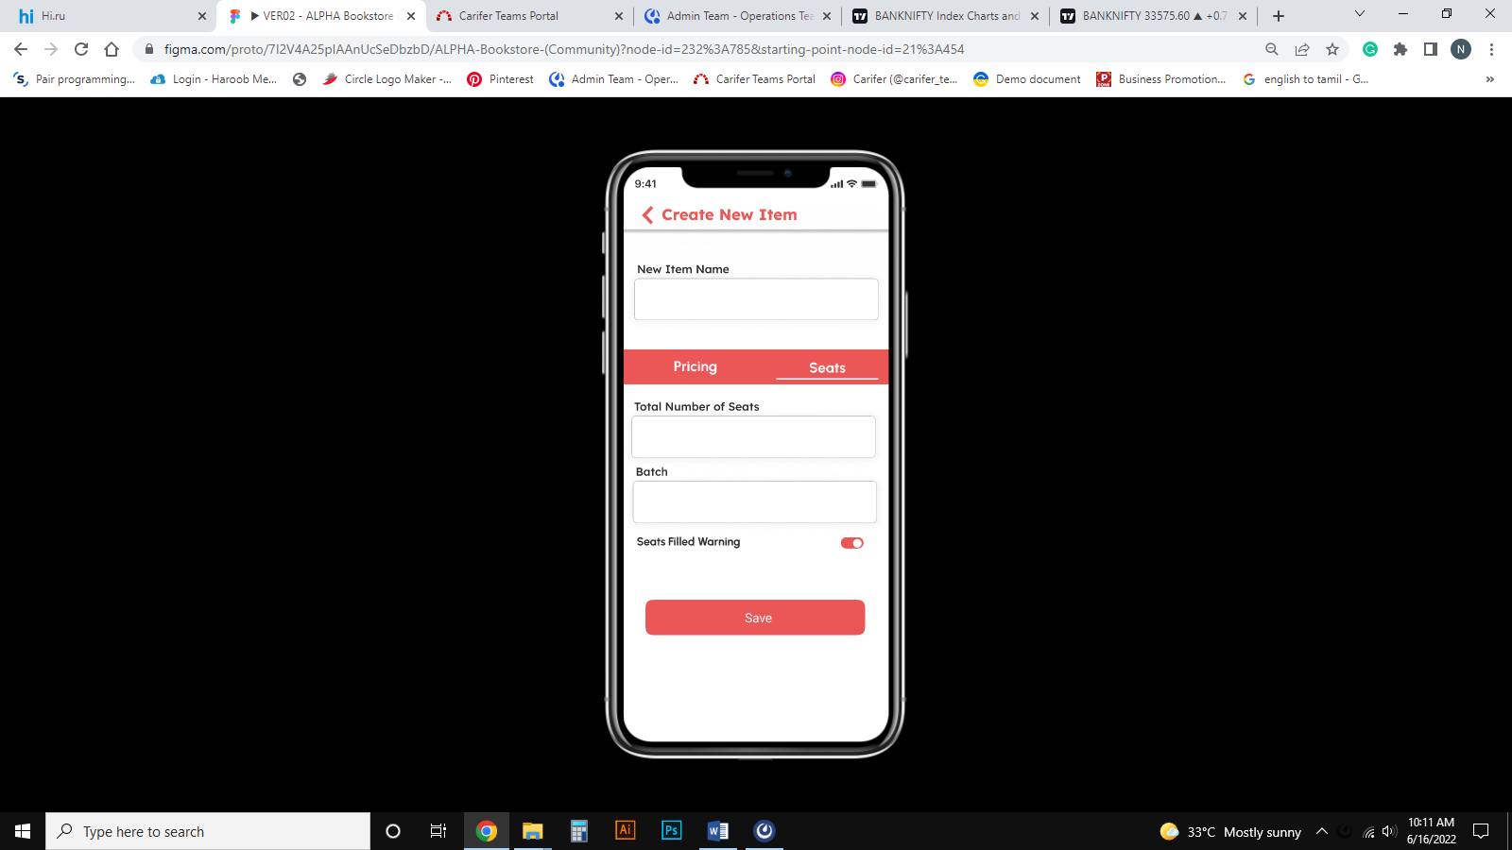
Page 32: Check box For Seats Filled Warning Button

