Team portal

**Team portal home page:**

On the home page, there is four options:

1. DASHBOARD
2. MY PAGE
3. PROJECT
4. ALL ISSUES

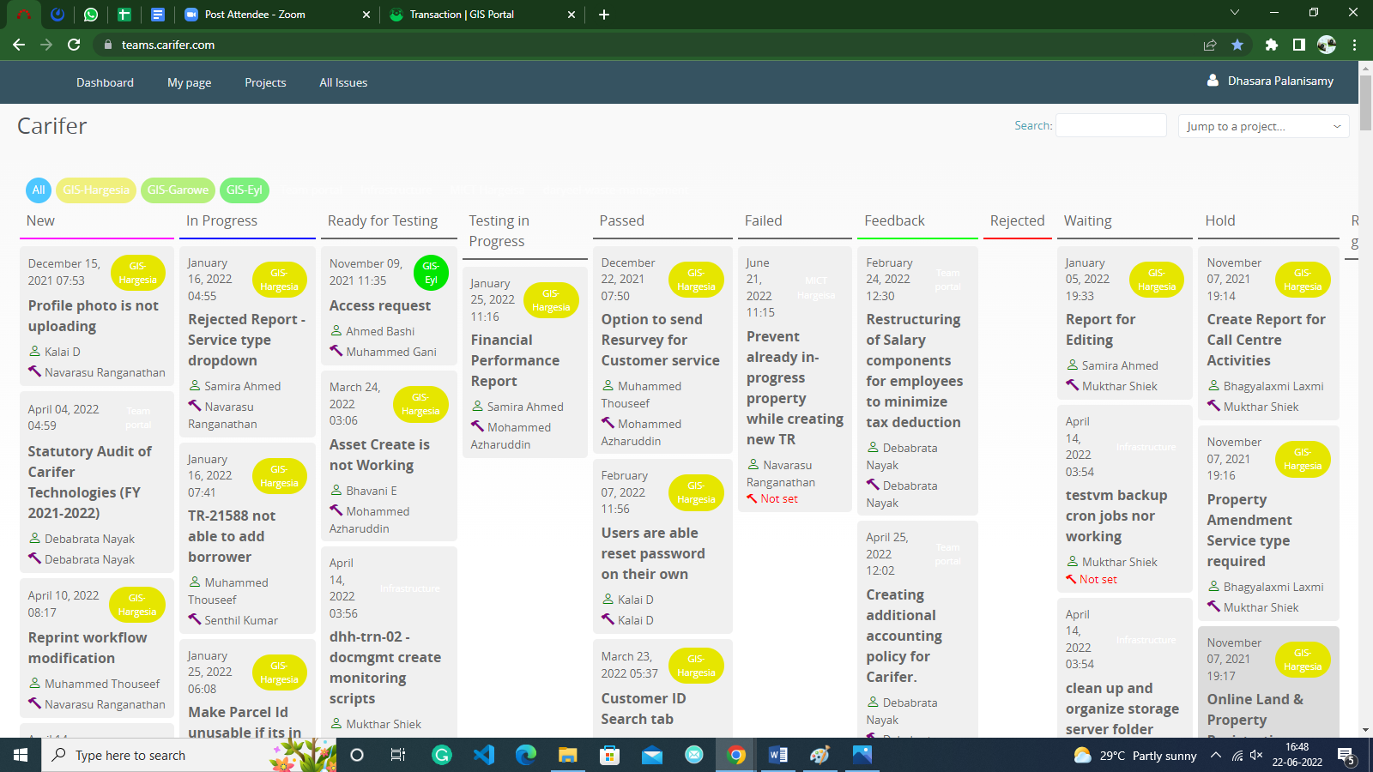

1. **DASHBOARD:**

In the dashboard, we can see the status of the tickets in order of the project.

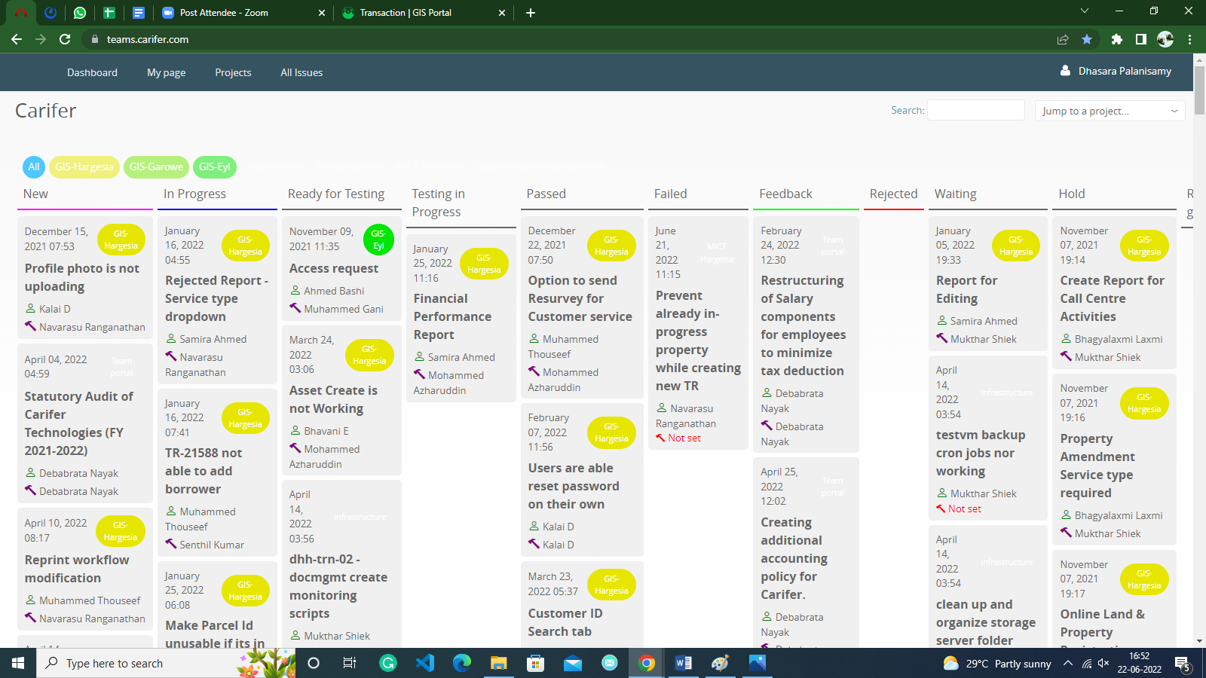

1. **MY PAGE:**

In My page, you can filter activity by using add search box .you can see following activities:

* Issues assigned to me
* Reported issues
* Updated issues
* Watched issues
* Issues
* Latest News
* Calendar
* Document
* Spent time
* Activity

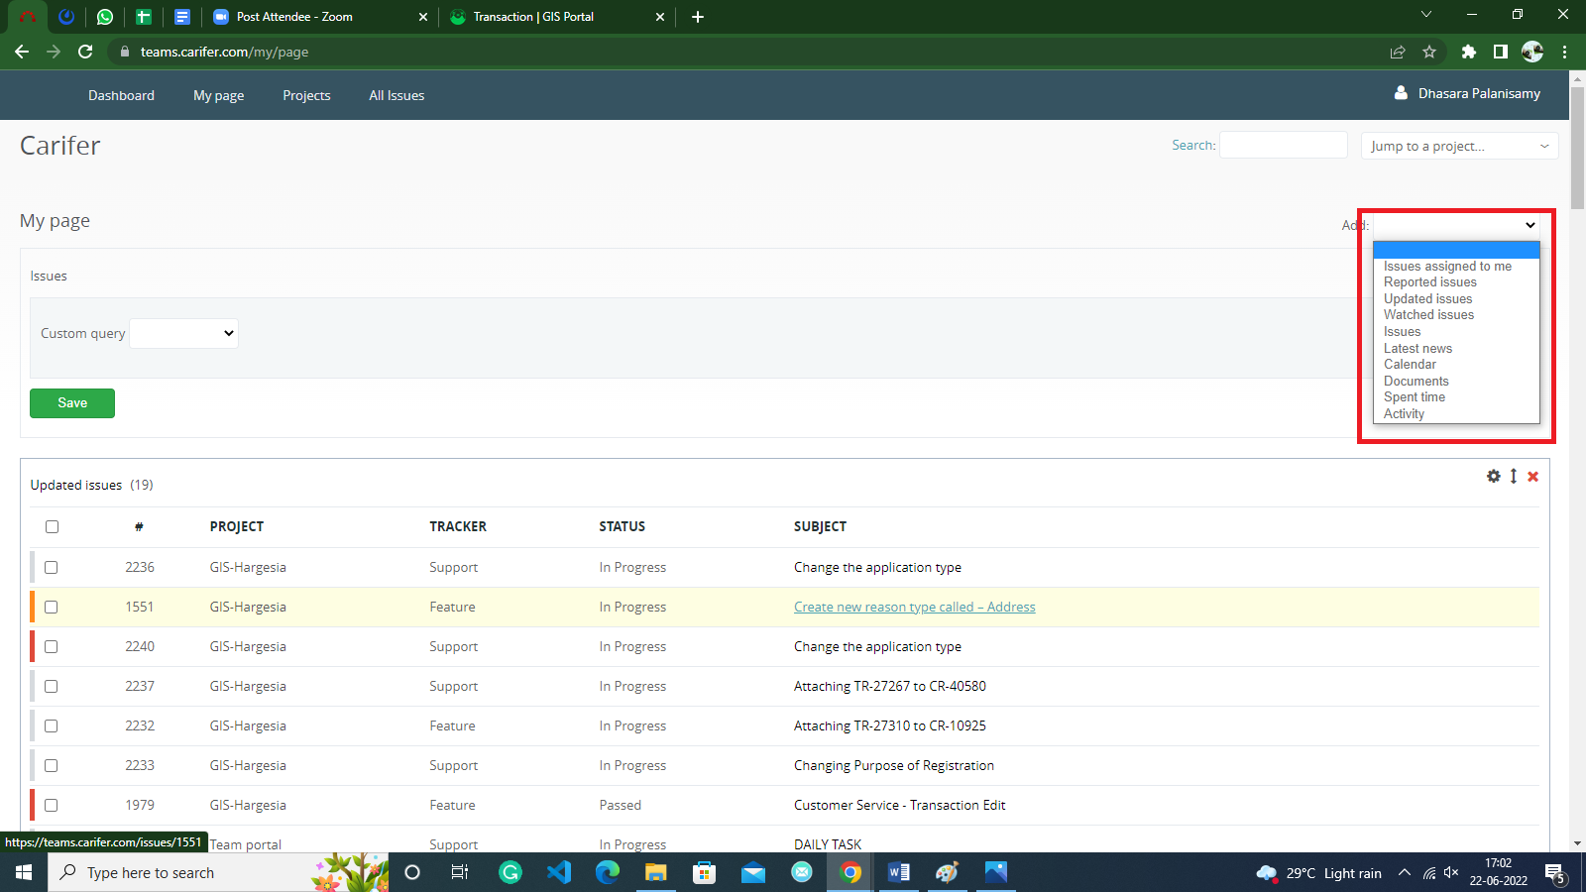

1. Projects:

In this page, you can track all issue’s status, Time tracking & see Members in project.

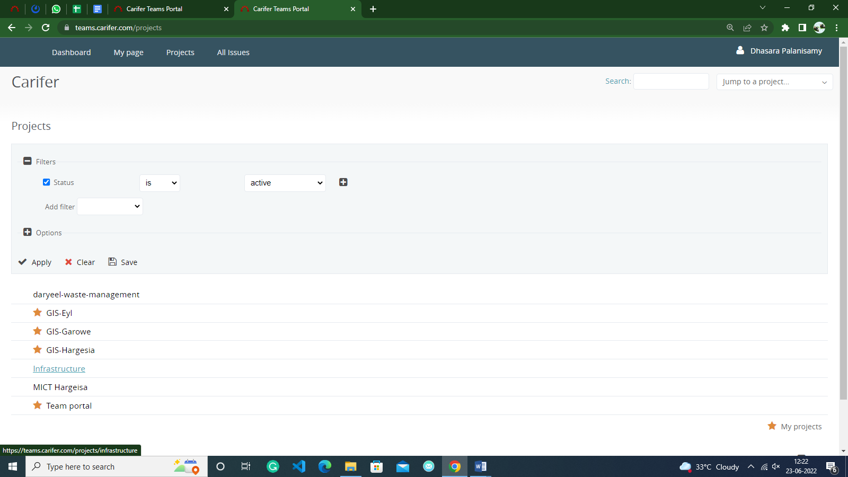

In addition you can get some more option

* View all issues
* Summary
* Calendar
* Gantt
* Log time
* Details
* Report

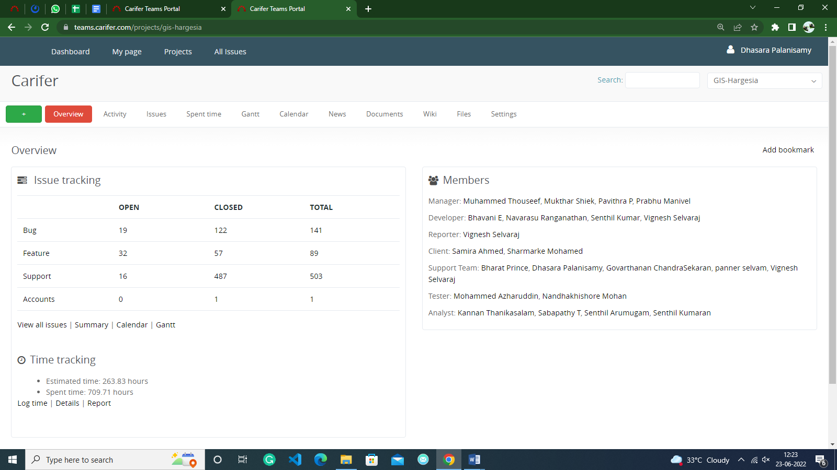

1. All issues

On this page you can see all issues in order of project, tracker, status, priority, subject, assignee, updated

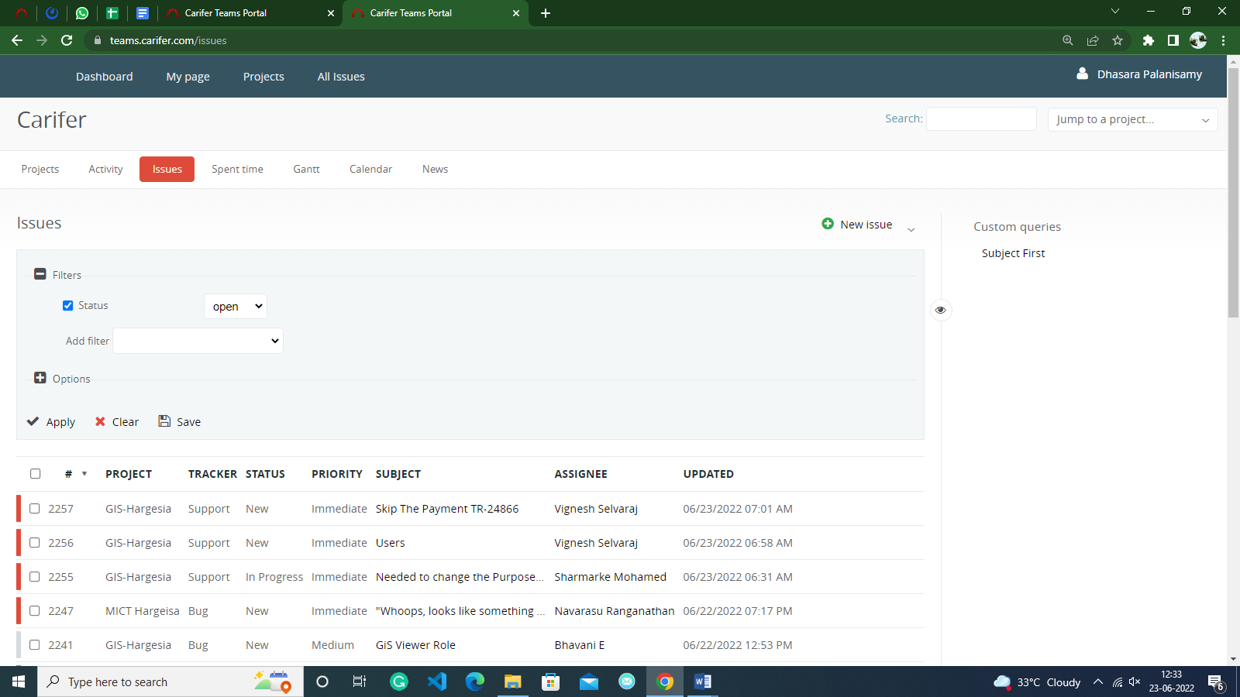

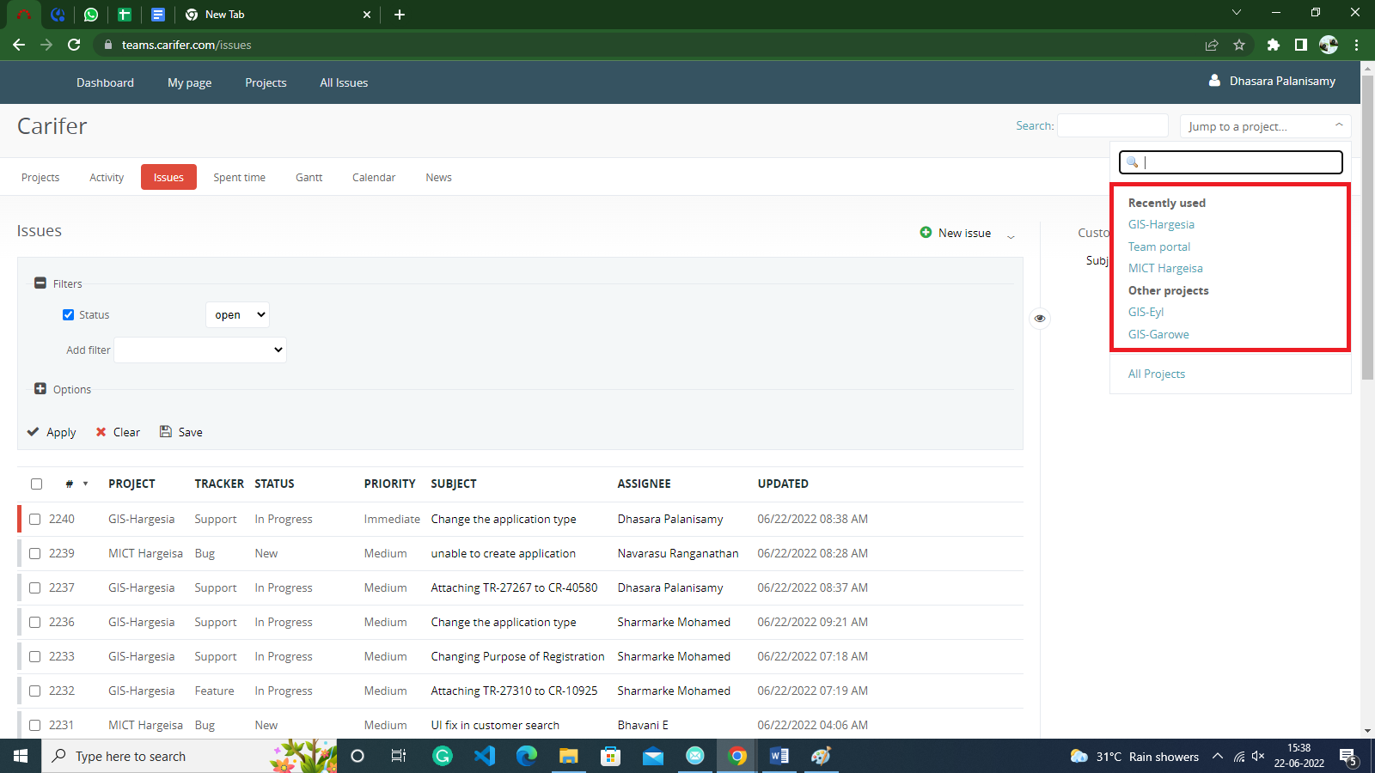You can filter the project by using this search box

How to create new issues:

1.click new issues

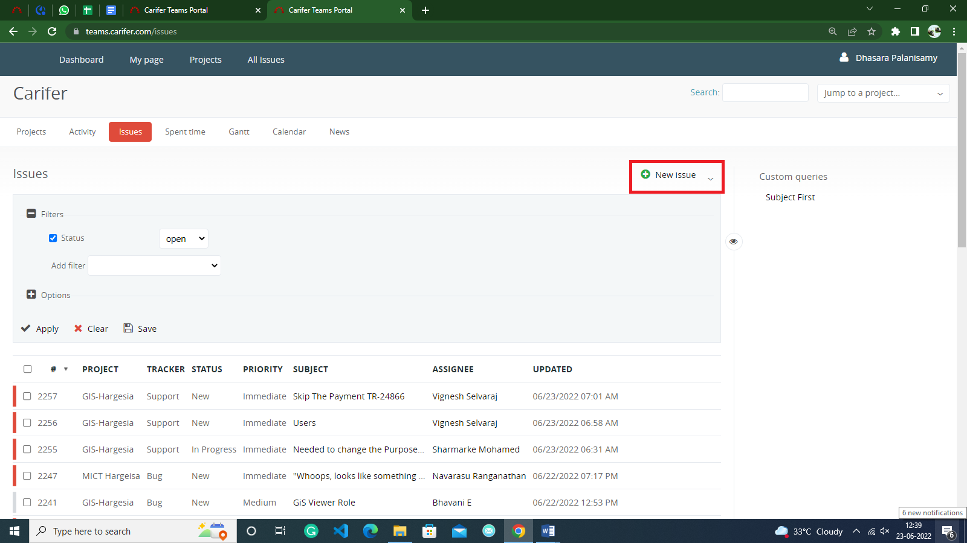

2.Fill in the following details.

* Project- select the your issuse related projects
* Tracker- select the issue type

1. Bug
2. Support
3. Feature
4. Account

* Subject- type the subject of issue
* Description- briefly exaplain the issue in description
* Status-upload the status of tickets

