Details
Portal Name: Teams Portal
Change Request #: 3191 | Date of Request: 19 September, 2022
Requested By: Sharmarke Mohamed
Change Request Description:
Can you please delete the former city map planning of TR-2849, which was attached on 26-07-2020 at 10:13 am
Reasons for this Change Request:
Geometer shaded the wrong plot on city map planning. It’s been corrected now and uploaded, DHH executives have provided written authority for the change
Approval Signature(s) and Date(s):
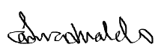 20th September 2022

