Details
Portal Name: Teams Portal
Change Request #:5011 | Date of Request: 33595
Requested By: Abdirahman Mohamoud
Change Request Description:
Finalised Tr 4450 finished at the wrong location. Coordinates & survey drawings provided. Please action as per survey drawing & GPS
Reasons for this Change Request:
The above Trs were incorrectly registered & finished at the location
Approval Signature(s) and Date(s):
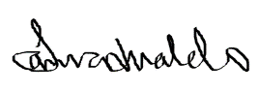 11th Feb, 2023

