Details
Portal Name: Teams Portal
Change Request #: 5261 | Date of Request TR – 25671 & TR - 25672
Requested By: Samira Ahmed
Change Request Description:
Cancel/invalid Serial number for the below parcel numbers & delete the boundary (if required)
919674712-25862& 522075718-25861

Reasons for this Change Request:
The above Trs were incorrectly registered at the location
Approval Signature(s) and Date(s):
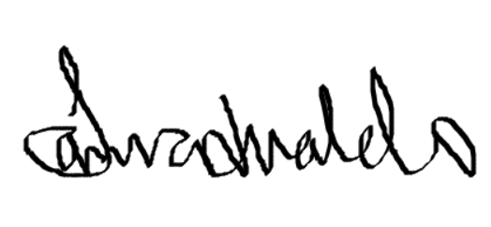 04/03/23

