Details
Portal Name: Teams Portal
Change Request #: DGPS Adjustments | Date of Request: 22/03/2023
Requested By: Khalid Elmi
Change Request Description:
Finalized Tr’s 5953 , 19403 , 19151 , 15330 finished at the wrong location. DGPS Team surveyed block
boundaries and property boundaries for this finalized tr’s. Please action asper DGPS Survey
Reasons for this Change Request:
The above Tr was incorrectly registered & finished at the location, new location has been approved by District head of planning .
Approval Signature(s) and Date(s):
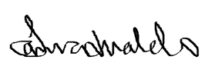 1st March 2023

