Details
Portal Name: Teams Portal
Change Request #: 7164 | Date of Request 7th September 2023
Requested By: Samira Ahmed
Change Request Description:
Below Trs finalized at the wrong location, Geometer updated the new coordinated, please action.
35408,13757, 13899, 5631 and 17115.

Reasons for this Change Request:
The above Trs were incorrectly registered at the location, the was a Geometer error
Approval Signature(s) and Date(s):
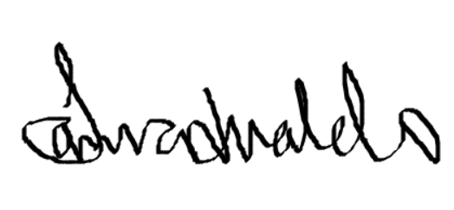 07/10/23

