Details
Portal Name: Teams Portal
Change Request #: 7204 | Date of Request 12th October
Requested By: Samira Ahmed
Change Request Description:

Please delete the comment entered at 11-10-2023 01:32 pm

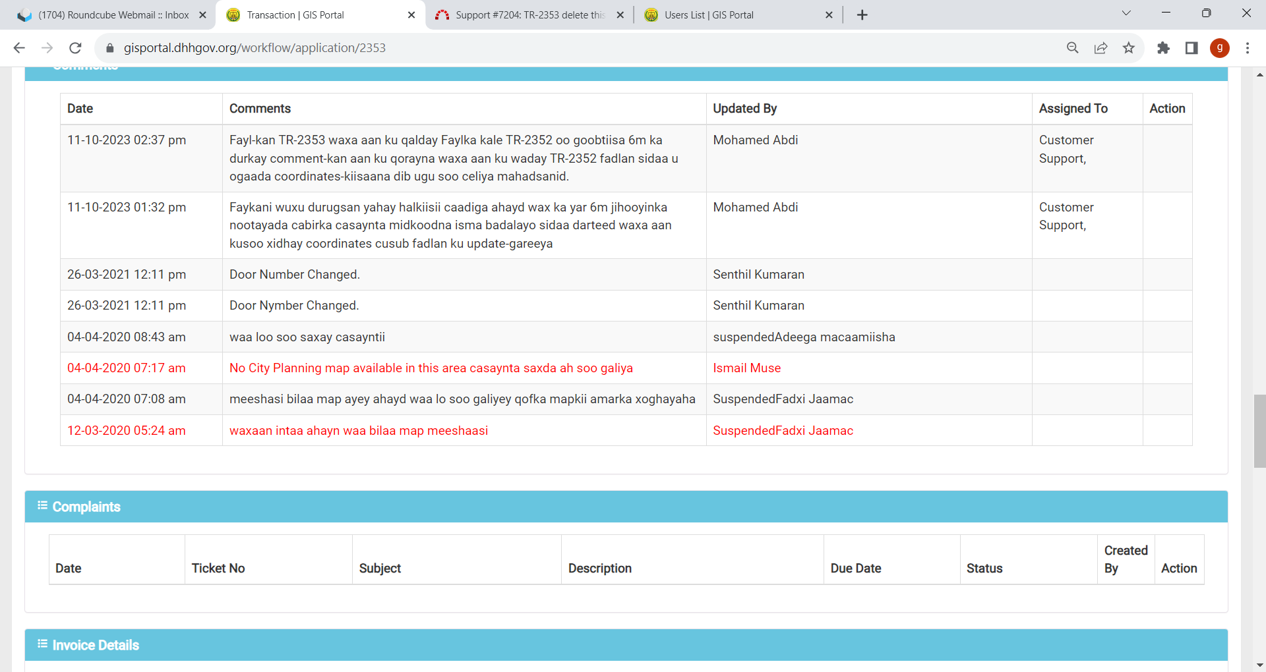

Reasons for this Change Request:
User Mistake – typo error by Geometer
Approval Signature(s) and Date(s):
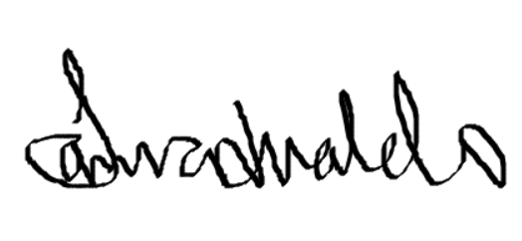 12/10/23

