Details
Portal Name: Teams Portal
Change Request #: 7363 | Date of Request 7th September 2023
Requested By: Samira Ahmed
Change Request Description:

Below Trs finalized at the wrong location, Geometer updated the new coordinated, please action.
41308, 23536, 10915.

Reasons for this Change Request:
The above Trs were incorrectly registered at the location, the was a Geometer error
Approval Signature(s) and Date(s):
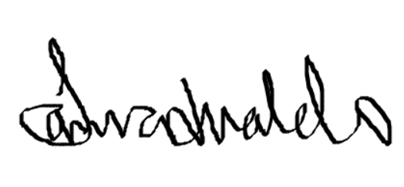 30/10/23

