Details
Portal Name: Teams Portal
Change Request #: | Date of Request 15th September 2023
Requested By: Samira Ahmed
Change Request Description:
The last name is misspelled, please regenerate title deed and update the last name to *CABDILE* from *CABDALE*

Reasons for this Change Request:
Typo error
Approval Signature(s) and Date(s):
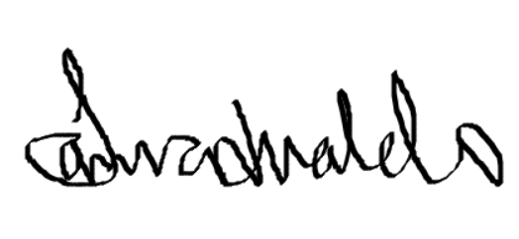 15/11/23

