Details
Portal Name: Teams Portal
Change Request #: 7707 | Date of Request 3rd Dec
Requested By: Samira Ahmed
Change Request Description:
TR-19241 was registered & finalized correctly.
Reasons for this Change Request:
Canceled by DHH Executives in an official letter which is attached. Please cancel TR and delete the boundary
Approval Signature(s) and Date(s):
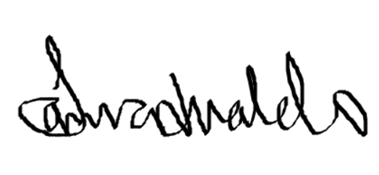 03/12/23

