Details
Portal Name: Teams Portal
Change Request #: 7725 | Date of Request 4th Dec
Requested By: Samira Ahmed
Change Request Description:
TR-10199 was registered and finalized incorrectly.
Reasons for this Change Request:
Canceled by DHH Executives in an official letter which is attached. Please cancel TR and delete the boundary
Approval Signature(s) and Date(s):
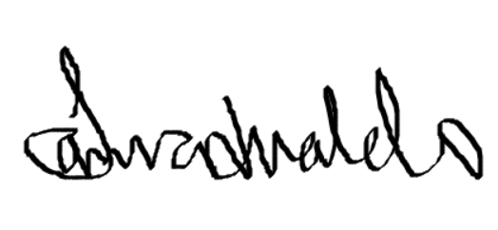 04/12/23

