Details
Portal Name: Teams Portal
Change Request #: | Date of Request 24th Dec
Requested By: Samira Ahmed
Change Request Description:
TR- 21792 was registered illegally.
Reasons for this Change Request:
Canceled by DHH Executives in an official letter which is attached. Please cancel TR and delete the boundary
Approval Signature(s) and Date(s):
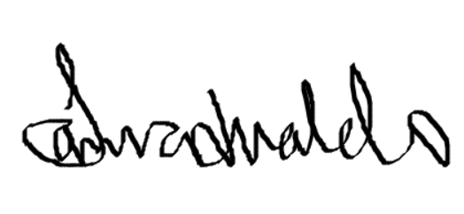 24/12/23

