Details
Portal Name: Teams Portal
Change Request #: 8492 | Date of Request 7th March 2024
Requested By: Samira Ahmed
Change Request Description:
TR-45200– The name on the map viewer needs to match the name on the dashboard and documents

Name on Dashboard and Documents - *ISMAACIIL CALI CABDILLAAHI* - is Correct
Reasons for this Change Request:
Nickname was used on Map Viewer
Approval Signature(s) and Date(s):
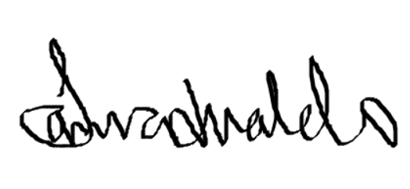 7/03/24

