Details
Portal Name: Teams Portal
Change Request #: | Date of Request 25th April 2024
Requested By: Samira Ahmed
Change Request Description:
TR-19069
TR-46077
Delete boundary & cancel these finialed TRs as per request from DHH Executives
Reasons for this Change Request:
TRs finalized wrong location incorrectly
Approval Signature(s) and Date(s):
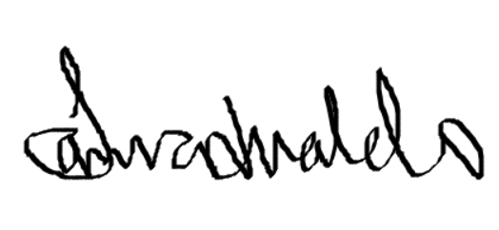 25/04/24

