Details
Portal Name: Teams Portal
Change Request #: 8492 | Date of Request 15th May 2024
Requested By: Samira Ahmed
Change Request Description:
Tr-39834, Tr-20744 , 36899 , Tr-44353 , Tr-18436 , Tr-7475 , Tr-46031 , Tr-47471 , These Trs has been corrected using DGPS , some of them are finalized but its not affecting as long as the address and frontage not changing , New coordinates for all this Tr's has been uploaded to dashboard , please proceed and prioritize .

Reasons for this Change Request:
Wrong GPS .
Approval Signature(s) and Date(s):
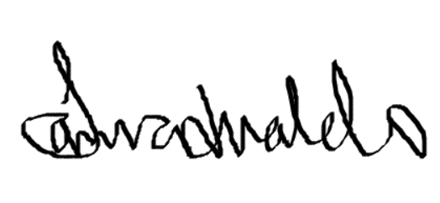 15/05/24

