Details
Portal Name: Teams Portal
Change Request #:10316 | Date of Request 14th September
Requested By: Samira Ahmed
Change Request Description:
Remove ID from TR 952 as it was incorrectly attached
Reasons for this Change Request:
Approval Signature(s) and Date(s):
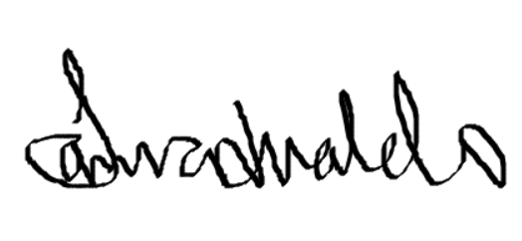 14th Sept 2024

