Details
Portal Name: Teams Portal
Change Request #:10461 | Date of Request 5th Oct
Requested By: Samira Ahmed
Change Request Description:
Move TR-41422 to its correction parcel location as gis-sale parent application become TR-34485 AS SOLD WHOLE PROPERTY TO TR-41422
Reasons for this Change Request:
TR-41422 finialed in wrong location also the wrong GIS certificate was used.

Approval Signature(s) and Date(s):
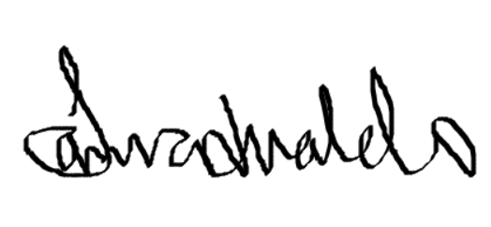 5th Oct 2024

