Details
Portal Name: Teams Portal
Change Request #10594 | Date of Request 14th Oct
Requested By: Samira Ahmed
Change Request Description:
Attach PR-53969 to TR-8048
Reasons for this Change Request:
TR8048 was finalised with the PR of another TR, Parcel Creation failed to correct this error

Approval Signature(s) and Date(s):
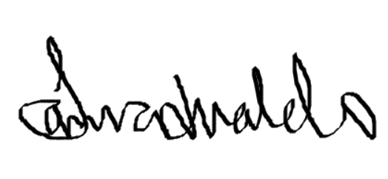 14th Oct 2024

