Details
Portal Name: Teams Portal
Change Request #10689 | Date of Request 26th Oct
Requested By: Samira Ahmed
Change Request Description:
Delete boundary for TR-47915 as per DHH Executives Request.
Reasons for this Change Request:
TR-47915 was finalised in the wrong location

Approval Signature(s) and Date(s):
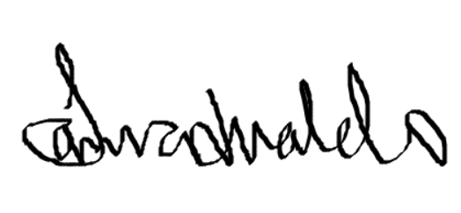 26th Oct 2024

