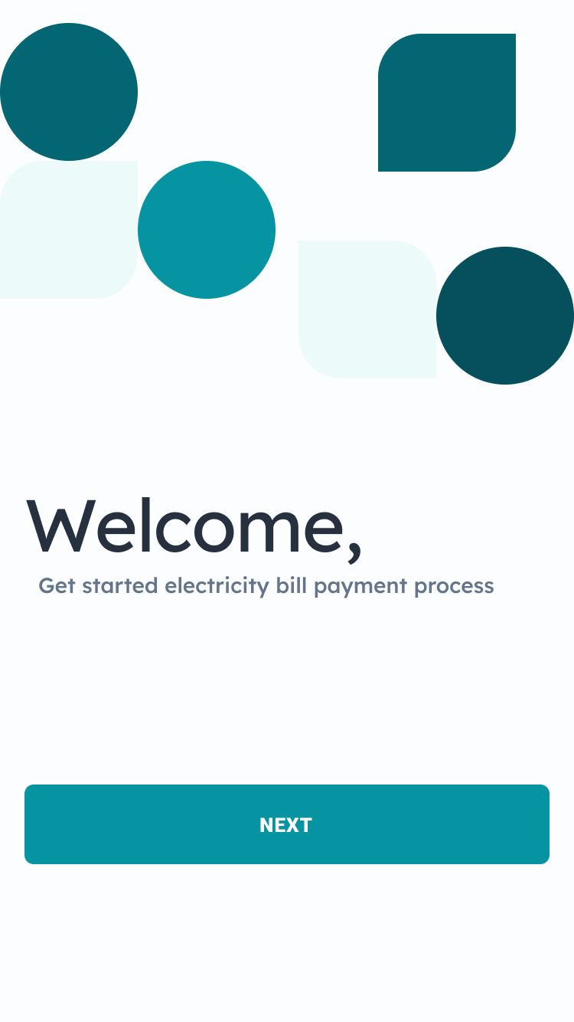 | 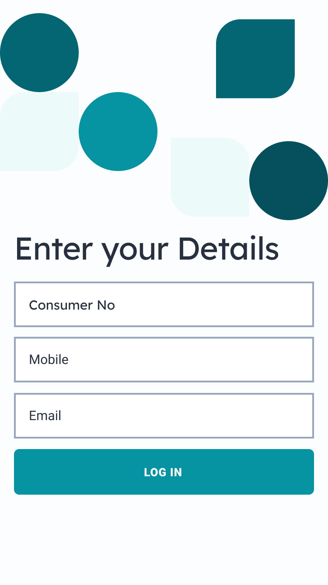
Page 1: Welcome Page | Page 2: Enter Your Details and click Log in
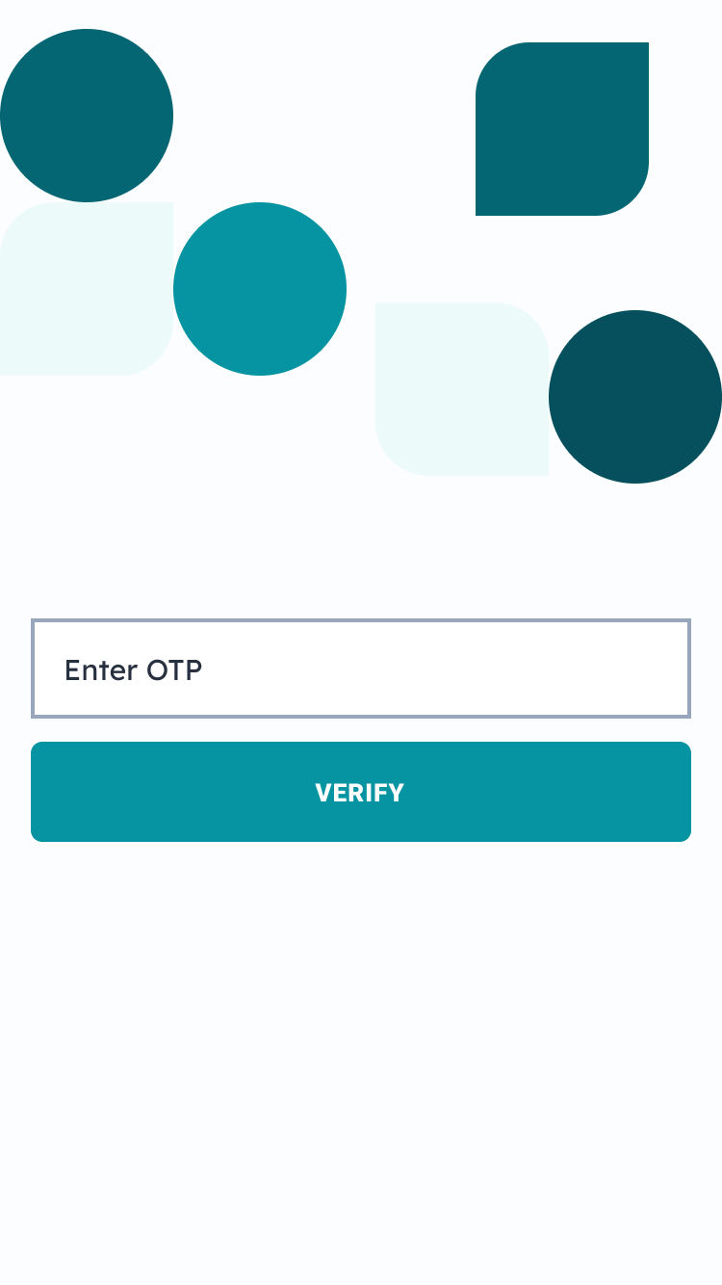 | 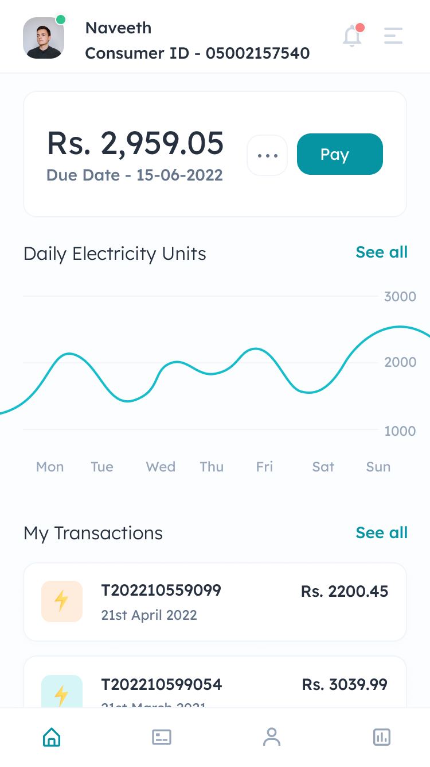
Page 3: Enter Your OTP | Page 4: Home Page
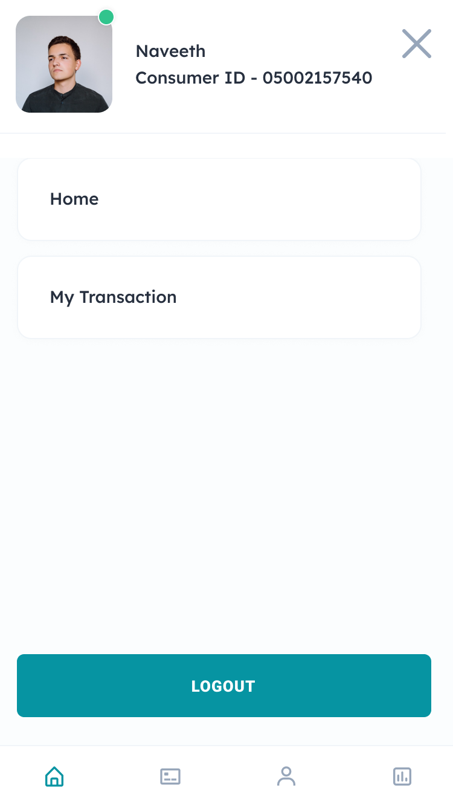 | 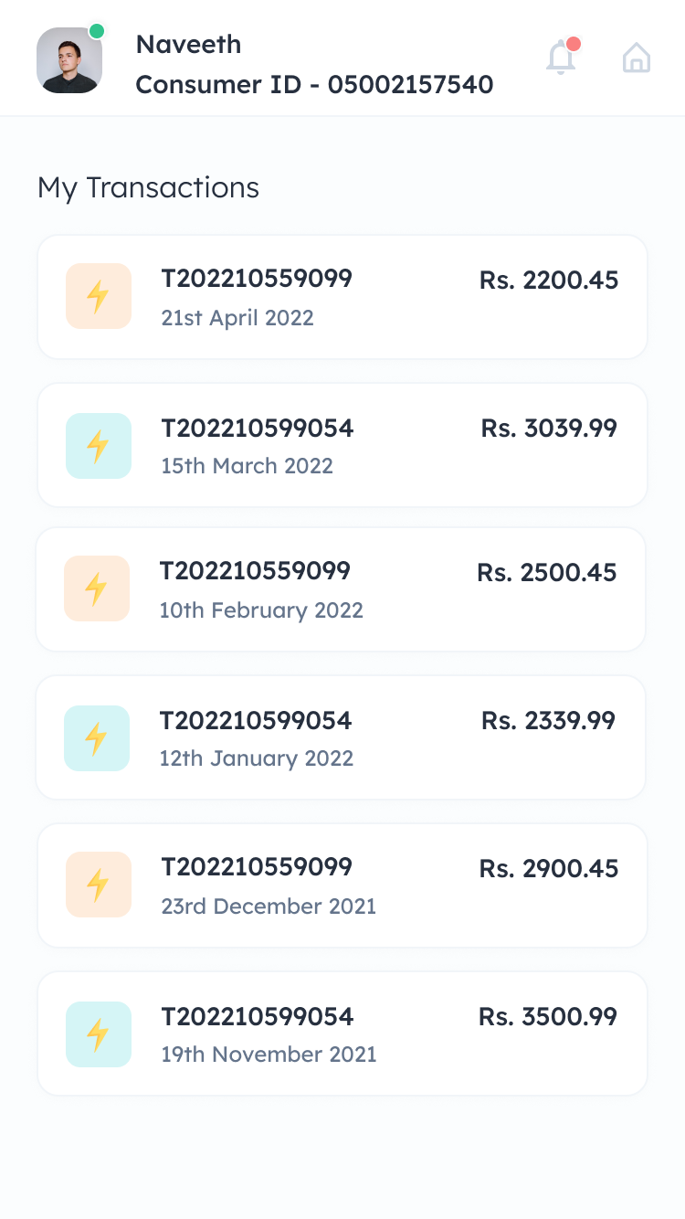
Page 5: Profile Page | Page 6: Transaction Page
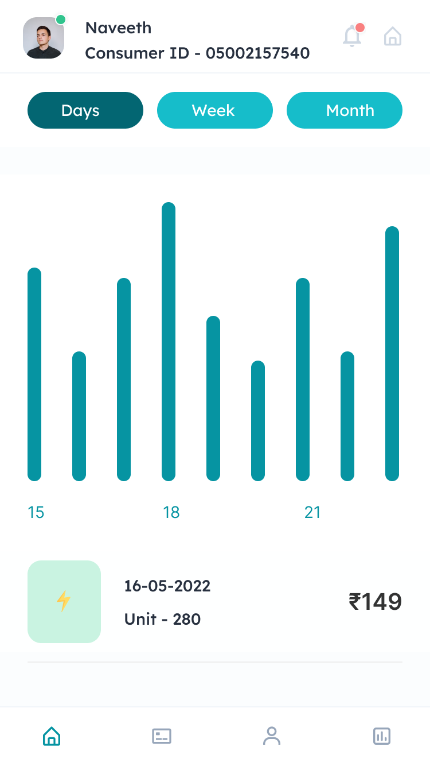 | 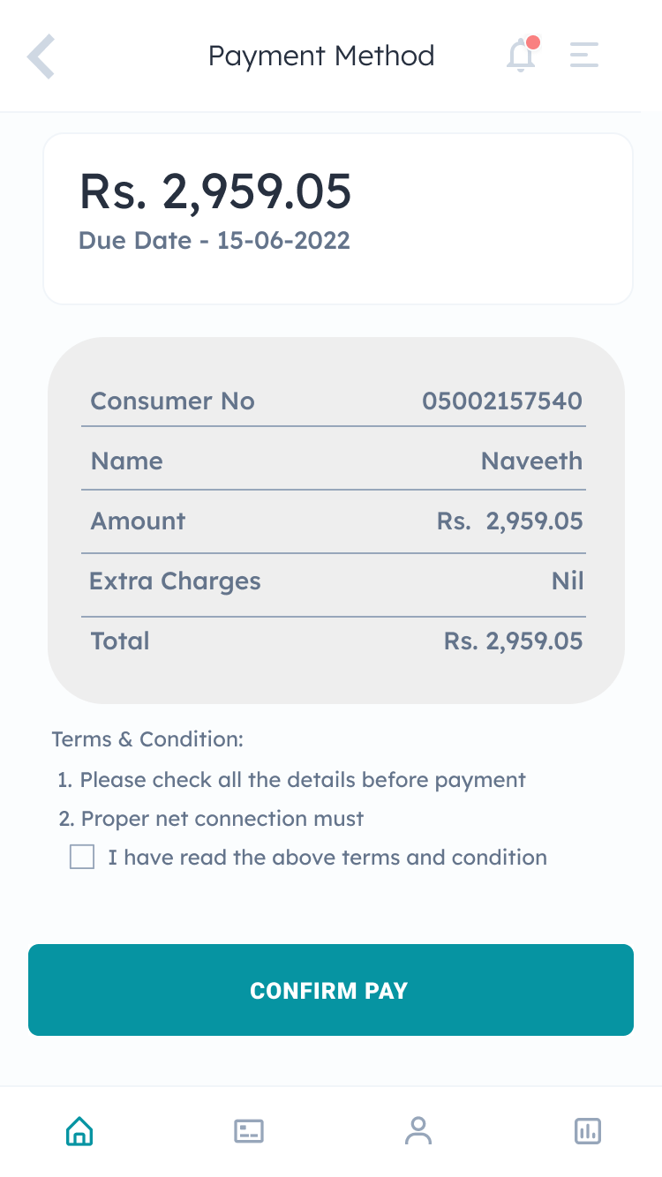
Page 7: if click Sell all (Daily Electricity unit page) | Page 8: Click pay button then open this page
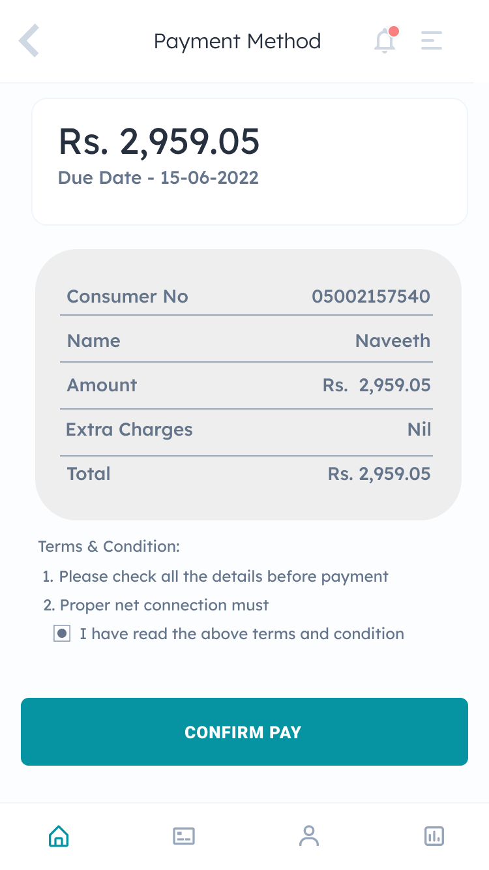 | 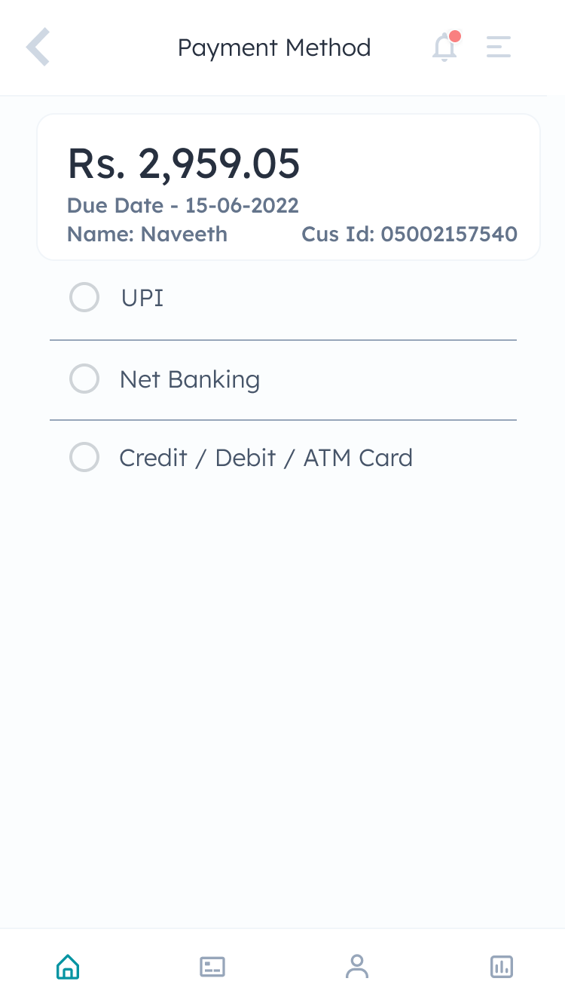
Page 9: Click tick box and confirm pay button | Page 10: Payment Option Page
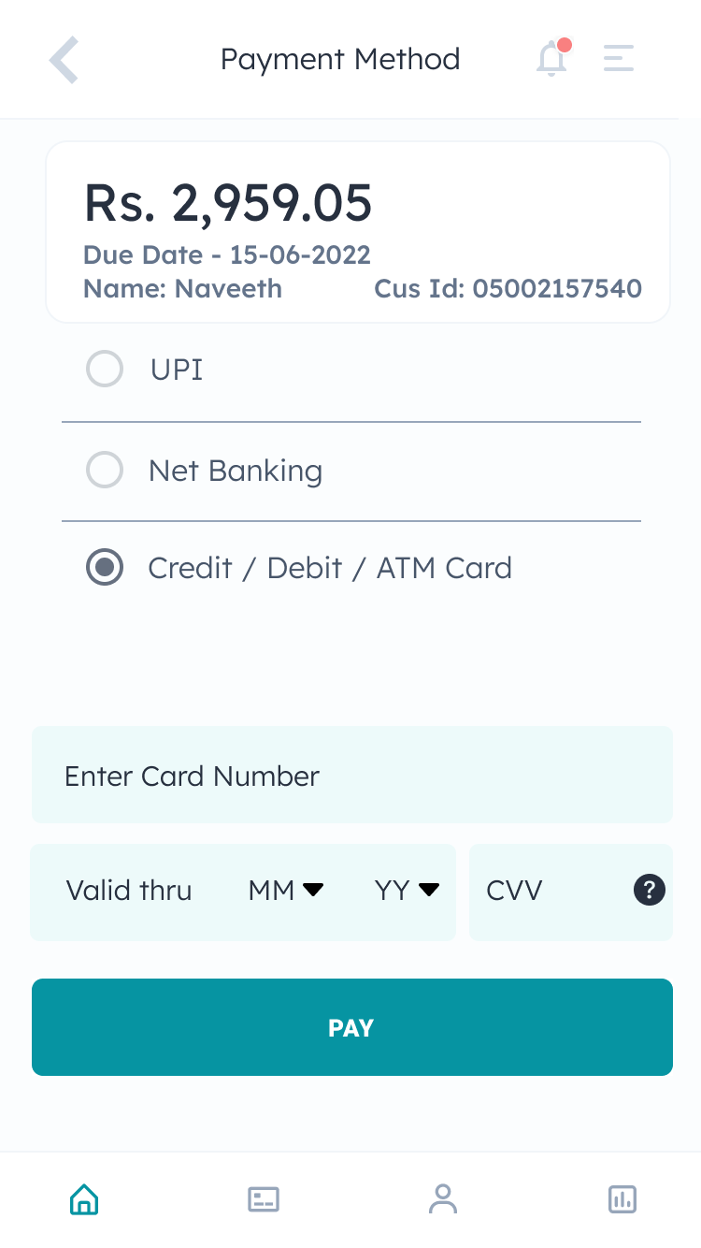 | 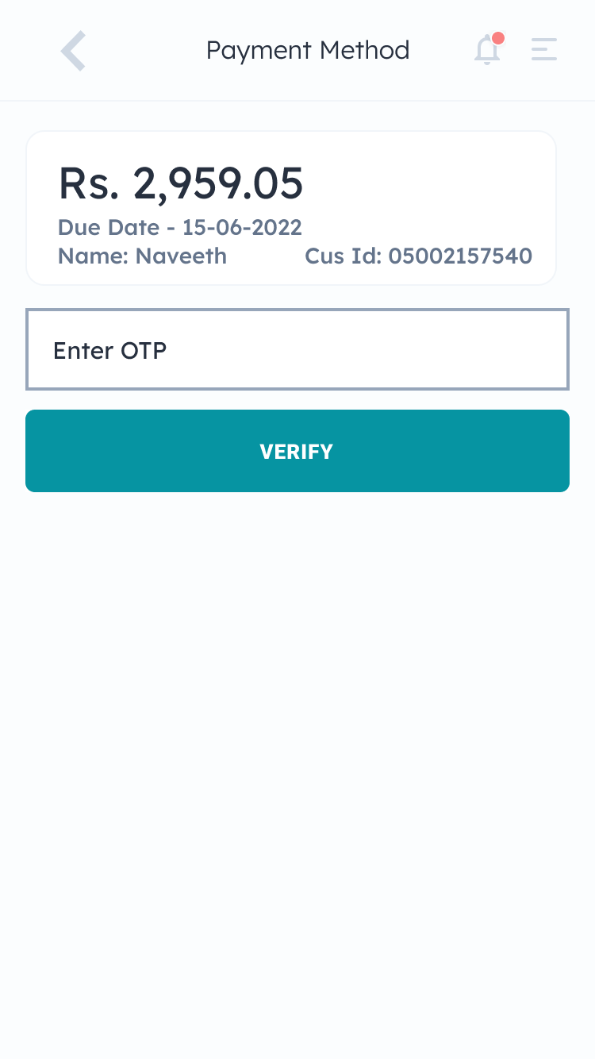
Page 11: Click payment method | Page 11: Security Verification page and click verify
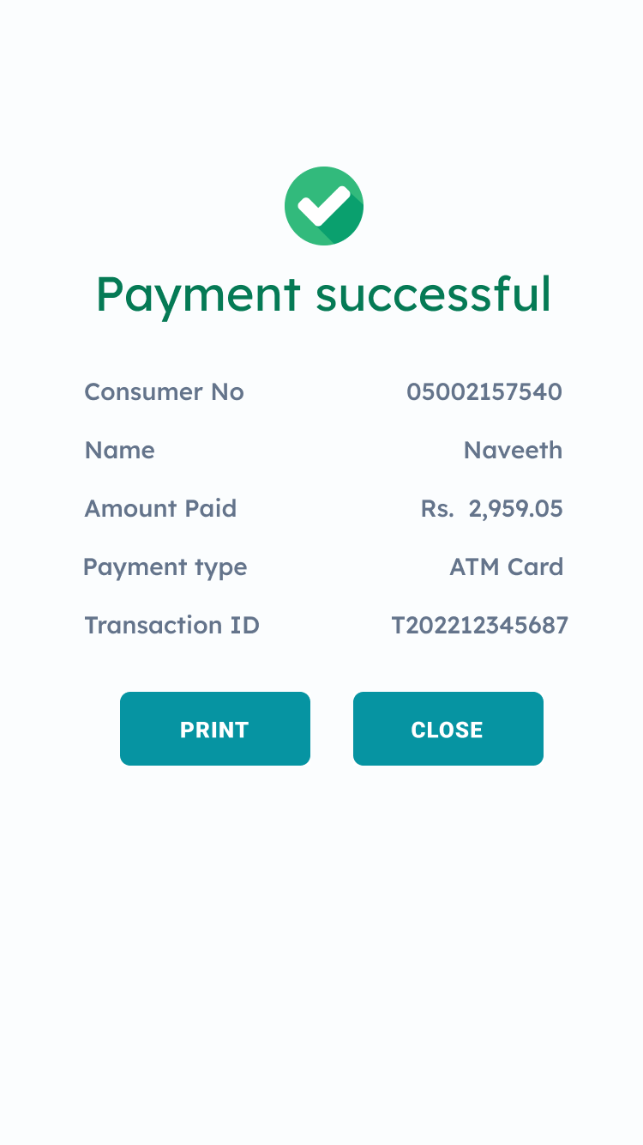 | 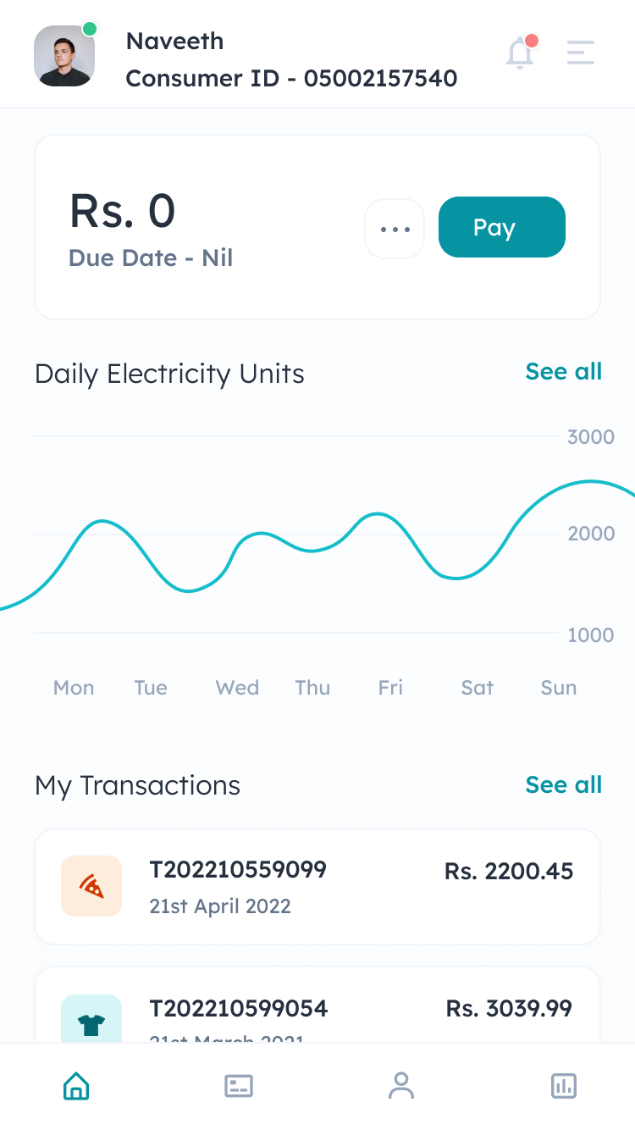
Page 12: Payment Status Page – Print PDF Document | Page 13: After Payment – Pending Balance is Zero

